Balance of the general government sector ended up in deficit 2.2% of the GDP
1 October 2026

Notification of government deficit and debt – 2025
For the year 2025, the balance of the general government sector ended up with a deficit corresponding to 2.2% of the GDP, which was by 0.2 percentage point (p. p.) more than in 2024. The general government sector debt in the end of the year 2025 reached 44.2% of the GDP while the year-on-year (y-o-y) increase was by 0.9 p. p.
“The balance of the general government sector for the year 2025 ended up with a deficit in the amount of CZK 185.5 billion (bn), which in the year-on-year comparison means worsening by CZK 26.2 billion. The government debt ratio increased to the level of 44.2% of the GDP,” Petr Musil, Director of the Government and Financial Accounts Department of the Czech Statistical Office (CZSO), stated.
Notification table of government deficit and debt
Indicator | 2022 | 2023 | 2024 | 2025
Net lending / net borrowing, CZK mil. | -213 884 | -282 814 | -159 222 | -185 469
Net lending / net borrowing,  % of GDP | -3.0 | -3.7 | -2.0 | -2.2
Consolidated gross debt,  CZK mil. | 2 997 632 | 3 234 102 | 3 488 500 | 3 787 253
Consolidated gross debt,  % of GDP | 42.5 | 42.2 | 43.2 | 44.2
Net lending / net borrowing
The largest part of the deficit was in the central government sub-sector that ended up with the deficit of CZK 202.6 bn. The local government sector ended up with a surplus of CZK 28.3 bn and the social security funds sub-sector (of health insurance companies) ended up with a deficit of CZK 11.2 bn.
The total general government sector revenue increased by 6.2%, y-o-y, in 2025; in absolute terms, it was an increase by CZK 204.9 bn. Received social contributions, revenue from income taxes, and revenue from taxes on production and imports increased the most in absolute terms (by CZK 80.2 bn, CZK 41.4 bn, and CZK 44.0 bn).
The total general government sector expenditure increased by 6.6%, y-o-y, or by CZK 231.1 bn in 2025. The biggest increase was recorded for gross fixed capital formation (CZK 65.5 bn), compensation of employees paid (CZK 56.7 bn), and social benefits paid (CZK 40.5 bn).
Compared to spring notifications, the balance of the general government sector (net lending / net borrowing) worsened in 2025 by 0.1 p. p. mainly due to updated information on income tax of legal persons. In all the years, data were refined on received social contributions to health insurance, which meant an increase in the revenue of the general government sector. The influence on a relative indicator of the balance was 0.1 p. p. in the years 2024 and 2025.

Debt
In the end of 2025, the relative debt of the general government reached 44.2% of the GDP. In the year-on-year comparison, the relative debt increased by 0.9 p. p. An increase in the nominal GDP contributed to the decrease of the relative amount of the debt (-2.5 p. p.), whereas the nominal growth of the debt contributed in relation to the GDP to an increase by 3.5 p. p.
Chart: Year-on-year relative changes in government debt
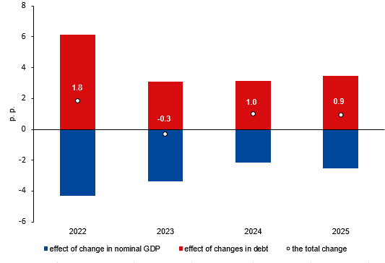
In the end of 2025, the general government debt increased by CZK 298.8 bn, y-o-y, and reached CZK 3 787.3 bn. A major part of the y-o-y change is due to the issued debt securities (CZK 276.9 bn).
In 2025, the year-on-year change in the debt (the increase by CZK 298.8 bn) was markedly different from the general government sector balance (a deficit of CZK 185.5 bn), which means that the general government sector borrowed by CZK 113.3 bn more than its need to be financed was. This fact was reflected on the assets side by an increase in the value of financial assets held, especially of deposits.
Indicators presented in the notification table were transmitted to Eurostat on 30 September 2026.

Notes: Notification of government deficit and debt is compiled always for the past four years and submitted to the European Commission by each Member State of the European Union always at the end of March and September each year, including a projection for the current year. The projection for the current year is compiled and published by the Ministry of Finance of the Czech Republic. Quantification of fiscal indicators is based on the ESA 2010 methodology and serves the assessment of how the Maastricht convergence criteria are complied with. Pursuant to the Maastricht criteria, the government deficit must not exceed 3% of the GDP and the level of the accumulated government debt must not exceed 60% of the GDP.

Government surplus/deficit is represented by the item B.9 “net borrowing (−) or net lending (+)” in the system of national accounts. The indicator refers to the ability of the general government sector in the given year to finance other sectors of the economy (+) or the need of the general government sector to be financed (−) by other sectors.

The government debt consists of consolidated liabilities of the general government sector in the form of currency and deposits, issued debt securities, and received loans. In case of foreign exchange debt instruments hedged against currency risk, value in CZK is obtained by means of a contractual exchange rate.
Minor differences in the last decimal place are due to rounding.
Responsible head at the CZSO: | Petr Musil, Director of the Government and Financial Accounts Department, T: +420 734 352 286, E: petr.musil@csu.gov.cz
Contact person:  Related information: | Jaroslav Kahoun, Head of the Government Accounts Unit,  T: +420 274 054 232, E: jaroslav.kahoun@csu.gov.cz  https://csu.gov.cz/government-finance-statistics
Next news release will be published on: | 21 October 2026

Annex:
Tab. 1: Notification tables of government deficit and debt, 2022–2025

