30 August 2024

GDP increased by 0.6%, year-on-year

## GDP resources and uses – the second quarter of 2024

According to the refined estimate, the gross domestic product increased by 0.3%, q-o-q, and by 0.6%, y-o-y, in the Q2 2024. The y-o-y GDP growth was mainly supported by higher final consumption expenditure. A change in inventories had a negative effect.

The refined estimate confirmed an increase of the Czech economy. The gross domestic product (GDP) adjusted for price effects and seasonally adjusted[1] was by 0.3% higher, quarter-on-quarter (q-o-q). In the year-on-year (y-o-y) comparison, it increased by 0.6%.

The **gross value added** (GVA) **increased by 0.5%, q-o-q,** and **by 0.1%, y-o-y**, in the Q2 2024. The q-o-q growth was mainly contributed to by a group of economic activities of trade, transportation, and accommodation and food service activities (growth by 2.3%). The following were also successful: financial and insurance activities, professional, scientific and technical activities, and administrative activities. Manufacturing had a negative effect (a decrease by 1.7%).

The y-o-y GVA development (+0.1%) was positively influenced mainly by a group of economic activities of trade, transportation, and accommodation and food service activities +0.4 percentage point (p. p.; growth by 2.3%) and by financial and insurance activities +0.2 p. p. (+7.3%). The following ones had a negative influence: industry -0.7 p. p. (-2.5%) and construction -0.1 p. p. (-2.4%).

*“In the Q2 2024, the Czech economy performance increased by 0.3%, q-o-q. Mainly increasing final consumption expenditure and gross fixed capital formation were the main factors of the growth. On the other hand, a change in inventories had a negative influence,”* Vladimír Kermiet, Director of the National Accounts Department of the Czech Statistical Office (CZSO) comments on the data.

The y-o-y growth of GDP (+0.6%) was positively influenced by expenditure on final consumption of households +1.2 p. p.[2], expenditure on final consumption of general government +0.8 p. p., gross fixed capital formation +0.4 p. p., and external demand +0.3 p. p. A change in inventories had a negative effect -2.1 p. p.

**Final consumption expenditure** increased by 0.6%, q-o-q. In the y-o-y comparison, it increased by 2.0%. Of that, final consumption expenditure of **households** increased by 0.2%, q-o-q, and by 1.0%, y-o-y. Year-on-year, mainly expenditure on purchase of non-durables and services were increasing. Final consumption expenditure of **general government** increased by 1.5%, q-o-q, and in the y-o-y comparison it was by 4.3%.

**Gross fixed capital formation** increased by 1.9%, q-o-q, and by 0.7%, y-o-y. Increasing, y-o-y, were investments in dwellings, other buildings and structures, transport equipment, and intellectual property products. Investments in ICT and in other machinery and equipment decreased. **Change in inventories**[3] was CZK +8.1 billion, which was, however, by CZK 27.1 billion less compared to the corresponding quarter of the previous year.

The **international trade balance of goods and services** at current prices reached the value of CZK 143.0 billion; it was thus by CZK 45.4 billion higher than in the corresponding period of the previous year. Exports increased in real terms by 0.6%, q-o-q. In the y‑o-y comparison, it increased by 0.4% thanks to increasing exports of services by 6.8%. Imports increased by 0.7%, quarter-on-quarter; in the y-o-y comparison, imports decreased by 1.5%.

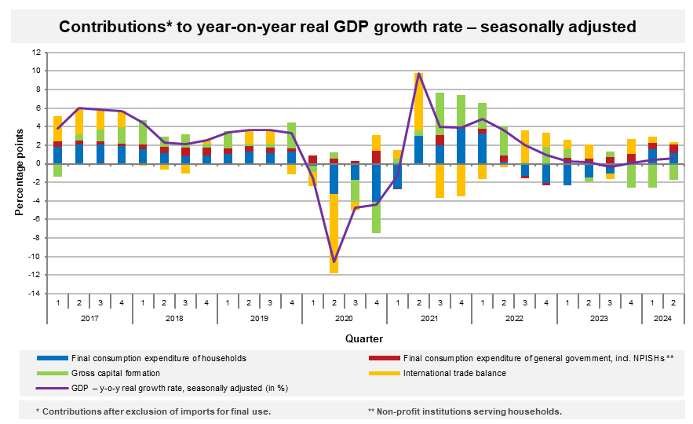

As for the price development in the Q2 2024, the total GDP deflator increased by 4.2%, y-o-y.

The volume of labour costs3 increased in the Q2 2024 by 5.5%, y-o-y.

The **total employment**[4] increased by 0.5%, q-o-q; in the y-o-y comparison, it increased by 0.2%. In total, by 0.5% more hours were worked in the q-o-q comparison; in the y-o-y comparison, it was by 1.0% less.

Notes:

Responsible head at the CZSO: Vladimír Kermiet, Director of the National Accounts Department, phone number (+420) 274 054 247, e‑mail: [vladimir.kermiet@csu.gov.cz](mailto:vladimir.kermiet@csu.gov.cz)

Contact person: Jan Benedikt, Head of the Quarterly Estimates Unit, phone number (+420) 274 052 750, e-mail: [jan.benedikt@csu.gov.cz](mailto:jan.benedikt@csu.gov.cz)

Used data sources updated as at: 22 August 2024

Time series: [Quarterly national accounts](https://apl.czso.cz/pll/rocenka/rocenka.indexnu_kvart?mylang=EN&co=Q_HDP_ZAM)

The news release web page: [Quarterly GDP estimates | Statistics (gov.cz)](https://csu.gov.cz/quarterly-gdp-estimates?pocet=10&start=0&podskupiny=051&razeni=-datumVydani)

*Next news release will be published on: 3O October 2024*

*(GDP preliminary estimate for the third quarter of 2024)*

1. *Unless otherwise stated, all data presented in this news release are adjusted for price, seasonal, and calendar effects.* 
2. *contributions to the GDP growth (imports for final use excluded, unless otherwise stated)*
3. *at current prices, not adjusted for seasonal effects*
4. *number of persons in terms of national accounts*