2 June 2025

The unemployment rate was 2.7% in April

Rates of employment, unemployment, and economic activity – April 2025
The employment rate
The proportion of employed persons in the number of all persons aged 15–64 years reached 75.8% in April 2025. It increased by 0.9 percentage point (p.p.) compared to that in April 2024. The male employment rate was 81.0%; the female employment rate was 70.5%.

The general unemployment rate
The percentage of the unemployed in the labour force, that is in the total number of the employed and the unemployed (that means economically active persons), reached 2.7% in April 2025. It decreased by 0.1 percentage point, year-on-year. The male unemployment rate reached 2.3%; the female unemployment rate reached 3.2%.

“Instead of seasonally adjusted figures presented so far, CZSO moves to trend-cycle. It shows smoothed time series, in which only permanent breaks in levels appear that usually accompany methodological changes to the survey. Trend-cycle figures are much more comparable both year-on-year and month-on-month; they should express the true dynamics on the labour market,” Dalibor Holý, Director of the Labour Market and Equal Opportunities Statistics Department of the Czech Statistical Office, explains.

Original (unadjusted) and smoothed (trend-cycle) unemployment rate, 2015–2025
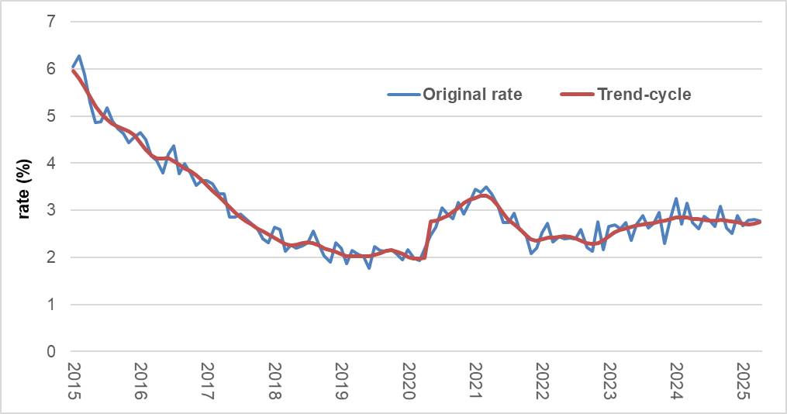

The economic activity rate
The percentage of the economically active in the total number of persons aged 15–64 years reached 77.9%. It increased by 0.8 p. p. compared to that in April 2024. The male economic activity rate (82.9%) exceeded the female economic activity rate (72.9%) by 10.0 p. p.

International comparability
All data presented in the News Release are adjusted. They apply to the age group of 15–64 years. They come from the Labour Force Sample Survey (LFSS) carried out by a network of interviewers of the CZSO in households and are different in terms of methodology from administrative data of the Labour Office of the Czech Republic on registered job applicants (namely the “Share of unemployed persons” indicator).
The LFSS has an internationally comparable methodology, which defines the employed and the unemployed in accordance with recommendations of the International Labour Organization. The CZSO regularly sends data from the LFSS to Eurostat, which prepares monthly press release on unemployment as for Member States of the EU, however, for the age group of 15–74 years. The unemployment rate in that age group (of the aged 15–74 years) was 2.7% in Czechia in April 2025.
In compliance with the international methodology for the LFSS, the survey is only carried out in private households; collective accommodation establishments as well as temporary shelters are not covered.
Tables 1 and 2 enclosed contain both trend-cycle and unadjusted time series of rates of employment, unemployment, and economic activity, starting from 1993. A shortened time series from 2015 has been used to identify the model.

Notes:
Responsible head at the CZSO: Dalibor Holý, Director of the Labour Market and Equal Opportunities Statistics Department, phone number: (+420) 274 052 694, e-mail: dalibor.holy@csu.gov.cz
Contact person: Petra Drobilíková, Unit for Labour Forces, Migration, and Equal Opportunities, phone number: (+420) 274 052 972, e-mail: petra.drobilikova@csu.gov.cz
Data source: CZSO, Labour Force Sample Survey (LFSS), which is conducted in selected private households; collective accommodation establishments are not included in the survey. The LFSS results have been grossed up to the total population of the Czech Republic using data of the population statistics as at 31. 12. 2024; estimations of the number of persons living outside private households have been subtracted from the population totals of vital statistics.
Methodological notes: https://csu.gov.cz/2-nez_m

End of data collection: 19 May 2025
End of preliminary data processing: 23 May 2025
Next news release will be published on: 1 July 2025

Since the reference month of April, there has been a change in the news release in the model of seasonal adjustment (a switchover to a trend-cycle); at the same time, the weighting scheme has been modified as every year in relation to new demographic background materials. A detailed explanation to the change was published in the Statistika & My magazine (Czech only) – see: Jak očistit nezaměstnanost | Statistika a my.

Annexes:

Table 1 Rates of employment, unemployment, and of economic activity (trend-cycle)
Table 2 Rates of employment, unemployment, and of economic activity (unadjusted)
Chart 1 The general unemployment rate (trend-cycle)

