April 25, 2022

Confidence among entrepreneurs increased m-o-m, while consumer confidence continued to decline

Business cycle survey – April 2022
The composite confidence indicator (economic sentiment indicator) – in the basis index form – increased by 3.4 percentage points to 100.0, m-o-m, with different development of its components. Business confidence indicator increased by 4.3 percentage points to 103.8, the consumer confidence indicator decreased by 1.1 percentage points to 81.3.
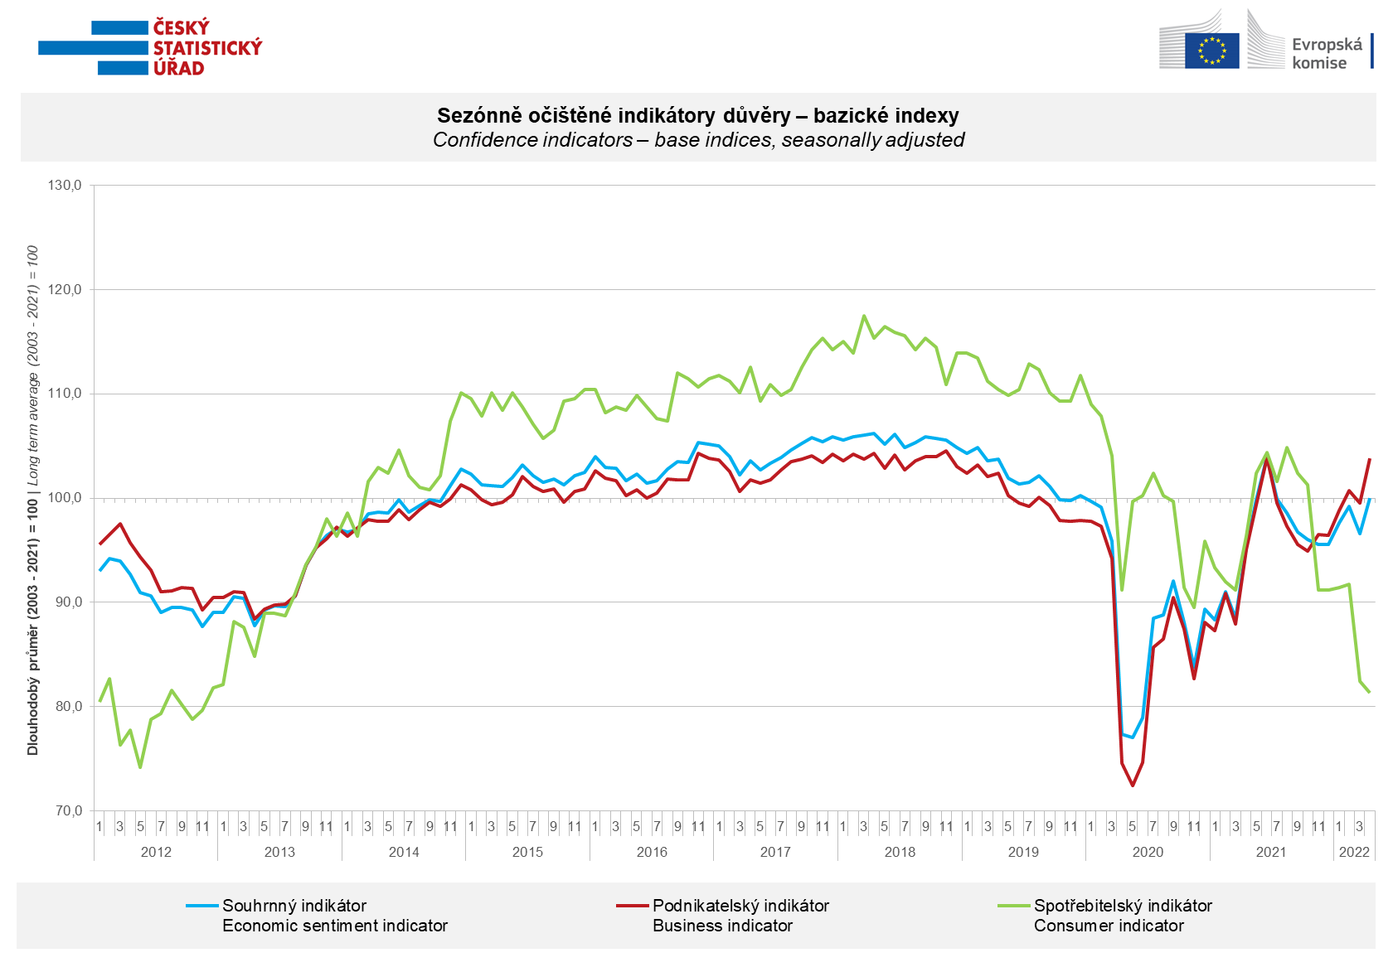
The month-on-month growth in economic sentiment among entrepreneurs in April was mainly due to higher expectations of growth in manufacturing activity in industry, and a positive assessment of current corporate demand in selected service sectors. In trade and construction sectors, business confidence declined.

April´s consumer confidence in the economy was the lowest since November 2012. Respondents negatively evaluate almost all aspects monitored. They are most worried about further price increases, the deterioration of the overall economic situation in the Czech Republic and their own financial situation.

***
More detailed information on the development of business and consumer confidence can be found in the supplementary information to the RI business surveys.

Notes:

Responsible manager: Juraj Lojka, Director of Business Statistics Coordination and Business Cycle Surveys Department, tel. +420731439291, e-mail: juraj.lojka@czso.cz
Contact person: Jiri Obst, Head of Business Cycle Surveys Unit, tel. +420604815440, e-mail: jiri.obst@czso.cz
Data source: CZSO business survey, Data Collect consumer survey (https://www.datacollect.cz)
Data collection date: Business part: April 19, 2022
Consumer part: April 14, 2022
Next News Release: May 24, 2022

This press release wasn´t edited for language.

Detailed time series of Balances and basic
indices of confidence indicators: https://www.czso.cz/csu/czso/kpr_ts
Business and Consumers Surveys are co-financed by grant agreements of the European Commission DG ECFIN.
https://ec.europa.eu/info/business-economy-euro/indicators-statistics/economic-databases/business-and-consumer-surveys_en
Link to European database: https://ec.europa.eu/eurostat/web/euro-indicators/business-and-consumer surveys

Annex:
Additional information to NR Business cycle survey
Table Confidence Indicators – basic indices
Graph 1 Confidence indicators – base indices, seasonally adjusted (2003–2022)
Graph 2.1 Confidence Indicators for industry, construction, trade, and in selected services – base indices, seasonally adjusted (2003–2022)
Graph 2.2 Balances of seasonally adjusted confidence indicators for industry, construction, trade, and in selected services (2003–2022)
Graph 3 Economic Sentiment Indicators – international comparison, seasonally adjusted (2007-2022)
Graph 4 Production Capacity Utilisation in Manufacturing Industry (2003-2022)
Graph 5 Limits of Production in Industry (2005-2022)
Graph 6 Limits of Production in Construction (2005-2022)
Graph 7 Limits of Production in Selected Services (2005-2022)

