April 24, 2026

Economic confidence reflects current uncertainty among businesses and concerns of households

Business cycle survey – April 2026

The composite confidence indicator (economic sentiment indicator), expressed as a basic index, decreased slightly m-o-m in April by 0.8 points to 101.3, reflecting differing developments in its two components. While the business confidence indicator remained at its March level (100.4), the consumer confidence indicator fell by 4.4 points to 106.0.

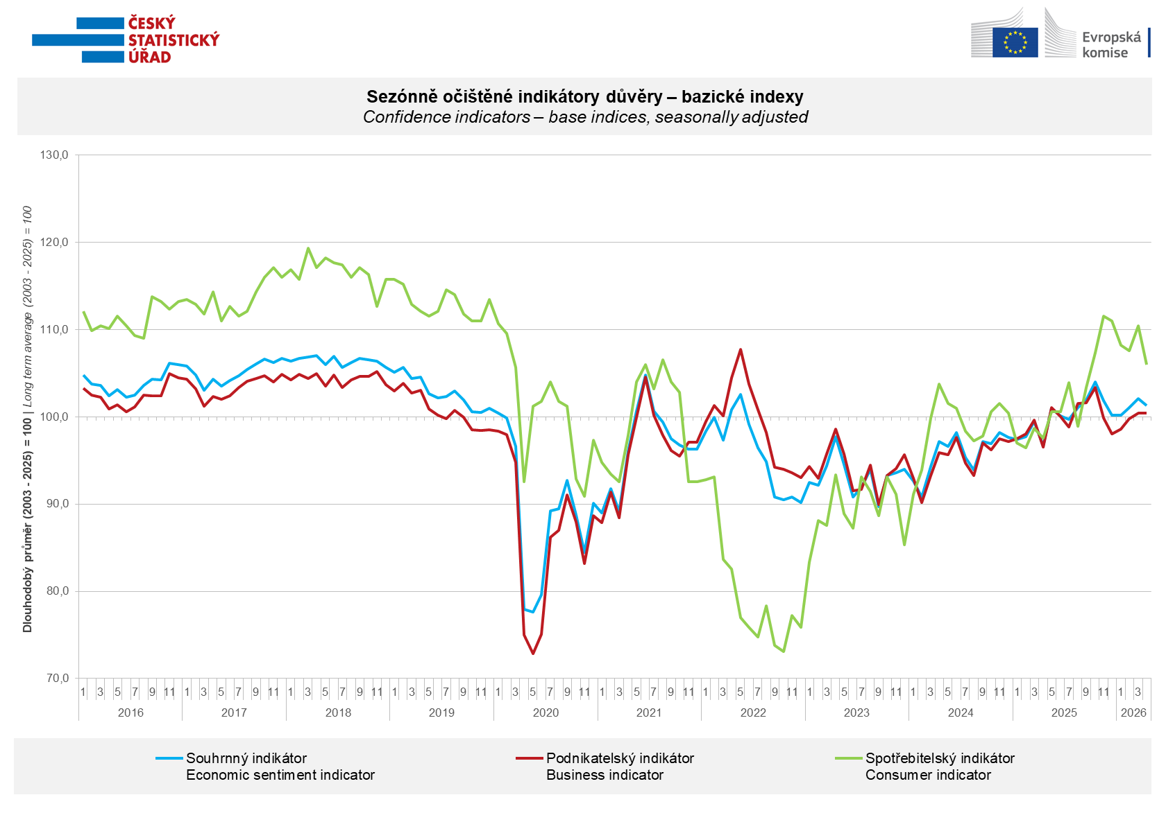

Among businesses, confidence in the economy increased m-o-m in April in selected services (+2.6 points) and in construction (+1.7 points). In trade, confidence declined by 3.2 points compared to March, and in industry by 2.4 points.

Among consumers, confidence in the economy decreased compared to March. The confidence indicator fell by 4.4 points to 106.0. The share of consumers expecting a deterioration in the overall economic situation in Czechia over the next twelve months increased significantly. The proportion of respondents assessing their current financial situation as worse than in the previous twelve months remained almost unchanged. M-o-m, the share of households expecting an improvement in their financial situation over the next twelve months declined. The number of respondents not planning to make major purchases over the next twelve months remained almost unchanged.
***
More detailed information on the development of business and consumer confidence can be found in the supplementary information to the RI business surveys.

Notes:

Responsible manager: Juraj Lojka, Director of Business Statistics Coordination and Business Cycle Surveys Department, tel. +420731439291, e-mail: juraj.lojka@csu.gov.cz
Contact person: Jiri Obst, Head of Business Cycle Surveys Unit, tel. +420604815440, e-mail: jiri.obst@csu.gov.cz
Data source: CZSO business survey, Data Collect consumer survey (https://www.datacollect.cz)
Data collection date: Business part: April 17, 2026
Consumer part: April 15, 2026
Next News Release: May 25, 2026

This press release wasn´t edited for language.

Detailed time series of Balances and basic
indices of confidence indicators: https://csu.gov.cz/produkty/kpr_ts
Business and Consumers Surveys are co-financed by grant agreements of the European Commission DG ECFIN.
https://ec.europa.eu/info/business-economy-euro/indicators-statistics/economic-databases/business-and-consumer-surveys_en
Link to European database: https://ec.europa.eu/eurostat/web/euro-indicators/database

Annex:
Additional information to NR Business cycle survey
Table Confidence Indicators – basic indices
Graph 1 Confidence indicators – base indices, seasonally adjusted (2003–2026)
Graph 2.1 Confidence Indicators for industry, construction, trade, and in selected services – base indices, seasonally adjusted (2003–2026)
Graph 2.2 Balances of seasonally adjusted confidence indicators for industry, construction, trade, and in selected services (2003–2026)
Graph 3 Economic Sentiment Indicators – international comparison, seasonally adjusted (2007-2026)
Graph 4 Production Capacity Utilisation in Manufacturing Industry (2003-2026)
Graph 5 Limits of Production in Industry (2005-2026)
Graph 6 Limits of Production in Construction (2005-2026)
Graph 7 Limits of Production in Selected Services (2005-2026)

