12 December 2025

Population of Czechia has declined

Population change – 1st – 3rd quarter of 2025
At the end of the third quarter of this year, Czechia had just under 10.9 million inhabitants, 12.3 thousand fewer than at the beginning of the year. The positive balance of international migration (12.8 thousand) was not sufficient to offset the natural population decline (−25.1 thousand). The number of live births (58.7 thousand) and marriages (36.0 thousand) declined again year-on-year. Conversely, there were slightly more deaths (83.8 thousand) and divorces.
As of 30 September 2025, the population of Czechia had 10,897,000 inhabitants, 12.3 thousand fewer than at the beginning of the year. The decline in the population was caused by a negative natural change, as the number of live births was 25.1 thousand lower than the number of deaths. It was the deepest natural decrease ever recorded for the first three quarters of the year in the history of the independent Czech Republic. The net international migration was positive, reaching 12.8 thousand persons, but was 8.3 thousand lower year-on-year. “In the first three quarters of this year, 85.2 thousand immigrants from abroad were registered, 10% fewer year-on-year. However, the monthly number of immigrants in September – 16.7 thousand – was the highest since September 2022. The data shows that behind the increase is the easing of exit restrictions in Ukraine for men aged 18–22,” said Michaela Němečková from the Demographic Statistics Unit of the Czech Statistical Office. A total of 72.4 thousand persons emigrated from Czechia to other countries during the first three quarters, 0.9 thousand fewer year-on-year. However, the number of emigrants in 2024 was record high. A large share of these departures consisted of persons whose temporary protection status had expired.

Figure Population change in the 1st–3rd quarters of 2024 and 2025
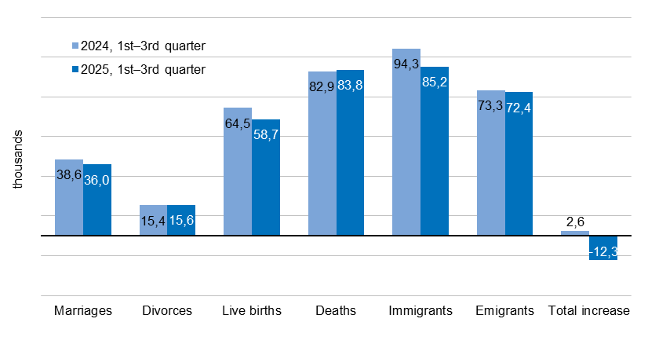
During the first three quarters of the year, 58.7 thousand children were born alive, 5.8 thousand (or 9%) fewer year-on-year. The decline in fertility has continued for the fourth consecutive year and has been observed across all birth orders. A total of 27.3 thousand children were first-born, 22.8 thousand were second-born, and 8.6 thousand children were born to mothers as their third or higher-order child. The proportion of children born outside marriage was 46.9%, similar to the previous year. In absolute terms, the highest number of children were born to women aged 30–32, i.e. women born in 1992–1994. In relative terms, fertility was highest among women born in 1995.

Between January and September, 83.8 thousand residents of Czechia died, 0.9 thousand (1%) more year-on-year. Among deceased men, the highest number of deaths occurred in the 75–79 age group, while among women it was in the 80–84 age group. One third of all deaths were recorded among persons aged 75 to 84.

A total of 36.0 thousand couples entered into marriage, 2.6 thousand (7%) fewer than in the same period of 2024. The number of marriages has been declining for the third consecutive year. The largest number of grooms were aged 30–34, while among brides the most numerous age group was 25–29. Every fourth person entering into marriage was doing so for at least the second time.

A total of 15.6 thousand marriages ended in divorce, 0.2 thousand more year-on-year. The highest number of divorces occurred after six years of marriage. The most numerous age group among those who divorced was people aged 45–49. 59% of divorced couples had at least one minor child in common. As a result, at least 14.9 thousand children were affected by parental divorce.
Notes:
All data refer to citizens of the Czech Republic and foreigners with permanent residence in the Czech Republic, third-country nationals with temporary residence in the territory of the Czech Republic based on a long-term visa (over 90 days) or a permanent residence permit, nationals of the EU Member States, Norway, Switzerland, Iceland, Liechtenstein and their dependants with notified temporary residence in the territory of the Czech Republic and foreigners with valid asylum status in the Czech Republic. Since 2022, the population has included persons granted temporary protection in the Czech Republic with usual residence in the Czech Republic. The data contain also information on events (marriages, births, and deaths) of Czech citizens with the permanent residence in the Czech Republic that occurred abroad and were registered by the special registry office in Brno.
All data for 2025 are preliminary.

Responsible manager: Mgr. Robert Šanda, director of Population Statistics Department,
tel. 274 052 160, e-mail: robert.sanda@csu.gov.cz
Contact person: Mgr. Michaela Němečková, Demographic Statistics Unit,
tel. 274 052 184, e-mail: michaela.nemeckova@csu.gov.cz
Data source: Demographic statistics – results of processing statistical reports of Obyv series and data from Census Information System of the CZSO
Divorces – Information system of the Ministry of Justice of the CR
Migration data – Information System of Inhabitants Records (Ministry of the Interior of the CR) and Alien Information System (Directorate of Alien Police)
End of data collection: 8 December 2025
Related publication: 130062-25 Population of the Czech Republic – 1st – 3rd quarter of 2025
https://vdb.czso.cz/vdbvo2/faces/en/index.jsf?page=statistiky&katalog=30845#katalog=34275
Related time series: https://vdb.czso.cz/vdbvo2/faces/en/index.jsf?page=statistiky&katalog=33157
Next News Release: 31 March 2026

Annexes:
Table 1 Population and population change in the 1st–3rd quarter
Chart 1 Population (quarterly data)
Chart 2 Population change in the 1st–3rd quarter
Chart 3 Live births (quarterly data)
Chart 4 Deaths (quarterly data)
Chart 5 Marriages (quarterly data)
Chart 6 Divorces (quarterly data)

