30 January 2026

GDP increased by 2.5% in 2025

GDP preliminary estimate – the fourth quarter of 2025
According to a preliminary estimate, the gross domestic product increased by 2.5%, in the year 2025. In the Q4 2025, the GDP increased by 0.5%, quarter-on-quarter, and by 2.4%, year-on-year.

The gross domestic product (GDP) adjusted for price effects and seasonally adjusted was by 2.5% higher in 2025 compared to 2024, according to the preliminary estimate. The all year round growth was mainly supported by the domestic demand. The growth of the gross value added was supported the most by a group of economic activities of trade, transportation, accommodation and food service activities.
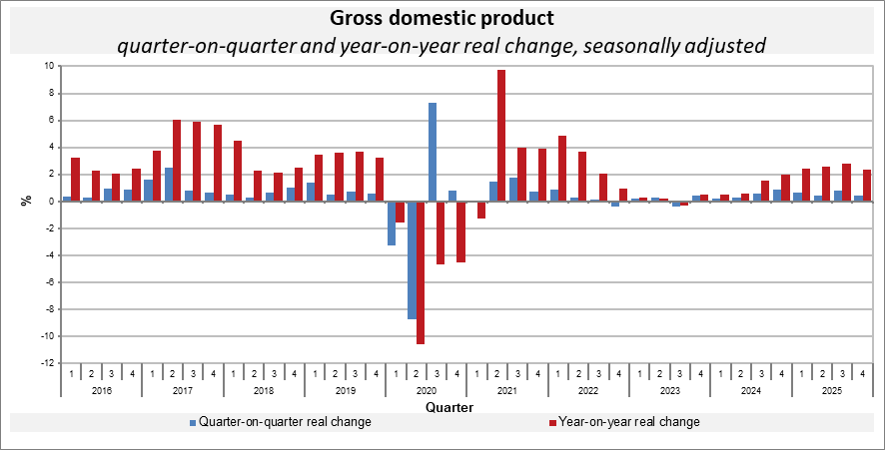
“In the last quarter of 2025, the GDP increased by 0.5%, quarter-on-quarter. The growth was mainly supported by higher final consumption expenditure. International trade balance also had a slightly positive influence,” Vladimír Kermiet, Director of the National Accounts Department of the Czech Statistical Office (CZSO), comments on the data.

In the year-on-year comparison, the GDP increased by 2.4% in the Q4 2025. Mainly final consumption expenditure of households and external demand contributed to the growth. Gross capital formation had a negative effect. An increase in the value added was the most supported by a group of economic activities of trade, transportation, accommodation and food service activities and by industry. Construction continued to be successful.

Employment increased by 1.0% in 2025. In the Q4 2025, employment remained unchanged, quarter-on-quarter; in a year-on-year comparison, it increased by 0.9%.

Responsible head at the CZSO: Vladimír Kermiet, Director of the National Accounts Department, phone number: (+420) 274 054 247,
e-mail: vladimir.kermiet@csu.gov.cz
Contact person: Jan Benedikt, Head of the Quarterly Estimates Unit,
phone number: (+420) 274 052 750,
e-mail: jan.benedikt@csu.gov.cz
Used data sources updated as at: 23 January 2026
Related CZSO’s web page: Quarterly GDP estimates | Statistics (gov.cz)
Next news release will be published on: 3 March 2026
(GDP resources and uses for the Q4 2025)

All data presented in this news release have been adjusted for price changes and seasonal and calendar effects.
employment in terms of national accounts

