June dates attracted fiancés
11. 09. 2026

Population change – 1st half of 2026
During the first half of the year, the population of Czechia decreased by 12.2 thousand to slightly less than 10.904 million. Net international migration (8.9 thousand) did not offset the natural population decrease (–21.1 thousand). Both the number of live births (36.5 thousand) and deaths (57.6 thousand) were lower year-on-year. However, there were more marriages (18.5 thousand) during the same period this year.
At the end of June this year, the Czech Republic had a population of 10.904 million, down by 12.2 thousand compared with the beginning of the year. Natural decrease, resulting from the number of deaths exceeding the number of live births, amounted to 21.1 thousand people. However, the net international migration mitigated the total decrease.
During the first half of this year, 36.5 thousand live births were born, representing a year-on-year decrease of 1.8 thousand (5%). The birth rate has been declining for the fifth consecutive year, however this year´s decrease has been less pronounced than in previous years, when it ranged between 8 and 10%. The highest number of children were born to mothers aged 30 to 32, while first births were most frequent among women aged 27 to 29. As in the first half of last year, a total of 53% children were born to married women in the first half of this year.
From January to June, 57.6 thousand residents of Czechia died, which was 0.4 thousand (1%) fewer year-on-year. The highest numbers of deaths belonged to those born in 1941–1948. In terms of five-year age groups, they aged 80–84 years (10.6 thousand) and 75–79 (10.4 thousand).
Figure Population change of 1st half of 2025 and 2026
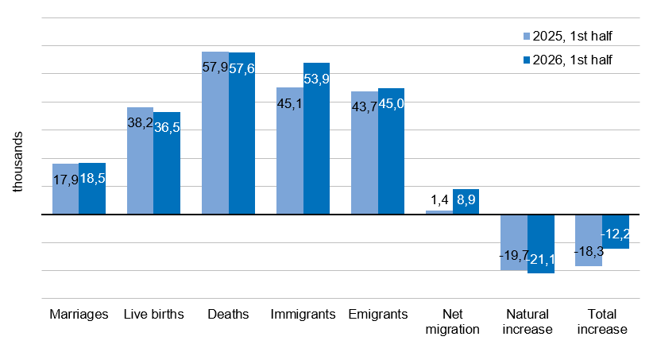
„According to the provisional data, there were 18.5 thousand new marriages in the first half of this year, five hundred more than a year earlier. In June, a total of 9.5 thousand marriages were registered, the highest monthly number in the last four years. The fiancés were particularly attracted by Saturday 6/6/2026,” adds Michaela Němečková from the Demographic Statistics Unit of the Czech Statistical Office.
The population of Czechia gained 8.9 thousand inhabitants through international migration, with 53.9 thousand people immigrating from abroad and 45.0 thousand emigrating. Compared to the first half of 2025, the net international migration was six times higher this year. In both directions of international migration, Ukrainian nationals predominated. However, the highest net migration balance was recorded for citizens of the Philippines (2.5 thousand), and Ukraine's was the second highest (2.2 thousand). Net international migration of Slovak citizens ranked third (1.8 thousand).

Notes:

All data refer to citizens of the Czech Republic and foreigners with permanent residence in the Czech Republic, third-country nationals with temporary residence in the territory of the Czech Republic based on a long-term visa (over 90 days) or a permanent residence permit, nationals of the EU Member States, Norway, Switzerland, Iceland, Liechtenstein and their dependants with notified temporary residence in the territory of the Czech Republic and foreigners with granted international protection in the Czech Republic and foreigners with granted temporary protection in the Czech Republic.
All data for 2026 are preliminary.
Data on divorces for the first half of 2026 are not included due to incomplete data from the Ministry of Justice of the Czech Republic.

Responsible manager: Mgr. Robert Šanda, director of Population Statistics Department,
tel. 274 052 160, e-mail: robert.sanda@csu.gov.cz
Contact person: Mgr. Michaela Němečková, Demographic Statistics Unit, tel. 274 052 184,
e-mail: michaela.nemeckova@csu.gov.cz
Data source: Demographic statistics – results of processing statistical reports of Obyv series and data from Census Information System of the CZSO
Migration data – Information System of Inhabitants Records (Ministry of the Interior of the CR) and Alien Information System (Directorate of Alien Police)
End of data collection: 7 September 2026
Related publication: 130062-26 Population of the Czech Republic – 1st half of 2026
https://data.csu.gov.cz/datastat/dash?aSada=OBY01PD%23katalog%3D34275&fTab=tree
Related time series: https://csu.gov.cz/produkty/oby_ts
Next News Release: 15 December 2026

Text is not edited for language.

Annexes:
Table 1 Population and population change in the 1st half

