2 July 2024

General government sector balance remained in a deficit

Government deficit and debt – the first quarter of 2024
In the Q1 2024, the general government sector balance ended up with a deficit corresponding to 3.2% of the GDP. The government debt ratio reached 43.4% of the GDP.

In the Q1 2024, the general government sector deficit reached CZK 59.4 billion, which means that it improved by CZK 49.2 billion in the year-on-year comparison. The central government ended up with a deficit of CZK 90.3 billion that decreased by CZK 49.3 billion, y-o-y. Performance of the local government sector ended up with a surplus in the amount of CZK 34.4 billion, which means, in a year-on-year comparison, an increase by CZK 4.1 billion. Performance of social security funds (of health insurance companies) ended up with a deficit of CZK 3.5 billion.

“In the first quarter of 2024, the general government sector ended up with a deficit of CZK 59.4 billion, which corresponded to 3.2% of the GDP. The government debt ratio reached 43.4% of the GDP,” Petr Musil, Director of the Macroeconomic Statistics Section of the Czech Statistical Office (CZSO), stated.

The general government sector balance, Q1 2022 – Q1 2024
Period | Q1 2022 | Q2 2022 | Q3 2022 | Q4 2022 | Q1 2023 | Q2 2023 | Q3 2023 | Q4 2023 | Q1 2024
CZK bn | -63.6 | 1.9 | -55.6 | -99.0 | -108.6 | -10.3 | -41.9 | -107.6 | -59.4
% of the GDP | -4.0 | 0.1 | -3.1 | -5.3 | -6.1 | -0.5 | -2.2 | -5.4 | -3.2
Note: Data in the table are not seasonally adjusted; they cannot be compared quarter-on-quarter.

The total government revenues increased by 9.2%, y-o-y, and reached 40.7% of the GDP. Especially the following contributed to the y-o-y increase in revenues: received taxes on income and received social contributions. The total government expenditure increased by 1.7%, y-o-y, and reached 44.0% of the GDP. Expenditure on social benefits increased the most, whereas the biggest decrease was recorded for subsidies.

The nominal debt of the general government increased, year-on-year, by CZK 232.8 bn to CZK 3 332.3 bn. The government debt ratio increased from 42.9% to 43.4% of the GDP, y-o-y; the influence of the nominal change of the debt was +3.1 p. p., while the increasing nominal GDP contributed to a decrease in indebtedness by –2.6 p. p. In the quarter-on-quarter comparison, the debt increased by CZK 103.9 bn, the nominal change of the debt was 1.4 p. p., whereas an increase in the nominal GDP contributed to a decrease in the indebtedness by –0.4 p. p., which resulted in an increase in the debt ratio by 1.0 p. p., quarter-on-quarter.

Regarding the debt structure, mainly issued debt securities increased, year-on-year (CZK +252.7 bn).

Debt of the general government sector, Q1 2022 – Q1 2024
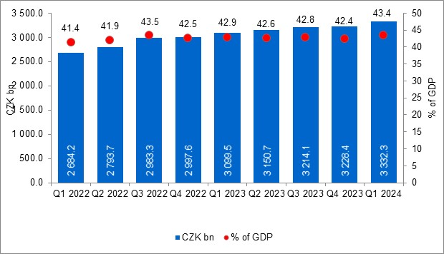

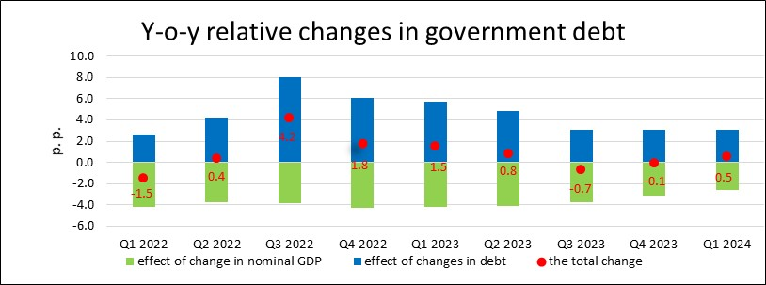

The general government sector balance after seasonal adjustment as well as adjustment for calendar effects ended up with a deficit of CZK 38.5 bn, which corresponded to 2.0% of the GDP. The general government sector balance improved by CZK 23.7 bn, q-o-q. The development of the general government sector balance adjusted by seasonal and calendar effects is shown in the chart below.

Seasonally adjusted general government sector balance, Q1 2022 – Q1 2024
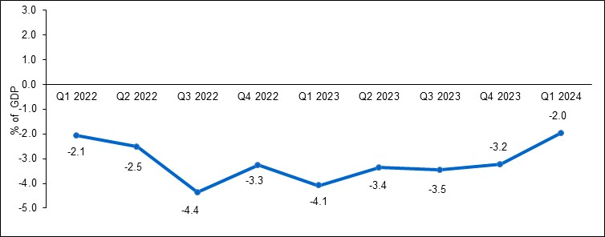
Notes:
Quantification of fiscal indicators of government deficit and debt mentioned above is based on the ESA2010 methodology. Data published in this news release are methodologically consistent with the data used for the statistics of the excessive deficit procedure (EDP) purposes and for the assessment of how Maastricht convergence criteria are met.

The government surplus/deficit is represented by the item B.9 “net borrowing (−) or net lending (+)” in the system of national accounts. It refers to the ability of the general government sector to finance other sectors of the economy (+) or the need of the general government sector to be financed (−) by other sectors of the economy in the given period.

The general government debt is the amount of consolidated liabilities of the general government sector comprising the following items: received deposits, issued debt securities, and received loans. In case of foreign exchange debt instruments hedged against the currency risk, the value in CZK is obtained by means of the contractual exchange rate.

The general government sector balance is compared with the amount of the GDP in the given quarter at current prices. The amount of the consolidated general government debt is compared with the sum of quarterly GDP for the last four quarters at current prices. Fiscal indicators of quarterly government deficit and debt are published within the Transmission programme (Table 25 and Table 28) on the CZSO’s website General government sector in the “GDP, National Accounts” section. Unless otherwise stated, data are not seasonally adjusted as well as they are not adjusted for calendar effects. Time series of seasonally adjusted sector accounts for the government sector (the item of net lending / net borrowing) Time series of seasonally adjusted sector accounts for S.13.

Responsible head at the CZSO: | Helena Houžvičková. Director of the Government and Financial Accounts Department,  phone number: (+420) 704 688 734,  e-mail: helena.houzvickova@csu.gov.cz
Contact person: | Jaroslav Kahoun, Head of the Government Accounts Unit, phone number: (+420) 274 054 232, e-mail: jaroslav.kahoun@csu.gov.cz
The next news release will be published on: | 2 October 2024

