May 24, 2022

Consumer confidence continues to decline, but overall confidence in the economy is growing

Business cycle survey – May 2022
The composite confidence indicator (economic sentiment indicator) – in the basis index form – increased by 1.8 percentage points to 101.8, m-o-m, with different development of its components. Business confidence indicator increased by 3.2 percentage points to 107.0, but the consumer confidence indicator decreased by 5.5 percentage points to 75.8.

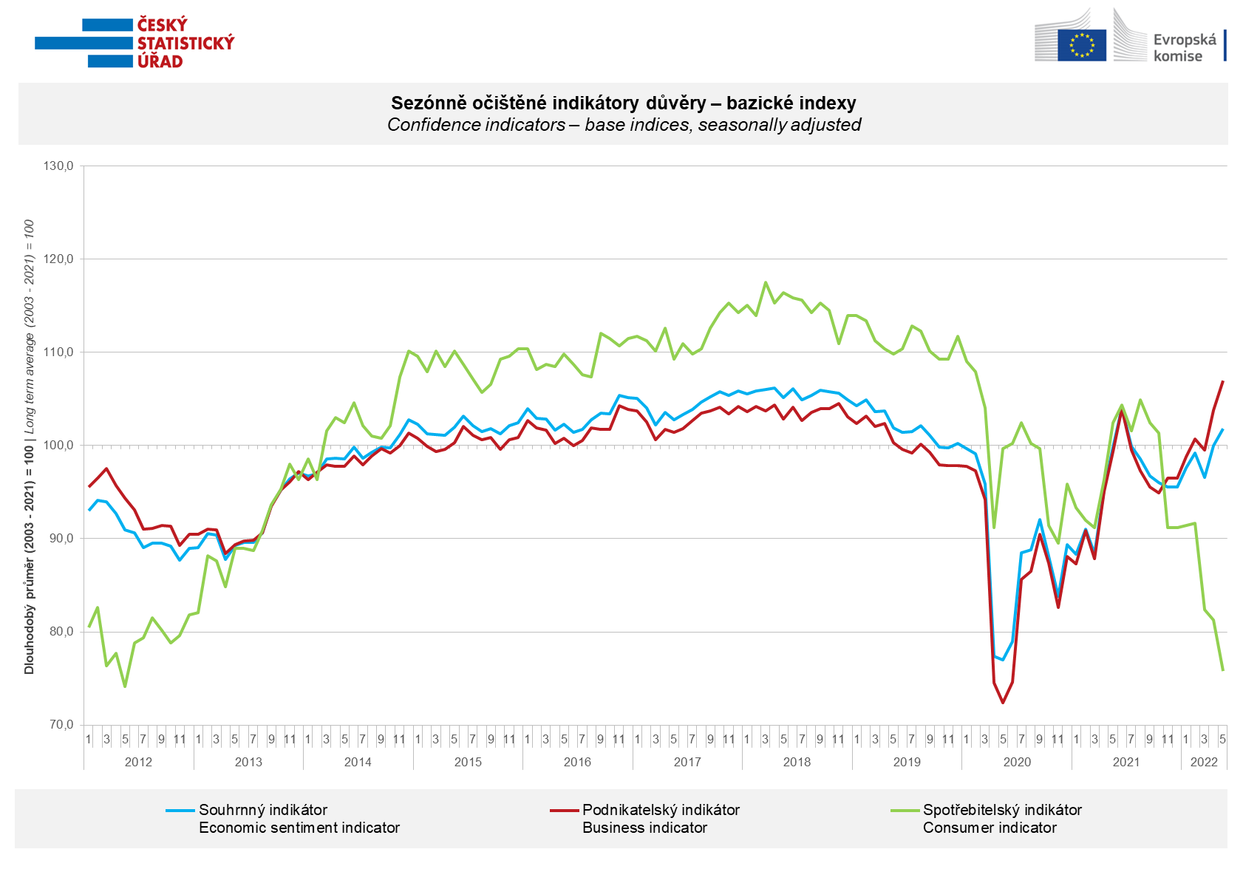

The growth of confidence among entrepreneurs in May was mainly due to favourable developments in industry and trade. In selected service sectors confidence stagnated month on month, while in construction it fell.

Consumer confidence in the economy was the lowest since May 2012. Compared to the previous month, in May the number of respondents worried about the deterioration of their own financial situation, the overall economic situation in the Czech Republic and rising unemployment increased.

***
More detailed information on the development of business and consumer confidence can be found in the supplementary information to the RI business surveys.

Notes:

Responsible manager: Juraj Lojka, Director of Business Statistics Coordination and Business Cycle Surveys Department, tel. +420731439291, e-mail: juraj.lojka@czso.cz
Contact person: Jiri Obst, Head of Business Cycle Surveys Unit, tel. +420604815440, e-mail: jiri.obst@czso.cz
Data source: CZSO business survey, Data Collect consumer survey (https://www.datacollect.cz)
Data collection date: Business part: May 17, 2022
Consumer part: May 17, 2022
Next News Release: June 24, 2022

This press release wasn´t edited for language.

Detailed time series of Balances and basic
indices of confidence indicators: https://www.czso.cz/csu/czso/kpr_ts
Business and Consumers Surveys are co-financed by grant agreements of the European Commission DG ECFIN.
https://ec.europa.eu/info/business-economy-euro/indicators-statistics/economic-databases/business-and-consumer-surveys_en
Link to European database: https://ec.europa.eu/eurostat/web/euro-indicators/business-and-consumer surveys

Annex:
Additional information to NR Business cycle survey
Table Confidence Indicators – basic indices
Graph 1 Confidence indicators – base indices, seasonally adjusted (2003–2022)
Graph 2.1 Confidence Indicators for industry, construction, trade, and in selected services – base indices, seasonally adjusted (2003–2022)
Graph 2.2 Balances of seasonally adjusted confidence indicators for industry, construction, trade, and in selected services (2003–2022)
Graph 3 Economic Sentiment Indicators – international comparison, seasonally adjusted (2007-2022)

