6 August 2025

Industrial production increased by 1.1%, year-on-year, in the first half-year

Supplementary information to the news release on industry –June 2025
Industry in the first half-year
Industrial production was in real terms by 1.3% higher, in the first half-year of 2025 compared to the second half-year of 2024. In the year-on-year comparison, it increased by 1.1%. The first half-year of 2025 had by one working day less compared to the corresponding half-year of the previous year. The following contributed the most to the year-on-year growth: electricity, gas, steam and air conditioning supply (a contribution of +0.7 percentage point (p. p.), growth by 8.3%), namely due to a low comparison basis in the previous year. Further, manufacture of electrical equipment (a contribution of +0.17 p. p., growth by 2.3%), manufacture of other non-metallic mineral products (a contribution of +0.16 p. p., growth by 3.8%), and manufacture of food products (a contribution of +0.15 p. p., growth by 3.0%). The highest negative contributions were recorded by the following: manufacture of computer, electronic and optical products (a contribution of -0.15 p. p., a decrease by 4.4%), manufacture of chemicals and chemical products (a contribution of -0.14 p. p., a decrease by 3.2%), and manufacture of motor vehicles, trailers and semi-trailers (a contribution of -0.12 p. p., a decrease by 0.6%). Production in manufacture of wearing apparel decreased by almost a tenth, y-o-y, and by 15% in manufacture of leather and related products.
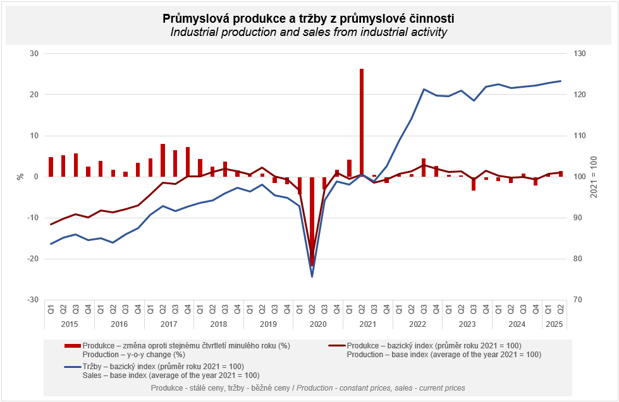
In the first quarter, the industrial production increased by 0.7%, y-o-y; in the q-o-q comparison, it was by 1.4% higher. In the second quarter, the increase rate accelerated: compared to the previous quarter, the industrial production increased by 0.3%, compared to the Q2 2024 by 1.4%. This year-on-year growth was the most contributed to by electricity, gas, steam and air conditioning supply and by manufacture of other transport equipment.

Sales from industrial activity at current prices increased by 0.7%, y-o-y, in the first half-year of 2025. Direct export sales of industrial enterprises increased at current prices by 2.7%. Domestic sales, which also include indirect export via non-industrial enterprises, decreased at current prices by 1.5%.
The following contributed the most to the growth: manufacture of food products (a contribution of +0.39 p. p., growth by 5.9%), manufacture of fabricated metal products (a contribution of +0.24 p. p., growth by 3.1%), and manufacture of motor vehicles, trailers and semi-trailers (a contribution of +0.21 p. p., an increase by 0.8%).
On the other hand, sales from industrial activity decreased the most in the following: manufacture of chemicals and chemical products (a contribution of -0.20 p. p., a decrease by 6.0%), manufacture of computer, electronic and optical products (a contribution of -0.18 p. p., a decrease by 3.6%), and mining and quarrying (a contribution of -0.12 p. p., a decrease by 11.5%).

The value of new orders at current prices in surveyed industrial CZ-NACE activities in the first half-year of 2025 increased by 1.2%, year-on-year. Non-domestic new orders increased by 1.7%. Domestic new orders increased by 0.2%.
The following contributed the most to the increase of the value of new orders: manufacture of fabricated metal products (a contribution of +0.75 p. p., an increase by 6.2%), manufacture of motor vehicles, trailers and semi-trailers (a contribution of +0.38 p. p., an increase by 1.0%), and manufacture of machinery and equipment (a contribution of +0.35 p. p., an increase by 3.4%).
The highest negative contributions were recorded by manufacture of chemicals and chemical products (a contribution of -0.27 p. p., a decrease by 4.9%), manufacture of computer, electronic and optical products (a contribution of -0.24 p. p., a decrease by 2.9%), and manufacture of wearing apparel (a contribution of -0.05 p. p., a decrease by 7.2%).

The average registered number of employees in industry in the first half-year of 2025 was by 2.0% lower compared to the corresponding period of the previous year.

Notes:

Contact person: Veronika Doležalová, Head of Industrial Statistics Unit, phone number (+420) 734 352 291, e-mail: veronika.dolezalova@csu.gov.cz

Related outputs: time series in the Public database, the Industry chapter

