28 November 2025

GDP increased by 0.8%, quarter-on-quarter

GDP resources and uses – the third quarter of 2025

According to the refined estimate, the gross domestic product increased by 0.8%, quarter-on-quarter, and by 2.8%, year-on-year, in the Q3 2025. The y-o-y GDP growth was supported by both the domestic and external demand. Final consumption expenditure of households contributed the most.
“The refined estimate confirmed continuing growth of the Czech economy. The gross domestic product (GDP) adjusted for price effects and seasonally adjusted increased by 0.8%, quarter-on-quarter. In the year-on-year comparison, it increased by 2.8%,” Vladimír Kermiet, Director of the National Accounts Department of the Czech Statistical Office (CZSO) comments on the data.

The gross value added (GVA) increased by 0.9%, quarter-on-quarter (q-o-q), and by 2.8%, year-on-year (y-o-y), in the Q3 2025. Most of economic activities of the national economy were successful. The q-o-q growth was mainly contributed to by construction (growth by 4.2%) and information and communication (+2.0%). Industry stagnated.

The y-o-y GVA development (+2.8%) was positively influenced mainly by a group of economic activities of trade, transportation, and accommodation and food service activities +0.6 percentage point (p. p.; growth by 3.4%), construction +0.5 p. p. (+9.7%), and information and communication +0.5 p. p. (+7.5%).

On the demand side, growing final consumption expenditure and the international trade balance were the main factors of the q-o-q growth of GDP. The y-o-y growth was also supported by gross capital formation.

The y-o-y growth of GDP (+2.8%) was positively influenced by final consumption expenditure of households +1.2 p. p., expenditure on final consumption of general government +0.4 p. p., gross capital formation +0.8 p. p., and the international trade balance (+0.4 p. p.).

Final consumption expenditure increased by 0.3%, q-o-q. In the y-o-y comparison, it increased by 2.7%. Of that, final consumption expenditure of households increased by 0.3%, q-o-q, and by 3.0%, y-o-y. Final consumption expenditure of general government increased,
q-o-q, by 0.1% and in the year-on-year comparison, it increased by 2.0%.

Gross fixed capital formation increased by 0.4%, q-o-q, and by 1.7%, y-o-y. Mainly investments in dwellings and in other buildings and structures recorded a y-o-y growth, whereas a decrease mainly occurred in investments in transport equipment. The change in inventories was CZK +61.5 billion, which was by CZK 8.4 billion more compared to the corresponding quarter of the previous year.

The international trade balance of goods and services at current prices reached the value of CZK 128.3 billion; it was thus by CZK 10.1 billion higher than in the corresponding period of the previous year. Exports increased in real terms by 1.0%, q-o-q. In the y-o-y comparison, it increased by 3.4%. Imports stagnated, q-o-q; in the y-o-y comparison, it increased by 3.7%.
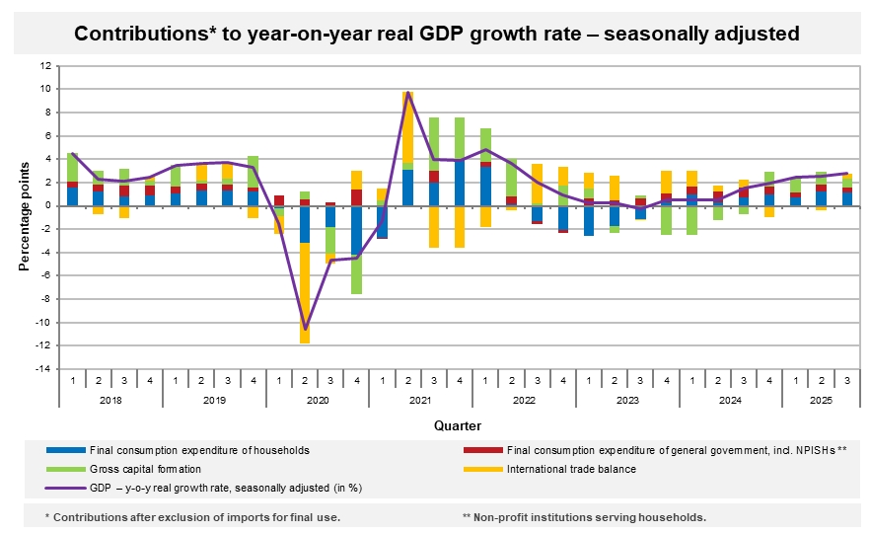
As for the price development in the Q3 2025, the total GDP deflator increased by 0.5%, q-o-q, and by 3.3%, y-o-y.

The volume of labour costs3 increased in the Q3 2025 by 7.1%, y-o-y.

The total employment increased by 0.1%, q-o-q; in the y-o-y comparison, it increased by 1.0%. In total, by 1.2% more hours were worked in the q-o-q comparison; in the y-o-y comparison, it was by 2.8% more.
Notes:
Responsible head at the CZSO: Vladimír Kermiet, Director of the National Accounts Department, phone number (+420) 274 054 247, e-mail: vladimir.kermiet@csu.gov.cz
Contact person: Jan Benedikt, Head of the Quarterly Estimates Unit, phone number (+420) 274 052 750, e-mail: jan.benedikt@csu.gov.cz
Used data sources updated as at: 25 November 2025
Time series: Quarterly national accounts
The news release web page: Quarterly GDP estimates | Statistics (gov.cz)
The next news release will be published on: 30 January 2026
(GDP preliminary estimate for the fourth quarter of 2025)

Unless otherwise stated, all data presented in this news release are adjusted for price, seasonal, and calendar effects.
contributions to the GDP growth (imports for final use excluded, unless otherwise stated)
at current prices, not adjusted for seasonal effects
the number of persons in terms of national accounts

