27 September 2024

The decline in the number of births has continued

Population change – 1st half of 2024

During the first half of this year, the population of Czechia decreased by 21.5 thousand. This was mainly due to the excess of deaths over live births (by 13.9 thousand), but the balance of international migration was also negative (–7.6 thousand). Compared to the first half of 2023, there were significantly fewer births and marriages this year. The number of deaths was also lower year-on-year.

According to the population balance of the CZSO, the **population** of Czechia fell from 10.90 to 10.88 million between 1 January and 30 June this year. The population decline resulted from both natural change and net migration. While the decline in natural change was recorded in all months of the first half of the year, the balance of international migration was negative only in March, but significantly (–41.8 thousand). This was related to the high increase in the number of emigrants, which mainly reflected the termination of the stay of persons whose temporary protection expired at the end of March and who did not apply for its prolongation. A total of 62.7 thousand people immigrated to Czechia from abroad in the first half of the year, by 13.8 thousand less year-on-year. The number of emigrants was 70.2 thousand, including 50.5 thousand in March, by 55.2 thousand more than in the first half of 2023.

Figure Population change of 1st half of 2023 and 2024

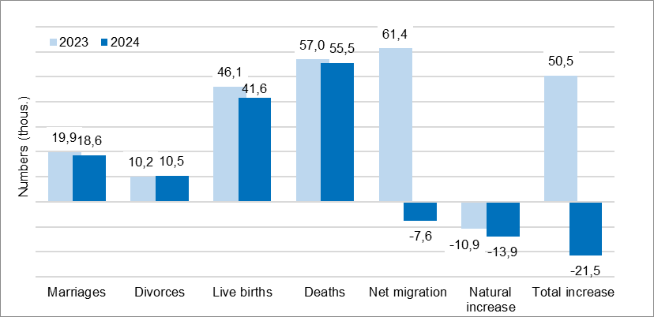

"*From January to June this year, the number of* ***live births*** *was 41.6 thousand. This was a year-on-year decrease of 4.5 thousand, or 10%. At the same time, the number of births had been declining with similar intensity in the previous two years"*, says Michaela Němečková from the Demographic Statistics Unit of the CZSO. The number of births to women aged 25–29 years decreased the most, by 15%, or 1.9 thousand. The decline in births was more profound for first-born children (by 11%) than for children of higher birth order (by 9%). A total of 47.1% of children were born outside marriage.

The number of **deaths** was 55.5 thousand, which was 1.5 thousand (or 3%) fewer than in the same period last year. Among the deceased, most were men aged 75–79 years and women aged 80–84 years. A total of 18.6 thousand couples entered into **marriage**, 1.3 thousand (or 7%) fewer than in the first half of 2023. There were fewer marriages year-on-year in all calendar months except April. Most grooms and brides were in the age of 30. According to preliminary data, there were 10.5 divorces. In 57.8% of them, there was at least one minor child at the time of divorce.

Notes:

All data refer to citizens of the Czech Republic and foreigners with permanent residence in the Czech Republic, third-country nationals with temporary residence in the territory of the Czech Republic based on a long-term visa (over 90 days) or a permanent residence permit, nationals of the EU Member States, Norway, Switzerland, Iceland, Liechtenstein, and their dependants with notified temporary residence in the territory of the Czech Republic and foreigners with international protection in the Czech Republic. Since 2022, the population has included persons granted temporary protection in the Czech Republic with usual residence in the Czech Republic. The data also contain information on events (marriages, births, and deaths) of Czech citizens with permanent residence in the Czech Republic that occurred abroad and were registered by the special registry office in Brno.

All data for 2024 are preliminary.

*Responsible manager: Mgr. Robert Šanda, director of Population Statistics Department,*

*tel. 274 052 160, e-mail: robert.sanda@csu.gov.cz*

*Contact person: Mgr. Michaela Němečková, Demographic Statistics Unit,*

*tel. 274 052 184, e-mail: michaela.nemeckova@csu.gov.cz*

*Data source: Demographic statistics – results of processing statistical reports of Obyv series and data from the Census Information System CZSO*

*Divorces – Information system of the Ministry of Justice of the CR  
Migration data – Information System of Population Records (Ministry of the Interior of the CR) and Foreigners Information System (Directorate of Alien Police)*

*End of data collection: 20 September 2024*

*Related publication: 130062-24 Population of the Czech Republic – 1st half of 2024*

[*https://vdb.czso.cz/vdbvo2/faces/en/index.jsf?page=statistiky&katalog=30845#katalog=34275*](https://vdb.czso.cz/vdbvo2/faces/en/index.jsf?page=statistiky&katalog=30845#katalog=34275)

*Related time series:* [*https://vdb.czso.cz/vdbvo2/faces/en/index.jsf?page=statistiky&katalog=33157*](https://vdb.czso.cz/vdbvo2/faces/en/index.jsf?page=statistiky&katalog=33157)

*Next News Release: 30 December 2024*

**Annexes:**

Table 1 Population (absolute and relative figures, year-to-year changes)

Chart 1 Population, quarterly data (numbers)

Chart 2 Population change, 1st half (numbers)

Chart 3 Live births, quarterly data (numbers)

Chart 4 Deaths, quarterly data (numbers)

Chart 5 Marriages, quarterly data (numbers)

Chart 6 Divorces, quarterly data (numbers)