June 24, 2025

Overall confidence in the economy remains just above its long-term average

Business cycle survey – June 2025

The composite confidence indicator (economic sentiment indicator), in the basic index form – decreased slightly by 0.9 points to 100.1 m-o-m, with the different development of its components. The business confidence indicator fell by 1.0 point to 100.0, while the consumer confidence indicator remained unchanged at 100.7.

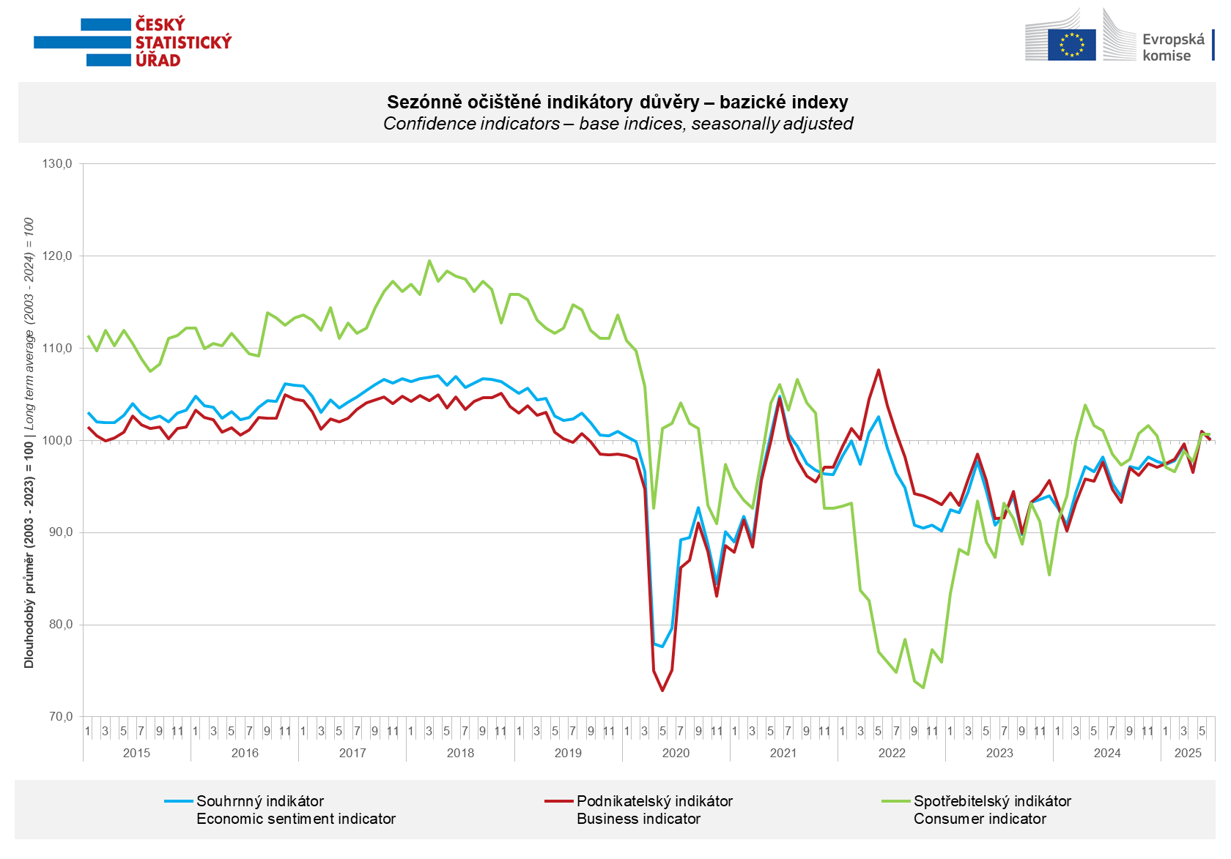
In June, business confidence increased in the construction sector (+6.5 points) and slightly in industry (+0.3 points). By contrast, it fell by 3.7 points in trade and by 2.8 points in selected service sectors.

Consumer confidence was unchanged from May. The balance of responses to questions on the overall economic situation in the Czech Republic, the expected financial situation of households in the next 12 months and the assessment of their current financial situation remained more or less at the previous month's level compared with the previous 12 months. The number of respondents who do not plan to make large purchases in the next 12 months has increased slightly.
***
More detailed information on the development of business and consumer confidence can be found in the supplementary information to the RI business surveys.

Notes:

Responsible manager: Juraj Lojka, Director of Business Statistics Coordination and Business Cycle Surveys Department, tel. +420731439291, e-mail: juraj.lojka@csu.gov.cz
Contact person: Jiri Obst, Head of Business Cycle Surveys Unit, tel. +420604815440, e-mail: jiri.obst@csu.gov.cz
Data source: CZSO business survey, Data Collect consumer survey (https://www.datacollect.cz)
Data collection date: Business part: June 18, 2025
Consumer part: June 16, 2025
Next News Release: July 24, 2025

This press release wasn´t edited for language.

Detailed time series of Balances and basic
indices of confidence indicators: https://csu.gov.cz/produkty/kpr_ts
Business and Consumers Surveys are co-financed by grant agreements of the European Commission DG ECFIN.
https://ec.europa.eu/info/business-economy-euro/indicators-statistics/economic-databases/business-and-consumer-surveys_en
Link to European database: https://ec.europa.eu/eurostat/web/euro-indicators/database

Annex:
Additional information to NR Business cycle survey
Table Confidence Indicators – basic indices
Graph 1 Confidence indicators – base indices, seasonally adjusted (2003–2025)
Graph 2.1 Confidence Indicators for industry, construction, trade, and in selected services – base indices, seasonally adjusted (2003–2025)
Graph 2.2 Balances of seasonally adjusted confidence indicators for industry, construction, trade, and in selected services (2003–2025)
Graph 3 Economic Sentiment Indicators – international comparison, seasonally adjusted (2007-2025)

