12 June 2025

Net international migration was negative

Population change – 1st quarter of 2025
The population of the Czech Republic fell by 32.6 thousand to 10.88 million in the first quarter of the year. This decline was caused due to an excess of 12.6 thousand deaths over live births and negative net international migration of 20.1 thousand. The number of deaths (30.6 thousand) increased slightly year-on-year. Conversely, there were fewer live births (18.1 thousand) and marriages (3.0 thousand) than in the previous year. The number of divorces did not change significantly over this period.
Between 1 January and 31 March this year, the population of the Czech Republic fell from 10,909,500 to 10,876,875. "In the first three months of this year, the Czech Republic lost 32.6 thousand inhabitants, which is similar to the first quarter of 2024. The population fell by 12.6 thousand due to an excess of deaths over births, and by a further 20.1 thousand due to negative net international migration," explains Michaela Němečková from the Demographic Statistics Unit of the Czech Statistical Office. The weight of natural decline increased slightly this year compared to last year.

Figure Population change of 1st quarter of 2024 and 2025
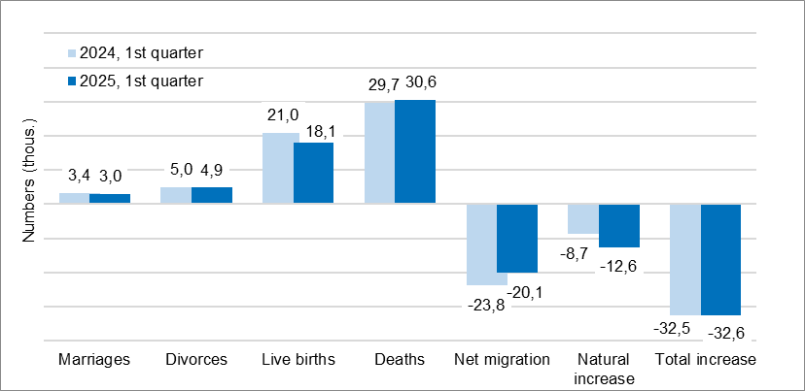

A total of 18.1 thousand children were born alive, which is 2.9 thousand, or by 14%, fewer than in the previous year. This is the fourth year in a row that the birth rate has been declining. Of these, 8.4 thousand were first-born, 7.0 thousand were second-born, and 2.7 thousand were third-born or higher-order. The women who gave birth most frequently were those born between 1993 and 1996. 48.1% of children were born outside of marriage.

During the first three months of 2025, 30.6 thousand Czech residents died, which is almost 1.0 thousand (or 3%) more than in the same period of 2024. There were more deaths year-on-year in all five-year age groups over 70. The highest number of deaths was among those aged 80–84 (5.3 thousand) and 75–79 (5.2 thousand).

In the first quarter of this year, 3.0 thousand couples entered into marriage, which is almost 0.4 thousand, or 14%, fewer than a year ago. This is the third year in a row that the number of marriages has been decreasing. Most of the grooms were aged 30–34, and most of the brides were aged 25–29. A total of 4.9 thousand marriages ended in divorce, which is 0.1 thousand (2%) fewer than the year before. The most common divorces were those involving marriages that had lasted five, six or two years, corresponding to the higher number of marriages concluded in 2019, 2018 and 2022 respectively. Three-fifths of divorced couples had at least one minor child together.

In the first quarter of 2025, the net international migration resulted in a balance of −20.1 thousand people. As in the first quarter of 2024, this decline was caused by a high number of people whose residence permits in Czechia had expired. Most of these were people whose granted international protection expired at the end of March. A total of 46.3 thousand people emigrated (6.1 thousand fewer than in the previous year), while 26.2 thousand people immigrated to the Czech Republic (2.4 thousand fewer than in the previous year). Citizens of Ukraine predominated in both migration flows.
Notes:
All data refer to citizens of the Czech Republic and foreigners with permanent residence in the Czech Republic, third-country nationals with temporary residence in the territory of the Czech Republic based on a long-term visa (over 90 days) or a permanent residence permit, nationals of the EU Member States, Norway, Switzerland, Iceland, Liechtenstein and their dependants with notified temporary residence in the territory of the Czech Republic and foreigners with valid asylum status in the Czech Republic. Since 2022, the population has included persons granted temporary protection in the Czech Republic with usual residence in the Czech Republic. The data contain also information on events (marriages, births, and deaths) of Czech citizens with the permanent residence in the Czech Republic that occurred abroad and were registered by the special registry office in Brno.
All data for 2025 are preliminary.

Responsible manager: Mgr. Robert Šanda, director of Population Statistics Department,
tel. 274 052 160, e-mail: robert.sanda@csu.gov.cz
Contact person: Mgr. Michaela Němečková, Demographic Statistics Unit,
tel. 274 052 184, e-mail: michaela.nemeckova@csu.gov.cz
Data source: Demographic statistics – results of processing statistical reports of Obyv series and data from Census Information System of the CZSO
Divorces – Information system of the Ministry of Justice of the CR
Migration data – Information System of Inhabitants Records (Ministry of the Interior of the CR) and Alien Information System (Directorate of Alien Police)
End of data collection: 3 June 2025
Related publication: 130062-25 Population of the Czech Republic – 1st quarter of 2025
https://vdb.czso.cz/vdbvo2/faces/cs/index.jsf?page=statistiky&katalog=30845#katalog=34275
Related time series: https://vdb.czso.cz/vdbvo2/faces/index.jsf?page=statistiky&katalog=33157
Next News Release: 11 September 2025

Text is not edited for language.

Annexes:
Table 1 Population (absolute and relative figures, year-to-year changes)
Chart 1 Population, quarterly data (numbers)
Chart 2 Population change, 1st quarter (numbers)
Chart 3 Live births, quarterly data (numbers)
Chart 4 Deaths, quarterly data (numbers)
Chart 5 Marriages, quarterly data (numbers)
Chart 6 Divorces, quarterly data (numbers)

