30 October 2025

GDP increased by 0.7%, quarter-on-quarter

GDP preliminary estimate – the third quarter of 2025
According to a preliminary estimate, the gross domestic product increased by 0.7%, quarter-on-quarter, in the Q3 2025. In the year-on-year comparison, it increased by 2.7%.

The gross domestic product (GDP) adjusted for price effects and seasonally adjusted increased in the Q3 2025, according to the preliminary estimate, by 0.7% compared to the previous quarter. When compared to the corresponding quarter of the previous year, it increased by 2.7%.

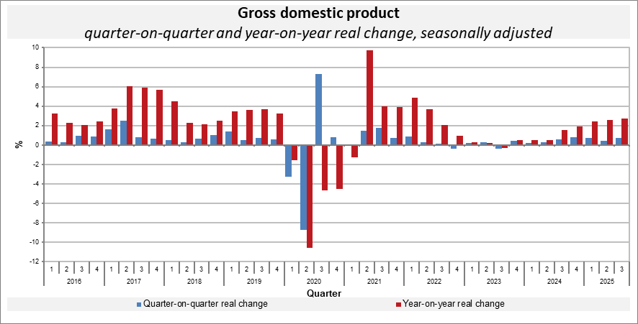

“The year-on-year growth of the GDP by 2.7% was mainly contributed to by final consumption expenditure of households and gross capital formation. The quarter-on-quarter growth was also contributed to by external demand,” Vladimír Kermiet, Director of the National Accounts Department of the Czech Statistical Office (CZSO), said.

The quarter-on-quarter as well as the year-on-year growth of the gross value added was positively influenced mainly by construction and a group of economic activities of trade, transportation, accommodation and food service activities. Other services were also successful.

Employment stagnated, quarter-on-quarter; compared to the corresponding quarter of the previous year, it increased by 0.9%.

Responsible head at the CZSO: Vladimír Kermiet, Director of the National Accounts Department, phone number: (+420) 274 054 247,
e-mail: vladimir.kermiet@csu.gov.cz
Contact person: Jan Benedikt, Head of the Quarterly Estimates Unit,
phone number: (+420) 274 052 750,
e-mail: jan.benedikt@csu.gov.cz
Used data sources updated as at: 21 October 2025
Related CZSO’s web page: Quarterly GDP estimates | Statistics (gov.cz)
Next news release will be published on: 28 November 2025
(GDP resources and uses for the Q3 2025)

All data presented in this news release have been adjusted for seasonal and calendar effects.
in terms of national accounts

