February 24, 2026

Overall confidence in the economy increased slightly

Business cycle survey – February 2026

The composite confidence indicator (economic sentiment indicator), expressed as a basic index, rose by 0.9 points m-o-m to 101.1 in February, with its two components developing differently. The business confidence indicator rose by 1.2 points to 99.8, while the consumer confidence indicator fell slightly by 0.6 points to 107.6.
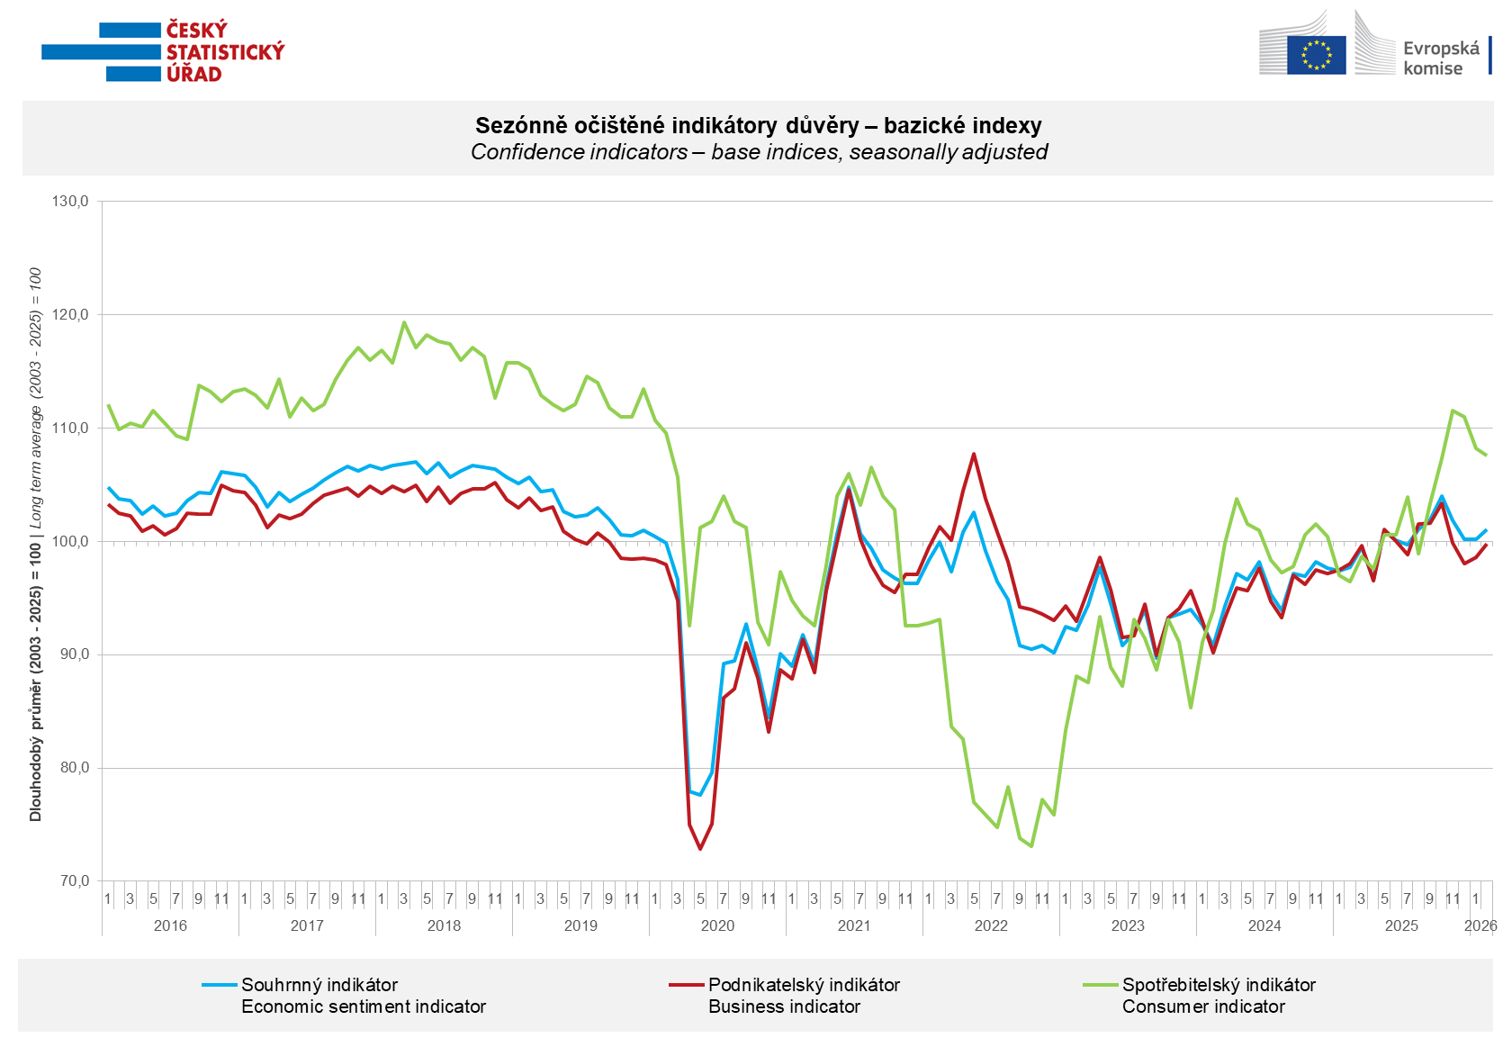

In February, confidence in the economy increased m-o-m in industry (+5.5 points) and construction (+4.1 points). In trade, business confidence remained unchanged m-o-m and fell by 3.3 points in selected services.

Consumer confidence declined slightly. The confidence indicator fell by 0.6 points m-o-m to 107.6. The share of consumers expecting the overall economic situation in Czechia to deteriorate over the next twelve months declined slightly. The share of respondents who assess their current financial situation as worse than in the previous twelve months also declined slightly. Compared to January, the share of households expecting their financial situation to improve over the next twelve months declined. The number of respondents who do not plan to make any major purchases in the next twelve months remained almost unchanged m-o-m.
***
More detailed information on the development of business and consumer confidence can be found in the supplementary information to the RI business surveys.

Notes:

Responsible manager: Juraj Lojka, Director of Business Statistics Coordination and Business Cycle Surveys Department, tel. +420731439291, e-mail: juraj.lojka@csu.gov.cz
Contact person: Jiri Obst, Head of Business Cycle Surveys Unit, tel. +420604815440, e-mail: jiri.obst@csu.gov.cz
Data source: CZSO business survey, Data Collect consumer survey (https://www.datacollect.cz)
Data collection date: Business part: February 17, 2026
Consumer part: February 16, 2026
Next News Release: March 24, 2026

This press release wasn´t edited for language.

Detailed time series of Balances and basic
indices of confidence indicators: https://csu.gov.cz/produkty/kpr_ts
Business and Consumers Surveys are co-financed by grant agreements of the European Commission DG ECFIN.
https://ec.europa.eu/info/business-economy-euro/indicators-statistics/economic-databases/business-and-consumer-surveys_en
Link to European database: https://ec.europa.eu/eurostat/web/euro-indicators/database

Annex:
Additional information to NR Business cycle survey
Table Confidence Indicators – basic indices
Graph 1 Confidence indicators – base indices, seasonally adjusted (2003–2026)
Graph 2.1 Confidence Indicators for industry, construction, trade, and in selected services – base indices, seasonally adjusted (2003–2026)
Graph 2.2 Balances of seasonally adjusted confidence indicators for industry, construction, trade, and in selected services (2003–2026)
Graph 3 Economic Sentiment Indicators – international comparison, seasonally adjusted (2007-2026)

