July 25, 2022

Consumer confidence is the lowest since the survey began

Business cycle survey – July 2022
The composite confidence indicator (economic sentiment indicator) – in the basis index form – decreased by 2.6 percentage points to 95.7, m-o-m, with the simultaneous decline of its components. Business confidence indicator decreased by 2.9 percentage points to 100.2, the consumer confidence indicator decreased by 1.1 percentage points to 73.6.

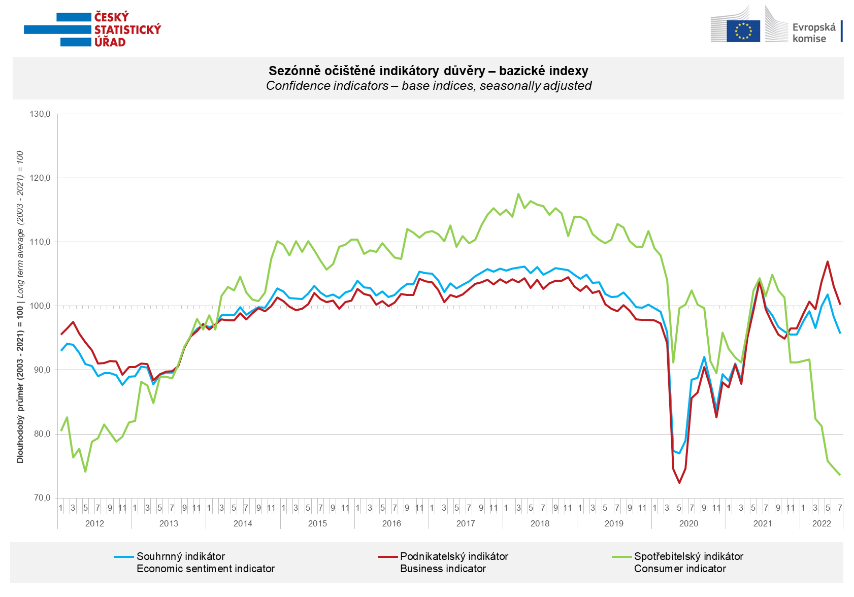

Confidence among entrepreneurs decreased in industry and trade in July. In a m-o-m comparison, it increased slightly in construction and selected services.

Consumer confidence in the economy fell to the lowest level since the survey began. A record number of respondents fear a deterioration in their own financial situation. The number of consumers who rate their financial situation worse than in the previous twelve months is also close to its historical maximum.

***
More detailed information on the development of business and consumer confidence can be found in the supplementary information to the RI business surveys.

Notes:

Responsible manager: Juraj Lojka, Director of Business Statistics Coordination and Business Cycle Surveys Department, tel. +420731439291, e-mail: juraj.lojka@czso.cz
Contact person: Jiri Obst, Head of Business Cycle Surveys Unit, tel. +420604815440, e-mail: jiri.obst@czso.cz
Data source: CZSO business survey, Data Collect consumer survey (https://www.datacollect.cz)
Data collection date: Business part: July 18, 2022
Consumer part: July 15, 2022
Next News Release: August 24, 2022

This press release wasn´t edited for language.

Detailed time series of Balances and basic
indices of confidence indicators: https://www.czso.cz/csu/czso/kpr_ts
Business and Consumers Surveys are co-financed by grant agreements of the European Commission DG ECFIN.
https://ec.europa.eu/info/business-economy-euro/indicators-statistics/economic-databases/business-and-consumer-surveys_en
Link to European database: https://ec.europa.eu/eurostat/web/euro-indicators/business-and-consumer surveys

Annex:
Additional information to NR Business cycle survey
Table Confidence Indicators – basic indices
Graph 1 Confidence indicators – base indices, seasonally adjusted (2003–2022)
Graph 2.1 Confidence Indicators for industry, construction, trade, and in selected services – base indices, seasonally adjusted (2003–2022)
Graph 2.2 Balances of seasonally adjusted confidence indicators for industry, construction, trade, and in selected services (2003–2022)
Graph 3 Economic Sentiment Indicators – international comparison, seasonally adjusted (2007-2022)
Graph 4 Production Capacity Utilisation in Manufacturing Industry (2003-2022)
Graph 5 Limits of Production in Industry (2005-2022)
Graph 6 Limits of Production in Construction (2005-2022)
Graph 7 Limits of Production in Selected Services (2005-2022)

