7 May 2025

Industrial production increased by 0.7%, year-on-year, in the first quarter

Supplementary information to the news release on industry – March 2025
Industry in the first quarter
Industrial production was in real terms by 1.5% higher, quarter-on-quarter (q-o-q), in the Q1 2025. In the year-on-year comparison, it increased by 0.7%. In the first quarter of 2025, there was the same number of working days as in the Q1 2024.
Industrial production in the first quarter of 2025 was on a very similar level as in the first quarter of 2024. It only slightly exceeded the level of production from the year 2021 (by 0.8%). Mining and quarrying recorded a year-on-year decrease. Production of manufacturing stagnated or rather decreased by 0.2%. Industry thus kept growing thanks to electricity, gas, steam and air conditioning supply, in which mainly a low comparison basis from the previous year contributed to the growth rate.

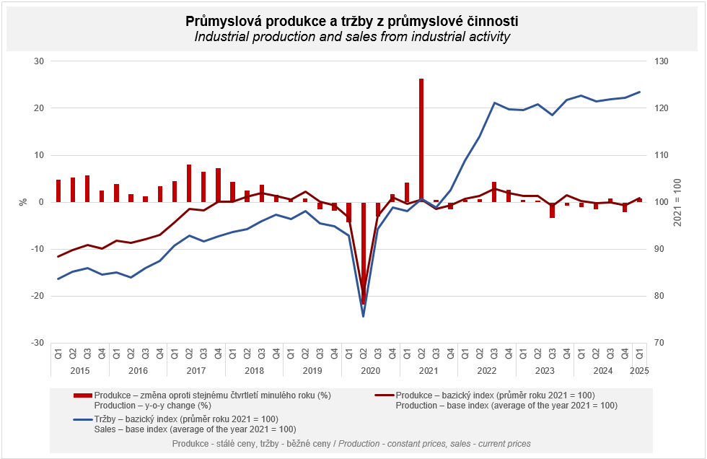

The industry in total increased by 0.7%, to which electricity, gas, steam and air conditioning supply contributed by 1 percentage point (p. p.; with a year-on-year growth by one tenth). As for individual economic activities of manufacturing that contributed in a positive way to the development of industrial production in the Q1 2025 we can name, for example, the following ones: repair and installation of machinery and equipment (a contribution of +0.18 p. p., an increase by 6.3%), manufacture of machinery and equipment (a contribution of +0.16 p. p., an increase by 2.2%), and manufacture of food products (a contribution of +0.15 p. p., an increase by 2.9%). The following had the highest negative contributions to the development of industrial production: manufacture of motor vehicles, trailers and semi-trailers (a contribution of -0.42 p. p., a decrease by 2.1%), manufacture of other transport equipment (a contribution of -0.19 p. p., a decrease by 11.6%), manufacture of computer, electronic and optical products (a contribution of -0.12 p. p., a decrease by 3.6%), and manufacture of chemicals and chemical products (a contribution of -0.11 p. p., a decrease by 2.5%).

Sales from industrial activity at current prices increased by 0.2%, y-o-y, in the Q1 2025. Direct export sales of industrial enterprises increased at current prices by 2.4%. Domestic sales, which also include indirect export via non-industrial enterprises, decreased at current prices by 2.3%.
The following contributed the most to the growth: manufacture of food products (a contribution of +0.32 p. p., an increase by 4.9%), manufacture of machinery and equipment (a contribution of +0.27 p. p., an increase by 4.3%), and repair and installation of machinery and equipment (a contribution of +0.24 p. p., an increase by 10.9%). On the other hand, the following contributed the most in a negative sense to the development of sales from industrial activity: manufacture of other transport equipment (a contribution of -0.13 p. p., a decrease by 8.0%), manufacture of basic metals (a contribution of -0.11 p. p., a decrease by 3.5%), and manufacture of motor vehicles, trailers and semi-trailers (a contribution of -0.11 p. p., a decrease by 0.4%).

The value of new orders at current prices in surveyed industrial CZ-NACE activities in the Q1 2025 decreased by 0.5%, year-on-year. Non-domestic new orders decreased by 0.3%. Domestic new orders decreased by 0.7%.
The following contributed the most to the decrease of the value of new orders in total: manufacture of motor vehicles, trailers and semi-trailers (a contribution of -1.86 p. p., a decrease by 4.7%), manufacture of chemicals and chemical products (a contribution of -0.21 p. p., a decrease by 3.8%), and manufacture of paper and paper products (a contribution of -0.10 p. p., a decrease by 3.5%). The biggest increase was recorded by manufacture of machinery and equipment (a contribution of +0.96 p. p., an increase by 9.9%), manufacture of fabricated metal products (a contribution of +0.50 p. p., an increase by 4.3%), manufacture of computer, electronic and optical products (a contribution of +0.20 p. p., an increase by 2.6%), and manufacture of other transport equipment (a contribution of +0.14 p. p., an increase by 6.5%).

The average registered number of employees in industry in the Q1 2025 was by 2.0% lower compared to the corresponding period of the previous year.
Notes:
Contact person: Veronika Doležalová, Head of Industrial Statistics Unit, phone number (+420) 734 352 291, e-mail: veronika.dolezalova@csu.gov.cz

Related outputs: time series in the Public database, the Industry chapter

