August 25, 2025

Consumer confidence declined m-o-m, while business confidence rose

Business cycle survey – August 2025

The composite confidence indicator (economic sentiment indicator), in the basic index form – increased by 1.4 points to 101.1 m-o-m, with the different development of its components. The business confidence indicator rose by 2.7 point to 101.5, while the consumer confidence indicator decreased by 5.1 point to 99.0.
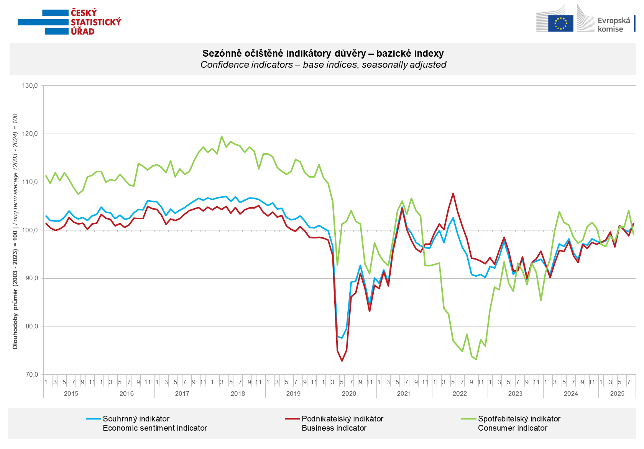

Business confidence in the economy increased in August in selected service sectors (+5.9 points), construction (+1.2 points) and trade (+1.1 points). In industry, it remained unchanged from July.

Consumer confidence declined m-o-m in August. The confidence indicator fell by 5.1 points to 99.0. Compared to July, the share of consumers expecting a deterioration in the overall economic situation in the Czech Republic and in their financial situation over the next twelve months increased. In addition, the number of households that assess their current financial situation as worse than in the previous twelve months increased m-o-m. The number of respondents who do not plan to make large purchases in the next twelve months remained almost unchanged.
***
More detailed information on the development of business and consumer confidence can be found in the supplementary information to the RI business surveys.

Notes:

Responsible manager: Juraj Lojka, Director of Business Statistics Coordination and Business Cycle Surveys Department, tel. +420731439291, e-mail: juraj.lojka@csu.gov.cz
Contact person: Jiri Obst, Head of Business Cycle Surveys Unit, tel. +420604815440, e-mail: jiri.obst@csu.gov.cz
Data source: CZSO business survey, Data Collect consumer survey (https://www.datacollect.cz)
Data collection date: Business part: August 19, 2025
Consumer part: August 15, 2025
Next News Release: September 24, 2025

This press release wasn´t edited for language.

Detailed time series of Balances and basic
indices of confidence indicators: https://csu.gov.cz/produkty/kpr_ts
Business and Consumers Surveys are co-financed by grant agreements of the European Commission DG ECFIN.
https://ec.europa.eu/info/business-economy-euro/indicators-statistics/economic-databases/business-and-consumer-surveys_en
Link to European database: https://ec.europa.eu/eurostat/web/euro-indicators/database

Annex:
Additional information to NR Business cycle survey
Table Confidence Indicators – basic indices
Graph 1 Confidence indicators – base indices, seasonally adjusted (2003–2025)
Graph 2.1 Confidence Indicators for industry, construction, trade, and in selected services – base indices, seasonally adjusted (2003–2025)
Graph 2.2 Balances of seasonally adjusted confidence indicators for industry, construction, trade, and in selected services (2003–2025)
Graph 3 Economic Sentiment Indicators – international comparison, seasonally adjusted (2007-2025)

