1 April 2026

General government sector balance ended up in a deficit

Government deficit and debt – the fourth quarter of 2025
In the Q4 2025, the general government sector balance ended up with a deficit corresponding to 4.3% of the GDP. The government debt ratio reached 44.2% of the GDP.

In the Q4 2025, the general government sector deficit reached CZK 97.7 billion, which means that it worsened by CZK 21.1 billion in the year-on-year comparison. The central government ended up with a deficit of CZK 48.6 billion that worsened by CZK 5.1 billion, y-o-y. Performance of the local government sector ended up with a deficit in the amount of CZK 36.5 bn, which in the year-on-year comparison means worsening by CZK 13.7 billion. Performance of social security funds (of health insurance companies) ended up with a deficit of CZK 12.6 billion.

“The general government sector balance ended up with a deficit of CZK 97.7 billion in the fourth quarter of 2025, which corresponds to 4.3% of the GDP when expressed in relative terms. The government debt ratio increased by 1.0 percentage point (p. p.), year-on-year,” Helena Houžvičková, Director of the Macroeconomic Statistics Section of the Czech Statistical Office (CZSO), stated.

Tab. 1.1 The general government sector balance
(Data in the table are not seasonally adjusted; they cannot be compared quarter-on-quarter.)
 | Q4 2023 | Q1 2024 | Q2 2024 | Q3 2024 | Q4 2024 | Q1 2025 | Q2 2025 | Q3 2025 | Q4 2025
CZK bn | -114.7 | -59.8 | 4.2 | -31.2 | -76.6 | -70.7 | 9.7 | -25.0 | -97.7
% of the GDP | -5.7 | -3.2 | 0.2 | -1.5 | -3.6 | -3.6 | 0.5 | -1.1 | -4.3

The total revenue of the general government sector increased by 5.2%, y-o-y, and reached 40.8% of the GDP. Especially the following contributed to the y-o-y increase in the revenue: received social contributions, received taxes on production and imports. The total government expenditure increased by 7.0%, y-o-y, and reached 45.2% of the GDP. The highest growth in terms of volume was mainly recorded in gross fixed capital formation and in compensation of employees paid.

The nominal debt of the general government increased, y-o-y, by CZK 297.8 bn to CZK 3 786.3 bn. The government debt ratio increased from 43.3% to 44.3% of the GDP, year-on-year; the influence of the nominal change of the debt was +3.5 p. p., while the increasing nominal GDP contributed to a decrease in indebtedness by –2.5 p. p. In the quarter-on-quarter comparison, the debt increased by CZK 162.9 billion, the nominal change of the debt was 2.0 p. p., whereas an increase in the nominal GDP contributed to a decrease in the indebtedness by –0.8 p. p., which resulted in an increase in the debt ratio by 1.2 p. p., quarter-on-quarter.

Regarding the debt structure, mainly issued debt securities increased, year-on-year (CZK +276.0 bn).

In the fourth quarter of 2025, the q-o-q change in the debt (the increase by CZK 162.9 bn) significantly differed from the general government sector balance (the deficit of CZK 97.7 bn). The general government borrowed by CZK 65.2 bn more than the general government sector balance was; the main reason for the difference was decreased drawing of pooled deposits within cash pooling (consolidated on the general government sector level) and also the need to finance advances for military equipment that do not influence the accrual balance.

Chart 1.1 Debt of the general government sector

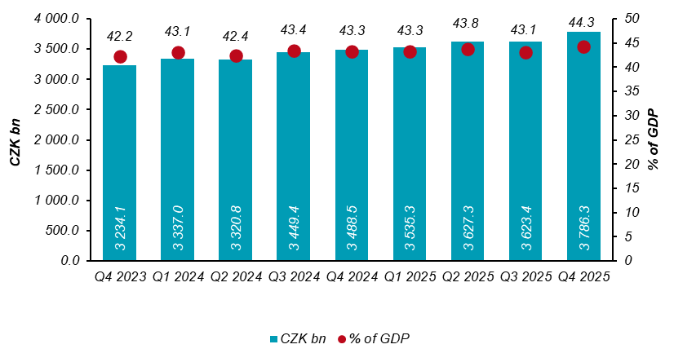

Chart 1.2 Year-on-year relative changes in government debt
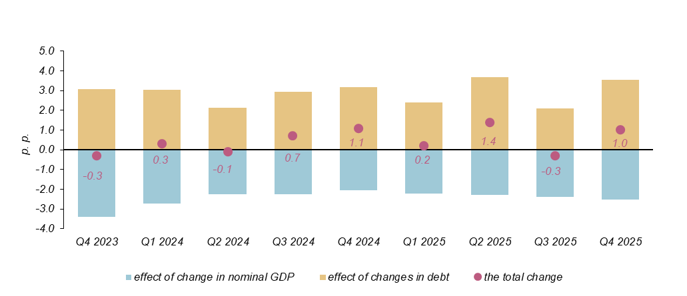

The general government sector balance after seasonal adjustment as well as adjustment for calendar effects ended up with a deficit of CZK 47.9 bn, which corresponded to 2.2% of the GDP. The general government sector balance worsened by CZK 2.1 bn, q-o-q. The development of the general government sector balance adjusted by seasonal and calendar effects is shown in the chart below.

Chart 1.3 Seasonally adjusted general government sector balance
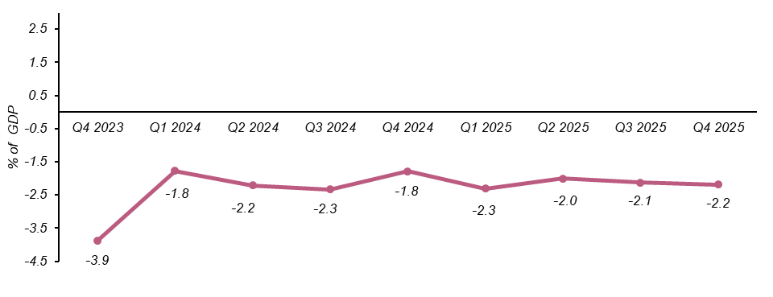
Notes:
Quantification of fiscal indicators of government deficit and debt mentioned above is based on the ESA2010 methodology. Data published in this news release are methodologically consistent with the data used for the statistics of the excessive deficit procedure (EDP) purposes and for the assessment of how Maastricht convergence criteria are met.

The government surplus/deficit is represented by the item B.9 “net borrowing (−) or net lending (+)” in the system of national accounts. It refers to the ability of the general government sector to finance other sectors of the economy (+) or the need of the general government sector to be financed (−) by other sectors of the economy in the given period.

The general government debt is the amount of consolidated liabilities of the general government sector comprising the following items: received deposits, issued debt securities, and received loans. In case of foreign exchange debt instruments hedged against the currency risk, the value in CZK is obtained by means of the contractual exchange rate.

The general government sector balance is compared with the amount of the GDP in the given quarter at current prices. The amount of the consolidated general government debt is compared with the sum of quarterly GDP for the last four quarters at current prices. Fiscal indicators of quarterly government deficit and debt are published within the Transmission programme (Tab. 25 and Tab. 28) on the CZSO’s website General government sector in the “GDP, National Accounts” section. Unless otherwise stated, data are not seasonally adjusted as well as they are not adjusted for calendar effects. Time series of seasonally adjusted sector accounts for the government sector (the item of net lending / net borrowing) Time series of seasonally adjusted sector accounts for S.13.

Responsible head at the CZSO: | Helena Houžvičková, Director of the Macroeconomic Statistics Section, phone number: (+420) 704 688 734,  e-mail: helena.houzvickova@csu.gov.cz
Contact person: | Jaroslav Kahoun, Head of the Government Accounts Unit, phone number: (+420) 274 054 232, e-mail: jaroslav.kahoun@csu.gov.cz
The next news release will be published on: | 1 July 2026

