January 26, 2026

Overall confidence in the economy remains just above its long-term average

Business cycle survey – January 2026

The composite confidence indicator (economic sentiment indicator), expressed as a basic index, remained unchanged m-o-m in January, staying at December's value of 100.2. While the business confidence indicator rose slightly by 0.6 points to 98.6, the consumer confidence indicator fell by 2.8 points to 108.2.

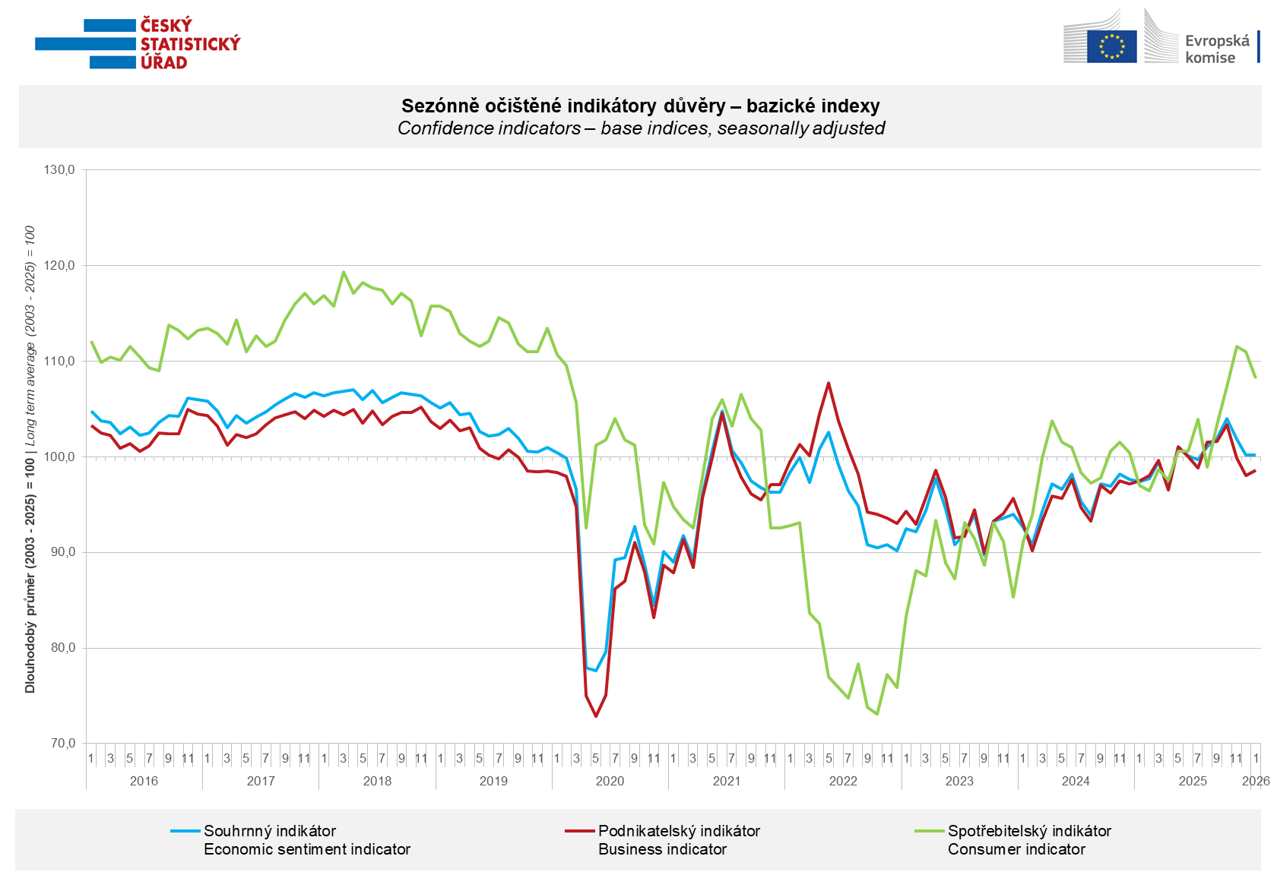

At the beginning of 2026, confidence in the economy increased m-o-m in selected services (+1.3 points), more moderately in industry (+0.5 points) and in trade (+0.3 points). Compared to December, business confidence declined only in the construction sector (-4.7 points).

Consumer confidence declined m-o-m. The confidence indicator fell by 2.8 points to 108.2. The share of consumers expecting the overall economic situation in Czechia to deteriorate over the next twelve months increased compared to December. The share of households expecting their financial situation to improve over the next twelve months increased slightly m-o-m. The share of respondents who assess their current financial situation as worse than in the previous twelve months also increased slightly. The number of respondents who do not plan to make any major purchases in the next twelve months increased.
***
More detailed information on the development of business and consumer confidence can be found in the supplementary information to the RI business surveys.

***
In January 2026, we change the base to calculate the basis index in a news release by the Czech Statistical Office. For 2026, we calculate the long-term average from January 2003 to December 2025. The long-term average is changed one a year in news release publication data in January.

Notes:

Responsible manager: Juraj Lojka, Director of Business Statistics Coordination and Business Cycle Surveys Department, tel. +420731439291, e-mail: juraj.lojka@csu.gov.cz
Contact person: Jiri Obst, Head of Business Cycle Surveys Unit, tel. +420604815440, e-mail: jiri.obst@csu.gov.cz
Data source: CZSO business survey, Data Collect consumer survey (https://www.datacollect.cz)
Data collection date: Business part: January 19, 2026
Consumer part: January 15, 2026
Next News Release: February 24, 2026

This press release wasn´t edited for language.

Detailed time series of Balances and basic
indices of confidence indicators: https://csu.gov.cz/produkty/kpr_ts
Business and Consumers Surveys are co-financed by grant agreements of the European Commission DG ECFIN.
https://ec.europa.eu/info/business-economy-euro/indicators-statistics/economic-databases/business-and-consumer-surveys_en
Link to European database: https://ec.europa.eu/eurostat/web/euro-indicators/database

Annex:
Additional information to NR Business cycle survey
Table Confidence Indicators – basic indices
Graph 1 Confidence indicators – base indices, seasonally adjusted (2003–2026)
Graph 2.1 Confidence Indicators for industry, construction, trade, and in selected services – base indices, seasonally adjusted (2003–2026)
Graph 2.2 Balances of seasonally adjusted confidence indicators for industry, construction, trade, and in selected services (2003–2026)
Graph 3 Economic Sentiment Indicators – international comparison, seasonally adjusted (2007-2026)
Graph 4 Production Capacity Utilisation in Manufacturing Industry (2003-2026)
Graph 5 Limits of Production in Industry (2005-2026)
Graph 6 Limits of Production in Construction (2005-2026)
Graph 7 Limits of Production in Selected Services (2005-2026)

