Consumer confidence in the economy increased m-o-m, while business confidence decreased
24. 09. 2026

Business Cycle Survey – September 2026
The composite confidence indicator (economic sentiment indicator), expressed as a basic index, decreased by 1.0-point m-o-m to 99.5 in September. Its two components developed differently. While the business confidence indicator decreased by 1.8 points to 98.4, the consumer confidence indicator increased by 2.8 points to 105.1.
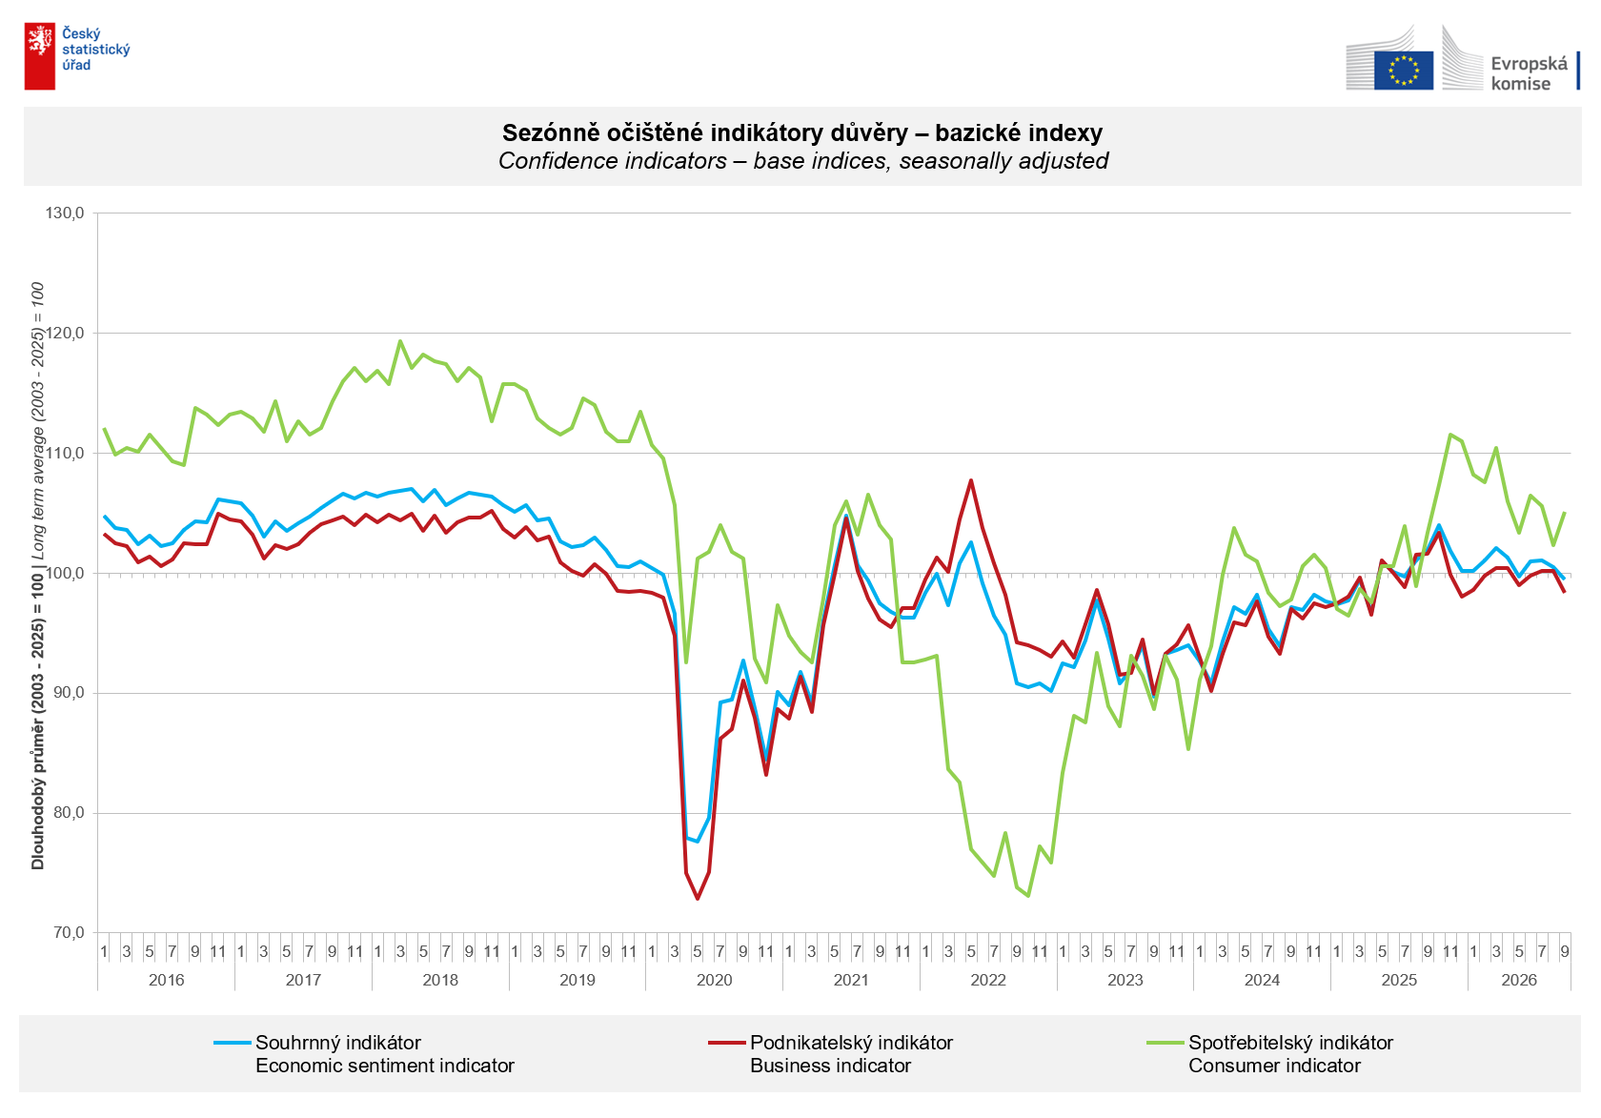
Business confidence in the economy increased in September only in trade (+1.7 points). It decreased by 2.3 points in selected services sectors, by 2.0 points in industry, and by a modest 0.6 points in construction.

Consumer confidence increased m-o-m. The confidence indicator rose by 2.8 points to 105.1. The share of consumers expecting the overall economic situation in Czechia to deteriorate over the next twelve months decreased m-o-m. The share of respondents who assess their current financial situation as worse than it was in the previous twelve months remained virtually unchanged compared with August. The share of households expecting their financial situation to improve over the next twelve months increased slightly. The share of respondents not planning to make major purchases over the next twelve months decreased slightly.
***
More detailed information on the development of business and consumer confidence can be found in the supplementary information to the RI business surveys.

Notes:

Responsible manager: Juraj Lojka, Director of Business Statistics Coordination and Business Cycle Surveys Department, tel. +420731439291, e-mail: juraj.lojka@csu.gov.cz
Contact person: Jiri Obst, Head of Business Cycle Surveys Unit, tel. +420604815440, e-mail: jiri.obst@csu.gov.cz
Data source: CZSO business survey, Data Collect consumer survey (https://www.datacollect.cz)
Data collection date: Business part: September 17, 2026
Consumer part: September 15, 2026
Next News Release: October 26, 2026

This press release wasn´t edited for language.

Detailed time series of Balances and basic
indices of confidence indicators: https://csu.gov.cz/produkty/kpr_ts
Business and Consumers Surveys are co-financed by grant agreements of the European Commission DG ECFIN.
https://ec.europa.eu/info/business-economy-euro/indicators-statistics/economic-databases/business-and-consumer-surveys_en
Link to European database: https://ec.europa.eu/eurostat/web/euro-indicators/database

Annex:
Additional information to NR Business cycle survey
Table Confidence Indicators – basic indices
Graph 1 Confidence indicators – base indices, seasonally adjusted (2003–2026)
Graph 2.1 Confidence Indicators for industry, construction, trade, and in selected services – base indices, seasonally adjusted (2003–2026)
Graph 2.2 Balances of seasonally adjusted confidence indicators for industry, construction, trade, and in selected services (2003–2026)
Graph 3 Economic Sentiment Indicators – international comparison, seasonally adjusted (2007-2026)

