December 23, 2025

Overall confidence in the economy declined m-o-m at the end of the year

Business cycle survey – December 2025

The composite confidence indicator (economic sentiment indicator), expressed as a basic index, fell by 1.7 points m-o-m to 100.2, with both of its components showing the same development. The business confidence indicator fell by 1.9 points to 98.0 and the consumer confidence indicator fell slightly by 0.6 points to 111.1. 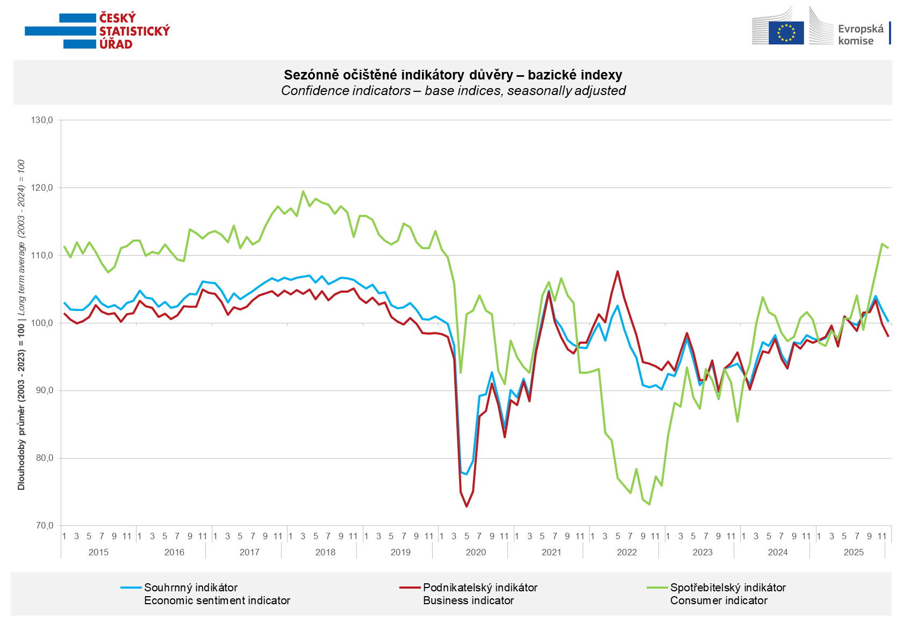

Business confidence in the economy increased in December only in construction (+3.5 points). By contrast, it declined m-o-m in selected service sectors (-2.5 points), industry (-2.0 points), and slightly also in trade (-0.6 points).

Consumer confidence declined slightly m-o-m. The confidence indicator fell by 0.6 points to 111.1. In December, the majority of consumers expected the overall economic situation in Czechia to deteriorate over the next twelve months. The share of households expecting their financial situation to improve over the next twelve months did not change much m-o-m. The share of respondents who assess their current financial situation as worse than in the previous twelve months remained the same as in November. The number of respondents who do not plan to make any major purchases in the next twelve months fell slightly for the second month in a row.
***
More detailed information on the development of business and consumer confidence can be found in the supplementary information to the RI business surveys.

Notes:

Responsible manager: Juraj Lojka, Director of Business Statistics Coordination and Business Cycle Surveys Department, tel. +420731439291, e-mail: juraj.lojka@csu.gov.cz
Contact person: Jiri Obst, Head of Business Cycle Surveys Unit, tel. +420604815440, e-mail: jiri.obst@csu.gov.cz
Data source: CZSO business survey, Data Collect consumer survey (https://www.datacollect.cz)
Data collection date: Business part: December 17, 2025
Consumer part: December 15, 2025
Next News Release: January 26, 2026

This press release wasn´t edited for language.

Detailed time series of Balances and basic
indices of confidence indicators: https://csu.gov.cz/produkty/kpr_ts
Business and Consumers Surveys are co-financed by grant agreements of the European Commission DG ECFIN.
https://ec.europa.eu/info/business-economy-euro/indicators-statistics/economic-databases/business-and-consumer-surveys_en
Link to European database: https://ec.europa.eu/eurostat/web/euro-indicators/database

Annex:
Additional information to NR Business cycle survey
Table Confidence Indicators – basic indices
Graph 1 Confidence indicators – base indices, seasonally adjusted (2003–2025)
Graph 2.1 Confidence Indicators for industry, construction, trade, and in selected services – base indices, seasonally adjusted (2003–2025)
Graph 2.2 Balances of seasonally adjusted confidence indicators for industry, construction, trade, and in selected services (2003–2025)
Graph 3 Economic Sentiment Indicators – international comparison, seasonally adjusted (2007-2025)

