April 24, 2023

Confidence in the economy continues to grow

Business cycle survey – April 2023
The composite confidence indicator (economic sentiment indicator) – in the basis index form – increased by 3.3 points compared to March to 97.2, with the same developments of its components. The business confidence indicator increased by 2.8 percentage points to 98.0 and the consumer confidence indicator increased by 5.8 points to 92.9.
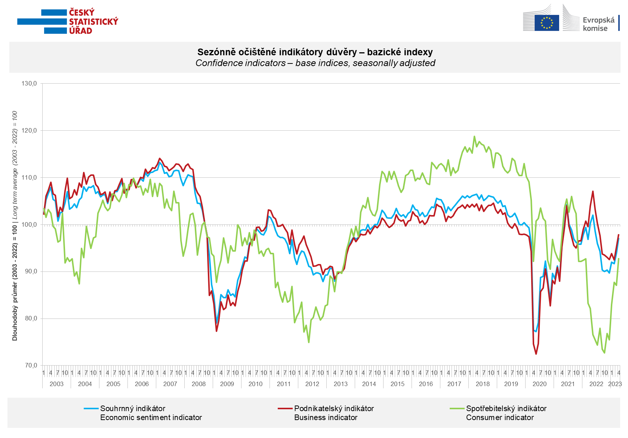

Confidence in the economy among entrepreneurs increased in April in all sectors, the most in industry (by 4.6 points), in which it also returned to its long-term average after ten months.

Consumer confidence in the economy increased. Compared to March, households are less worried about the deterioration of the overall economic situation and rate their current financial situation slightly better compared to the previous twelve months. At the same time, the number of consumers expecting a worsening of their financial situation in the next 12 months decreased. The share of respondents who believe that the current time is not suitable for making large purchases decreased slightly m-o-m.

***
More detailed information on the development of business and consumer confidence can be found in the supplementary information to the RI business surveys.

Notes:

Responsible manager: Juraj Lojka, Director of Business Statistics Coordination and Business Cycle Surveys Department, tel. +420731439291, e-mail: juraj.lojka@czso.cz
Contact person: Jiri Obst, Head of Business Cycle Surveys Unit, tel. +420604815440, e-mail: jiri.obst@czso.cz
Data source: CZSO business survey, Data Collect consumer survey (https://www.datacollect.cz)
Data collection date: Business part: April 17, 2023
Consumer part: April 17, 2023
Next News Release: May 24, 2023

This press release wasn´t edited for language.

Detailed time series of Balances and basic
indices of confidence indicators: https://www.czso.cz/csu/czso/kpr_ts
Business and Consumers Surveys are co-financed by grant agreements of the European Commission DG ECFIN.
https://ec.europa.eu/info/business-economy-euro/indicators-statistics/economic-databases/business-and-consumer-surveys_en
Link to European database: https://ec.europa.eu/eurostat/web/euro-indicators/business-and-consumer surveys

Annex:
Additional information to NR Business cycle survey
Table Confidence Indicators – basic indices
Graph 1 Confidence indicators – base indices, seasonally adjusted (2003–2023)
Graph 2.1 Confidence Indicators for industry, construction, trade, and in selected services – base indices, seasonally adjusted (2003–2023)
Graph 2.2 Balances of seasonally adjusted confidence indicators for industry, construction, trade, and in selected services (2003–2023)
Graph 3 Economic Sentiment Indicators – international comparison, seasonally adjusted (2007-2023)
Graph 4 Production Capacity Utilisation in Manufacturing Industry (2003-2023)
Graph 5 Limits of Production in Industry (2005-2023)
Graph 6 Limits of Production in Construction (2005-2023)
Graph 7 Limits of Production in Selected Services (2005-2023)

