September 26, 2022

Confidence in the economy continues to decline

Business cycle survey – September 2022
The composite confidence indicator (economic sentiment indicator) – in the basis index form – decreased by 4.0 percentage points to 90.1, m-o-m, with the same developments of its components. Business confidence indicator decreased by 4.0 percentage points to 93.6, the consumer confidence indicator decreased by 4.4 percentage points to 72.7, the lowest since the start of monitoring.
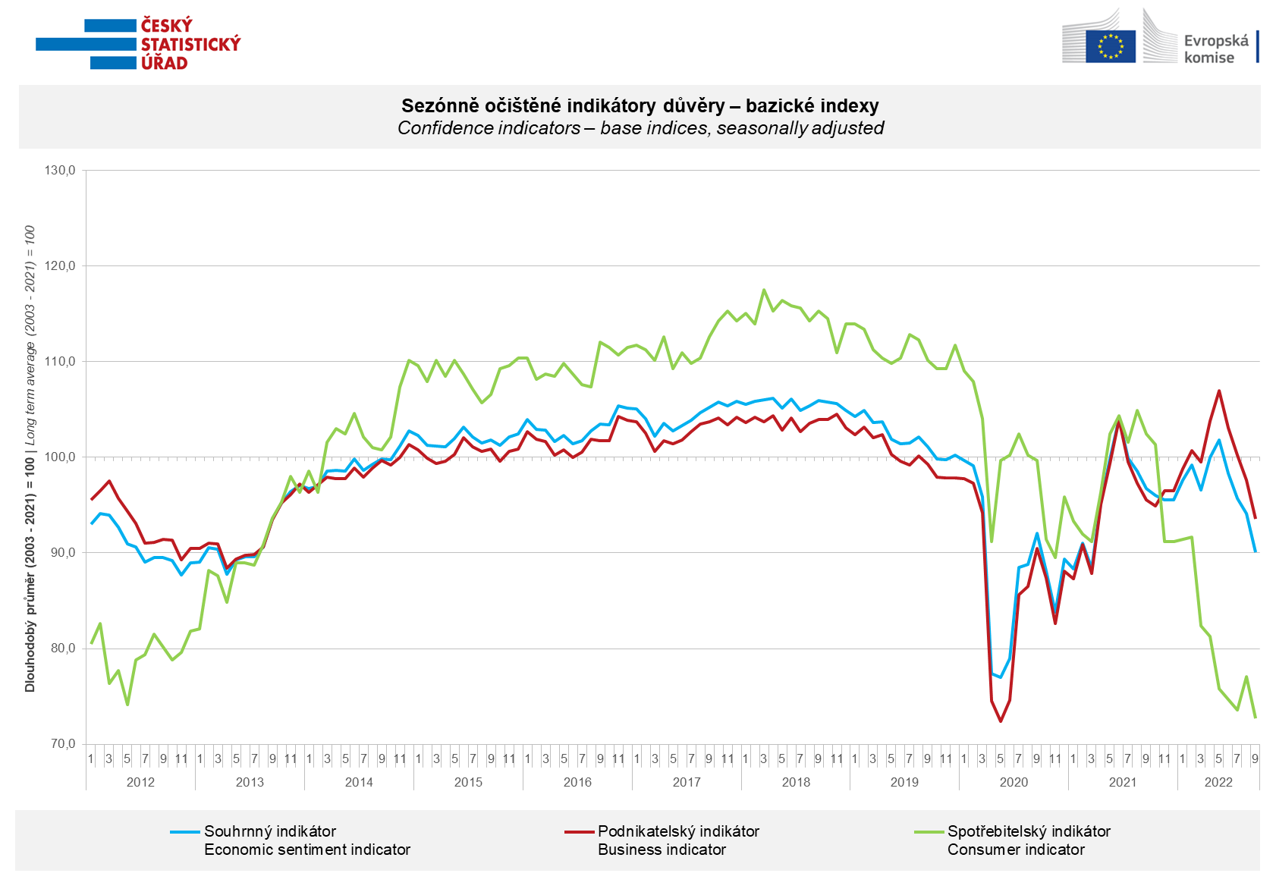

In the business sphere, confidence in the economy decreased in industry, selected service sectors and trade. After a significant decrease in August, on the contrary, it increased slightly in the construction.

Confidence in the economy among consumers decreased significantly again after the increase in August, to the lowest level since monitoring began. Compared to last month, respondents are more worried about the deterioration of the economic situation and of the overall economic situation and their own financial situation. The number of respondents who do not find the current time suitable for making large purchases increased significantly.

***
More detailed information on the development of business and consumer confidence can be found in the supplementary information to the RI business surveys.

Notes:

Responsible manager: Juraj Lojka, Director of Business Statistics Coordination and Business Cycle Surveys Department, tel. +420731439291, e-mail: juraj.lojka@czso.cz
Contact person: Jiri Obst, Head of Business Cycle Surveys Unit, tel. +420604815440, e-mail: jiri.obst@czso.cz
Data source: CZSO business survey, Data Collect consumer survey (https://www.datacollect.cz)
Data collection date: Business part: September 19, 2022
Consumer part: September 15, 2022
Next News Release: October 24, 2022

This press release wasn´t edited for language.

Detailed time series of Balances and basic
indices of confidence indicators: https://www.czso.cz/csu/czso/kpr_ts
Business and Consumers Surveys are co-financed by grant agreements of the European Commission DG ECFIN.
https://ec.europa.eu/info/business-economy-euro/indicators-statistics/economic-databases/business-and-consumer-surveys_en
Link to European database: https://ec.europa.eu/eurostat/web/euro-indicators/business-and-consumer surveys

Annex:
Additional information to NR Business cycle survey
Table Confidence Indicators – basic indices
Graph 1 Confidence indicators – base indices, seasonally adjusted (2003–2022)
Graph 2.1 Confidence Indicators for industry, construction, trade, and in selected services – base indices, seasonally adjusted (2003–2022)
Graph 2.2 Balances of seasonally adjusted confidence indicators for industry, construction, trade, and in selected services (2003–2022)
Graph 3 Economic Sentiment Indicators – international comparison, seasonally adjusted (2007-2022)

