May 25, 2026

Overall confidence in the economy decreased

Business cycle survey – May 2026

The composite confidence indicator (economic sentiment indicator), expressed as a basic index, decreased by 1.6 points m-o-m in May to 99.7, reflecting the same development in both of its components. The business confidence indicator fell by 1.4 points to 99.0 and the consumer confidence indicator decreased by 2.6 points to 103.4.
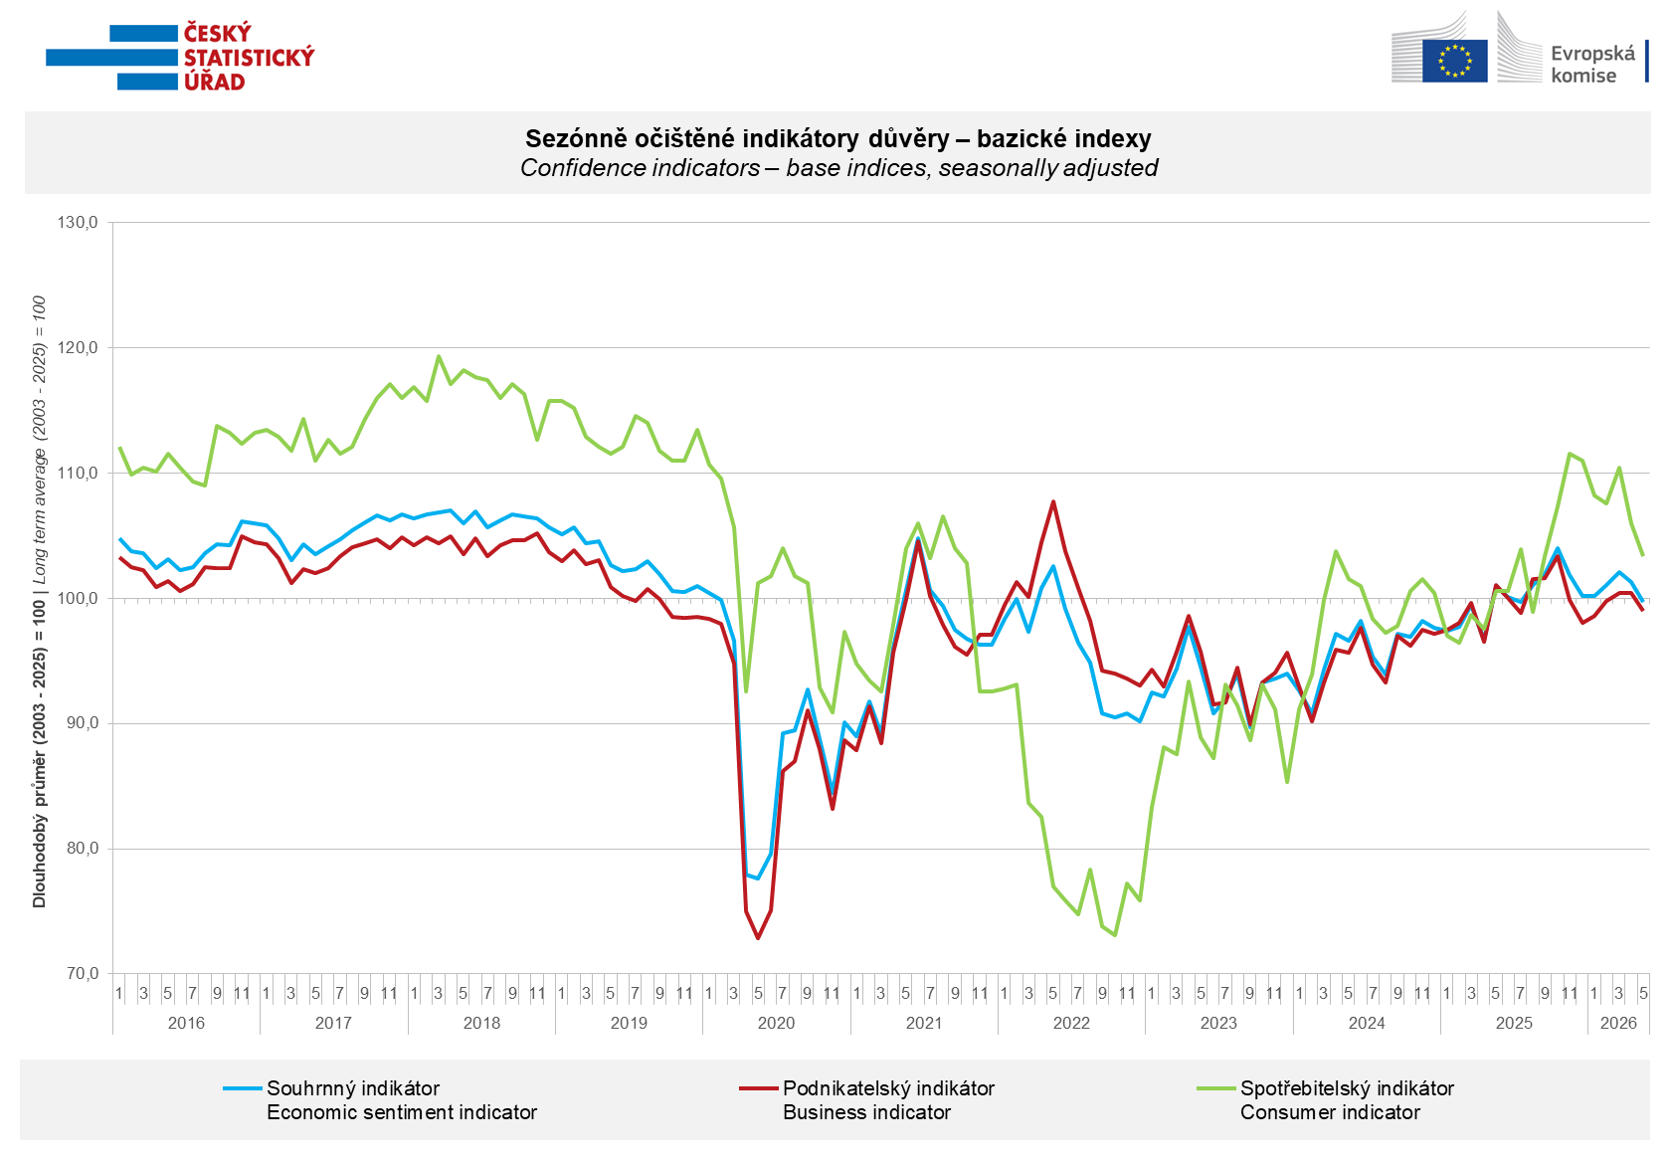

Business confidence in the economy increased m-o-m only in construction (+2.4 points), while it decreased in industry (-2.6 points), trade (-2.2 points) and selected service sectors (-0.5 points).

Consumer confidence in the economy decreased again m-o-m. The confidence indicator fell by 2.6 points to 103.4. Following the significant increase in April, the share of consumers expecting a deterioration in the overall economic situation in Czechia over the next twelve months remained almost unchanged. The proportion of respondents assessing their current financial situation as worse than in the previous twelve months increased, while the share of households expecting an improvement in their financial situation over the next twelve months decreased slightly m-o-m. The number of respondents not planning to make major purchases over the next twelve months increased compared to April.
***
More detailed information on the development of business and consumer confidence can be found in the supplementary information to the RI business surveys.

Notes:

Responsible manager: Juraj Lojka, Director of Business Statistics Coordination and Business Cycle Surveys Department, tel. +420731439291, e-mail: juraj.lojka@csu.gov.cz
Contact person: Jiri Obst, Head of Business Cycle Surveys Unit, tel. +420604815440, e-mail: jiri.obst@csu.gov.cz
Data source: CZSO business survey, Data Collect consumer survey (https://www.datacollect.cz)
Data collection date: Business part: May 18, 2026
Consumer part: May 15, 2026
Next News Release: June 24, 2026

This press release wasn´t edited for language.

Detailed time series of Balances and basic
indices of confidence indicators: https://csu.gov.cz/produkty/kpr_ts
Business and Consumers Surveys are co-financed by grant agreements of the European Commission DG ECFIN.
https://ec.europa.eu/info/business-economy-euro/indicators-statistics/economic-databases/business-and-consumer-surveys_en
Link to European database: https://ec.europa.eu/eurostat/web/euro-indicators/database

Annex:
Additional information to NR Business cycle survey
Table Confidence Indicators – basic indices
Graph 1 Confidence indicators – base indices, seasonally adjusted (2003–2026)
Graph 2.1 Confidence Indicators for industry, construction, trade, and in selected services – base indices, seasonally adjusted (2003–2026)
Graph 2.2 Balances of seasonally adjusted confidence indicators for industry, construction, trade, and in selected services (2003–2026)
Graph 3 Economic Sentiment Indicators – international comparison, seasonally adjusted (2007-2026)

