October 24, 2023

Positive development in the automotive industry influenced the growth of confidence in the economy
Business cycle survey – October 2023

The composite confidence indicator (economic sentiment indicator) – in the basis index form – increased by 3.6 points to 92.8 m-o-m, with the same developments of its components. The business confidence indicator increased by 3.4 percentage points to 92.8 and the consumer confidence indicator increased by 4.4 points to 92.7.
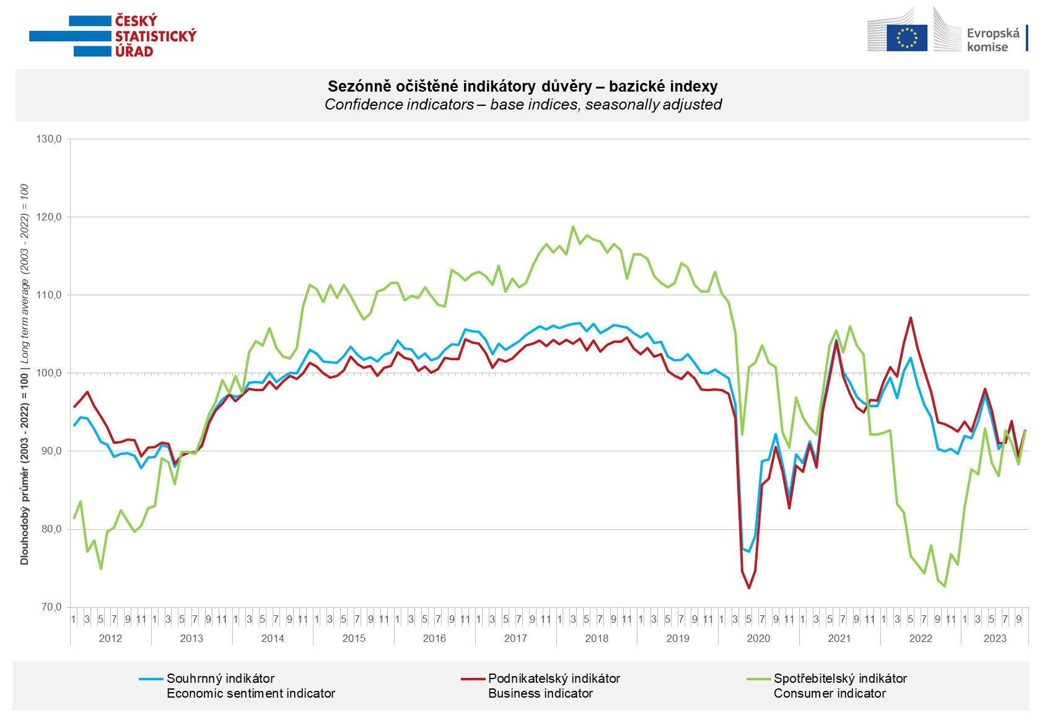

Confidence among entrepreneurs increased in October due to significant growth in the industrial sector (+8.9 points). Confidence in the economy fell in other sectors, specifically in selected services by 1.3 points, in trade by 1.1 points and in construction by 0.6 points.

Consumer confidence in the economy increased. The number of respondents expecting a deterioration of the overall economic situation in the Czech Republic in the next twelve months decreased in October. The number of households assessing their current financial situation as worse compared to the previous twelve months remained approximately the same, but the number of respondents expecting it to worsen in the next twelve months decreased. The share of respondents who believe that the current time is not suitable for making large purchases has slightly decreased compared to September.

***
More detailed information on the development of business and consumer confidence can be found in the supplementary information to the RI business surveys.

Notes:

Responsible manager: Juraj Lojka, Director of Business Statistics Coordination and Business Cycle Surveys Department, tel. +420731439291, e-mail: juraj.lojka@czso.cz
Contact person: Jiri Obst, Head of Business Cycle Surveys Unit, tel. +420604815440, e-mail: jiri.obst@czso.cz
Data source: CZSO business survey, Data Collect consumer survey (https://www.datacollect.cz)
Data collection date: Business part: October 18, 2023
Consumer part: October 16, 2023
Next News Release: November 24, 2023

This press release wasn´t edited for language.

Detailed time series of Balances and basic
indices of confidence indicators: https://www.czso.cz/csu/czso/kpr_ts
Business and Consumers Surveys are co-financed by grant agreements of the European Commission DG ECFIN.
https://ec.europa.eu/info/business-economy-euro/indicators-statistics/economic-databases/business-and-consumer-surveys_en
Link to European database: https://ec.europa.eu/eurostat/web/euro-indicators/database

Annex:
Additional information to NR Business cycle survey
Table Confidence Indicators – basic indices
Graph 1 Confidence indicators – base indices, seasonally adjusted (2003–2023)
Graph 2.1 Confidence Indicators for industry, construction, trade, and in selected services – base indices, seasonally adjusted (2003–2023)
Graph 2.2 Balances of seasonally adjusted confidence indicators for industry, construction, trade, and in selected services (2003–2023)
Graph 3 Economic Sentiment Indicators – international comparison, seasonally adjusted (2007-2023)
Graph 4 Production Capacity Utilisation in Manufacturing Industry (2003-2023)
Graph 5 Limits of Production in Industry (2005-2023)
Graph 6 Limits of Production in Construction (2005-2023)
Graph 7 Limits of Production in Selected Services (2005-2023)

