May 26, 2025

Business and consumer confidence in the economy increased

Business cycle survey – May 2025

The composite confidence indicator (economic sentiment indicator), in the basic index form – increased by 4.3 points to 101.0 m-o-m, with the same development of its components. The business confidence indicator rose by 4.5 points to 101.1, the consumer confidence indicator increased by 3.0 points to 100.7.
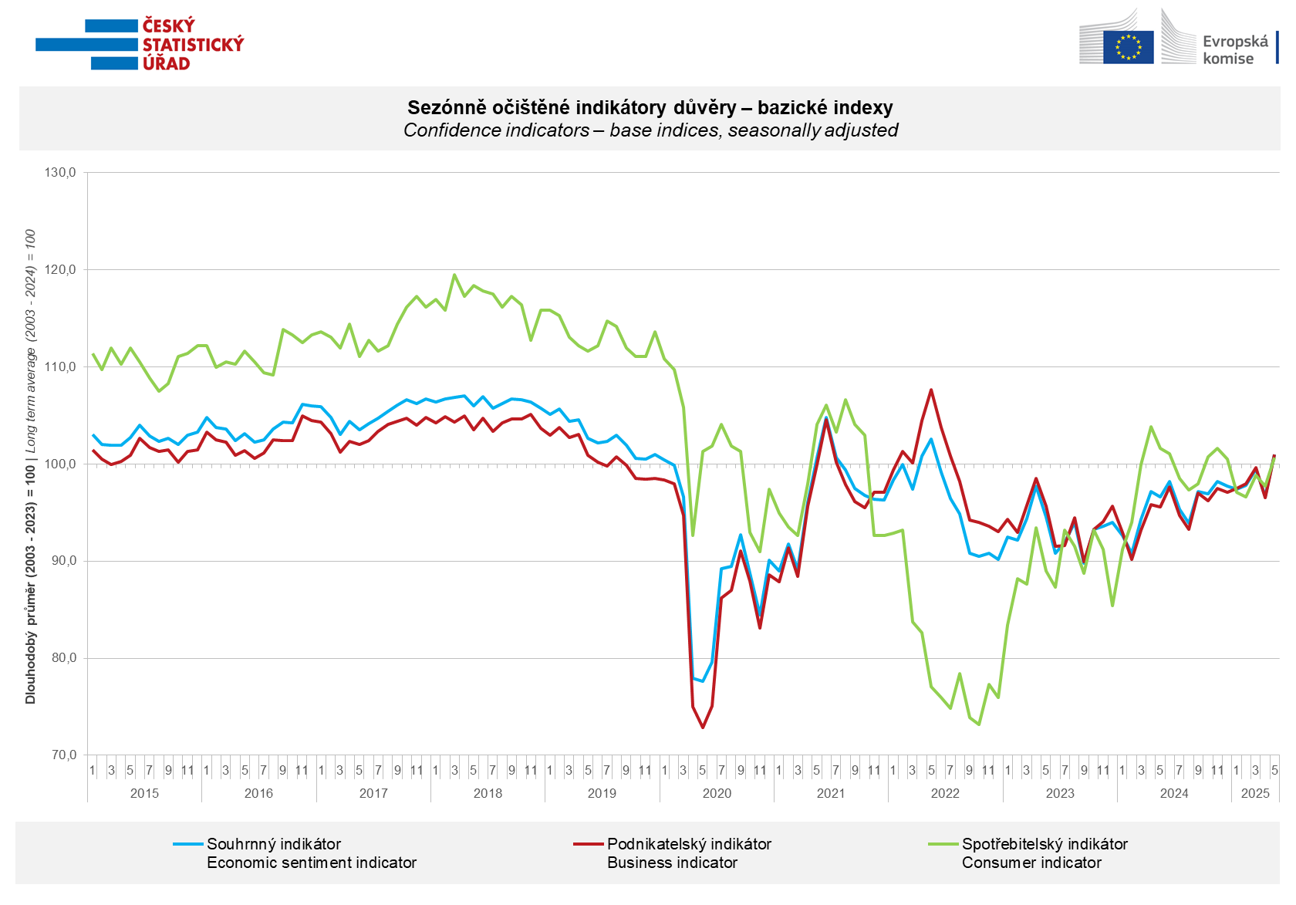
Business confidence increased in May in the industry sector (+3.9 points) and more strongly in selected service sectors (+6.6 points). By contrast, it fell by 1.8 points in trade and by 1.7 points in construction.

Consumer confidence rose m-o-m. The confidence indicator increased by 3.0 points to 100.7 in May. The share of consumers expecting the overall economic situation in the Czech Republic to deteriorate over the next twelve months decreased m-o-m. The share of households expecting their financial situation to worsen over the next 12 months fell slightly, as did the number of households rating their current financial situation worse than in the previous 12 months. The number of respondents who do not plan to make large purchases in the next twelve months is unchanged from April.
***
More detailed information on the development of business and consumer confidence can be found in the supplementary information to the RI business surveys.

Notes:

Responsible manager: Juraj Lojka, Director of Business Statistics Coordination and Business Cycle Surveys Department, tel. +420731439291, e-mail: juraj.lojka@csu.gov.cz
Contact person: Jiri Obst, Head of Business Cycle Surveys Unit, tel. +420604815440, e-mail: jiri.obst@csu.gov.cz
Data source: CZSO business survey, Data Collect consumer survey (https://www.datacollect.cz)
Data collection date: Business part: May 19, 2025
Consumer part: May 15, 2025
Next News Release: June 24, 2025

This press release wasn´t edited for language.

Detailed time series of Balances and basic
indices of confidence indicators: https://csu.gov.cz/produkty/kpr_ts
Business and Consumers Surveys are co-financed by grant agreements of the European Commission DG ECFIN.
https://ec.europa.eu/info/business-economy-euro/indicators-statistics/economic-databases/business-and-consumer-surveys_en
Link to European database: https://ec.europa.eu/eurostat/web/euro-indicators/database

Annex:
Additional information to NR Business cycle survey
Table Confidence Indicators – basic indices
Graph 1 Confidence indicators – base indices, seasonally adjusted (2003–2025)
Graph 2.1 Confidence Indicators for industry, construction, trade, and in selected services – base indices, seasonally adjusted (2003–2025)
Graph 2.2 Balances of seasonally adjusted confidence indicators for industry, construction, trade, and in selected services (2003–2025)
Graph 3 Economic Sentiment Indicators – international comparison, seasonally adjusted (2007-2025)

