April 24, 2025

Overall confidence in the economy decreased

Business cycle survey – April 2025

The composite confidence indicator (economic sentiment indicator), in the basic index form – decreased by 2.8 points to 96.7 m-o-m, with the same development of its components. The business confidence indicator decreased by 3.1 points to 96.5, the consumer confidence indicator fell down by 1.1 points to 97.7.

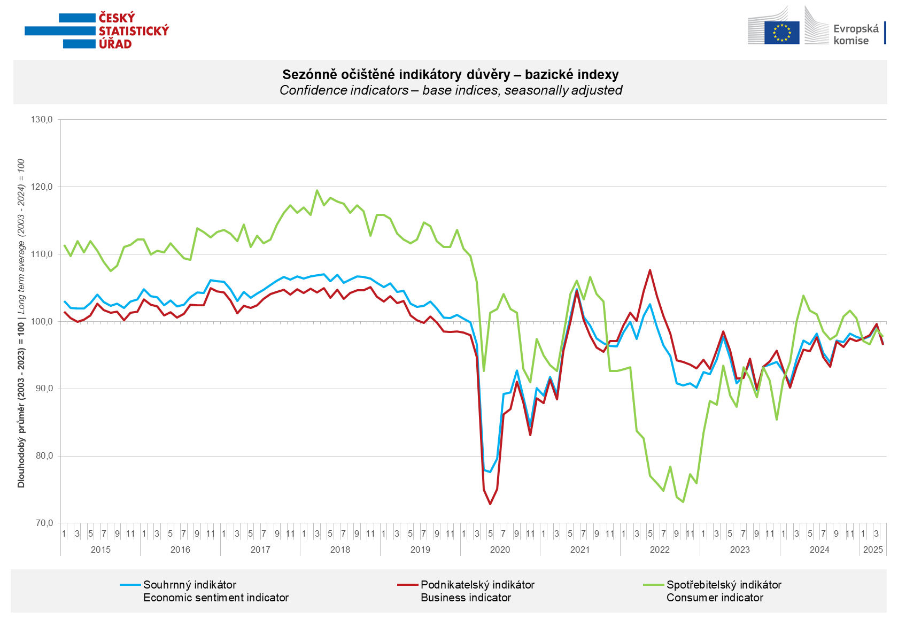
Business confidence in the economy increased in April only in the construction sector (+ 0.6 points). Compared with March, it decreased the most in industry (-4.5 points), followed by trade and selected services (-2.0 points).

Consumer confidence decreased compared the last month. The confidence indicator fell down by 1.1 points to 97.7 in April. The share of consumers expecting the overall economic situation in the Czech Republic to deteriorate over the next twelve months increased. The share of households expecting their financial situation to deteriorate over the next twelve months increased. The number of households assessing their current financial situation as worse than in the previous twelve months remained the same as in March. The proportion of consumers who believe that the current period is not conducive to making large purchases decreased for the second time in a row.
***
More detailed information on the development of business and consumer confidence can be found in the supplementary information to the RI business surveys.

Notes:

Responsible manager: Juraj Lojka, Director of Business Statistics Coordination and Business Cycle Surveys Department, tel. +420731439291, e-mail: juraj.lojka@csu.gov.cz
Contact person: Jiri Obst, Head of Business Cycle Surveys Unit, tel. +420604815440, e-mail: jiri.obst@csu.gov.cz
Data source: CZSO business survey, Data Collect consumer survey (https://www.datacollect.cz)
Data collection date: Business part: April 16, 2025
Consumer part: April 15, 2025
Next News Release: May 26, 2025

This press release wasn´t edited for language.

Detailed time series of Balances and basic
indices of confidence indicators: https://csu.gov.cz/produkty/kpr_ts
Business and Consumers Surveys are co-financed by grant agreements of the European Commission DG ECFIN.
https://ec.europa.eu/info/business-economy-euro/indicators-statistics/economic-databases/business-and-consumer-surveys_en
Link to European database: https://ec.europa.eu/eurostat/web/euro-indicators/database

Annex:
Additional information to NR Business cycle survey
Table Confidence Indicators – basic indices
Graph 1 Confidence indicators – base indices, seasonally adjusted (2003–2025)
Graph 2.1 Confidence Indicators for industry, construction, trade, and in selected services – base indices, seasonally adjusted (2003–2025)
Graph 2.2 Balances of seasonally adjusted confidence indicators for industry, construction, trade, and in selected services (2003–2025)
Graph 3 Economic Sentiment Indicators – international comparison, seasonally adjusted (2007-2025)
Graph 4 Production Capacity Utilisation in Manufacturing Industry (2003-2025)
Graph 5 Limits of Production in Industry (2005-2025)
Graph 6 Limits of Production in Construction (2005-2025)
Graph 7 Limits of Production in Selected Services (2005-2025)

