30 May 2025

GDP increased by 0.8%, quarter-on-quarter

GDP resources and uses – the first quarter of 2025

According to the refined estimate, the gross domestic product increased by 0.8%, quarter-on-quarter, and by 2.2%, year-on-year, in the Q1 2025. The year-on-year growth of GDP was supported by higher final consumption expenditure and by change in inventories. A negative influence came mainly from the international trade balance.
The refined estimate confirmed the ongoing growth of the Czech economy. The gross domestic product (GDP) adjusted for price effects and seasonally adjusted increased by 0.8% compared to the previous quarter. In the year-on-year comparison, it increased by 2.2%.

The gross value added (GVA) increased in the Q1 2025 by 1.3%, quarter-on-quarter (q-o-q), and by 2.5%, year-on-year (y-o-y). Mainly industry contributed to the q-o-q growth (an increase by 1.6%). Also the following were successful: construction (+3.4%), information and communication (+2.0%), financial and insurance activities (+5.9%), as well as other services. On the other hand, a negative influence came from a group of economic activities of trade, transportation, accommodation and food service activities (-0.6%).

The y-o-y development of the GVA (+2.5%) was positively influenced especially by industry +0.4 percentage point (p. p.; an increase by 1.4%) and by a group of economic activities of trade, transportation, accommodation and food service activities +0.5 p. p. (an increase by 2.8%). All economic activities of the national economy were successful.

On the demand side, increasing final consumption expenditure of households and gross capital formation were the key factors of the q-o-q GDP growth in the first quarter of 2025. A negative influence came from final consumption expenditure of general government. The influence of the international trade balance was neutral,” Vladimír Kermiet, Director of the National Accounts Department of the Czech Statistical Office (CZSO), comments on the data.

The following had a positive influence on the y-o-y GDP growth (+2.2%): final consumption expenditure of households +1.5 p. p. , final consumption expenditure of general government +0.4 p. p., and a change in inventories (+1.3 p. p.). A negative influence came from the gross fixed capital formation (-0.3 p. p.) and international trade balance -0.7 p. p.

Final consumption expenditure decreased by 0.4%, q-o-q. In the y-o-y comparison, it increased by 2.3%. Final consumption expenditure of households increased by 0.1%, q-o-q, and by 2.5%, y-o-y. Final consumption expenditure of general government decreased by 1.5%, q-o-q, and in the y-o-y comparison it increased by 1.9%.

Gross fixed capital formation increased by 1.1%, q-o-q; however, in the y-o-y comparison, it decreased by 0.6%. A y-o-y decrease mainly occurred in investments to machinery and equipment and to transport equipment. Only investments to other buildings and structures increased. The change in inventories was CZK -4.6 billion, which was by CZK 13.6 billion more compared to the corresponding quarter of the previous year.

The international trade balance of goods and services at current prices reached the value of CZK 140.8 bn; thus it was by CZK 3.3 bn higher than in the corresponding period of the previous year. Exports increased in real terms by 2.8%, q-o-q, and in the y-o-y comparison it increased by 3.6%. The development was influenced the most by an increase in exports of electrical equipment and machinery and equipment. Imports increased by 2.1%,
q-o-q, and in the y-o-y comparison it increased by 4.6%.

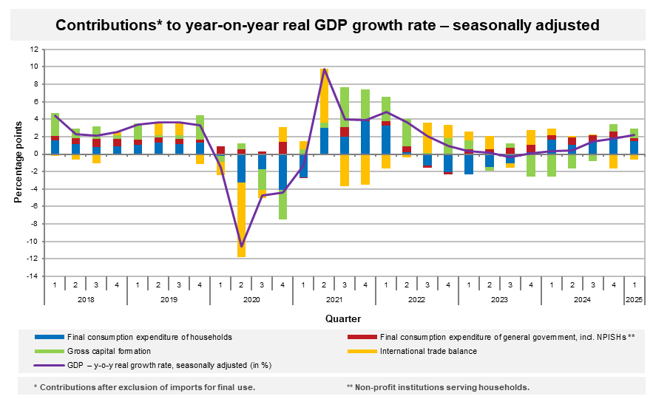
As for the price development in the Q1 2025, the total GDP deflator increased by 1.0%, q-o-q, and by 3.1%, y-o-y.

The volume of labour costs³ increased by 7.0%, y-o-y, in the Q1 2025.
Total employment increased by 0.7% compared to the previous quarter and in the y-o-y comparison it increased by 1.1%. The number of hours worked in total increased by 0.1%, quarter-on-quarter, and in the y-o-y comparison it increased by 2.0%.
Notes:
Responsible head at the CZSO: Vladimír Kermiet, Director of the National Accounts Department, phone number (+420) 274 054 247, e-mail: vladimir.kermiet@csu.gov.cz
Contact person: Jan Benedikt, Quarterly Estimates Unit, phone number (+420) 274 052 750, e-mail: jan.benedikt@csu.gov.cz
Used data sources updated as at: 26 May 2025
Time series: Quarterly national accounts
The news release web page: Quarterly GDP estimates | Statistics (gov.cz)
The next news release will be published on: 30 July 2025
(GDP preliminary estimate for the second quarter of 2025)

Unless otherwise stated, all data presented in this news release are adjusted for price, seasonal, and calendar effects.
contributions to the GDP growth (imports for final use excluded, unless otherwise stated)
at current prices, not adjusted for seasonal effects
4 the number of persons in terms of national accounts

