3 March 2026

GDP increased by 2.6% in 2025

GDP resources and uses – the fourth quarter of 2025

According to the refined estimate, the gross domestic product increased by 0.6%, quarter-on-quarter, and by 2.6%, year-on-year, in the Q4 2025. The GDP for the whole year 2025 increased by 2.6%.
The gross domestic product (GDP) adjusted for price effects and seasonally adjusted in the Q4 2025 was by 0.6% higher compared to the previous quarter. Compared to the corresponding quarter of 2024, it increased by 2.6%.
GDP development (%)
 | Q1 | Q2 | Q3 | Q4 | Year 2025
compared to the previous quarter | +0.7 | +0.5 | +0.8 | +0.6 | +2.6
compared to the corresponding quarter of 2024 | +2.4 | +2.6 | +2.8 | +2.6 | +2.6
GVA development (%)
 | Q1 | Q2 | Q3 | Q4 | Year 2025
compared to the previous quarter | +0.9 | +0.5 | +0.9 | +0.5 | +2.8
compared to the corresponding quarter of 2024 | +2.7 | +2.8 | +2.9 | +2.8 | +2.8

The gross value added (GVA) increased by 0.5%, quarter-on-quarter (q-o-q), in the Q4 2025, and by 2.8%, year-on-year (y-o-y). In the q-o-q comparison, especially the following were successful: economic activities of manufacturing (+2.2%) and financial and insurance activities (+2.7%). On the other hand, there was a decrease in construction (-3.3%).

The following were contributing the most to the y-o-y increase of the GVA (+2.8%): a group of economic activities of trade, transportation, accommodation and food service activities +0.8 percentage point (p. p.; an increase by +4.4%), industry +0.6 p. p. (+2.2%), information and communication +0.6 p. p. (+7.7%), and construction +0.3 p. p. (+5.6%).

“On the demand side, higher final consumption expenditure and gross fixed capital formation were the key factors of the q-o-q GDP increase in the Q4 2025. External demand also had a positive contribution. A change in inventories had a negative influence,” Vladimír Kermiet, Director of the National Accounts Department of the Czech Statistical Office (CZSO), comments on the data.

The following had a positive influence on the year-on-year GDP growth (+2.6%): final consumption expenditure +1.7 p. p., the gross fixed capital formation +1.2 p. p., and international trade balance +0.7 p. p. A change in inventories had a negative influence -1.0 p. p.

Final consumption expenditure of households increased by 1.3%, q-o-q. In the y-o-y comparison, it increased by 3.2%, while especially purchases of non-durables and services increased.

Final consumption expenditure of general government increased by 1.0%, q-o-q, and in the y-o-y comparison by 2.5%.

Gross fixed capital formation increased by 1.7%, q-o-q, and by 5.3%, y-o-y. A y-o-y increase mainly occurred in investments in dwellings and investments in other buildings and structures. The change in inventories amounted to CZK -67.9 billion, which was by CZK 4.6 billion less compared to the corresponding quarter of the previous year.

The international trade balance of goods and services at current prices reached the value of CZK 133.9 bn; thus it was by CZK 9.5 bn higher than in the corresponding period of the previous year. Exports increased in real terms by 0.8%, q-o-q, and in the y-o-y comparison by 5.1%. Imports increased by 0.6%, q-o-q, and in the y-o-y comparison by 5.3%.

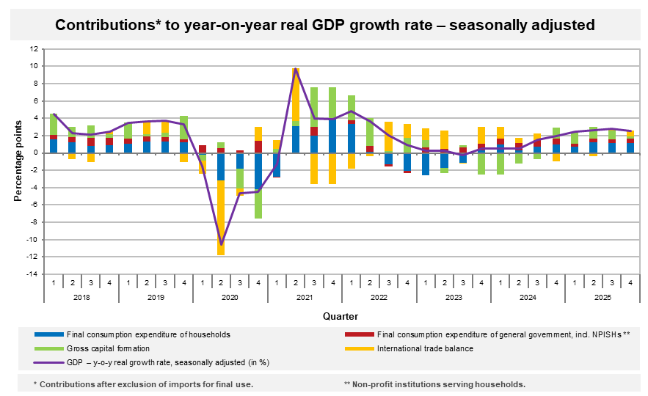
As for the price development in the Q4 2025, the total GDP deflator increased by 1.0%, q-o-q, and by 3.9%, y-o-y.

The volume of labour costs increased by 9.0%, y-o-y, in the Q4 2025.
Total employment remained unchanged compared to the previous quarter and in the y-o-y comparison it increased by 1.0%. The number of hours worked in total increased by 1.2%,
q-o-q, and in the y-o-y comparison by 2.9%.

GDP resources and uses in 2025
The GDP for 2025 was by 2.6% higher compared to the year 2024. The year-round increase was positively influenced by both the domestic and external demand. The final consumption expenditure of households contributed +1.1 p. p., the final consumption expenditure of general government +0.4 p. p., the gross capital formation +1.0 p. p., and international trade balance +0.1 p. p.

Final consumption expenditure of households increased by 3.0%, final consumption expenditure of general government increased by 2.2%, and gross fixed capital formation was by 2.0% higher. The international trade balance increased at current prices by CZK 0.8 bn, y-o-y, to CZK +504.2 bn.
The GVA in 2025 increased by 2.8% compared to the previous year. The GVA growth was the most significantly contributed to by industry (+0.4 p. p.), a group of economic activities of trade, transportation, and accommodation and food service activities (+0.7 p. p.), and information and communication (+0.6 p. p.).
Total employment increased by 1.1%, y-o-y, to 5 509 thousand persons. In total, there were by 2.3% more hours worked than in the year 2024.
Notes:
Responsible head at the CZSO: Vladimír Kermiet, Director of the National Accounts Department, phone number (+420) 274 054 247, e-mail: vladimir.kermiet@csu.gov.cz
Contact person: Jan Benedikt, Quarterly Estimates Unit, phone number (+420) 274 052 750, e-mail: jan.benedikt@csu.gov.cz
Used data sources updated as at: 25 February 2026
Time series: Quarterly national accounts
The news release web page: Quarterly GDP estimates | Statistics (gov.cz)
The next news release will be published on: 30 April 2026
(GDP preliminary estimate for the first quarter of 2026)

Unless otherwise stated, all data presented in this news release are adjusted for price, seasonal, and calendar effects.
contributions to the GDP growth (imports for final use excluded, unless otherwise stated)
at current prices, not adjusted for seasonal effects
at current prices, not adjusted for seasonal effects
the number of persons in terms of national accounts

