February 21, 2025

**Consumer confidence declines marginally, business confidence improves slightly**

**Business cycle survey – February 2025**

**The composite confidence indicator (economic sentiment indicator), in the basic index form – increased slightly by 0.4 points to 97.8 compared with January this year, with both components of the index developing differently. While the business confidence indicator increased slightly by 0.5 points to 98.0, the consumer confidence indicator fell by 0.5 points to 96.6.**

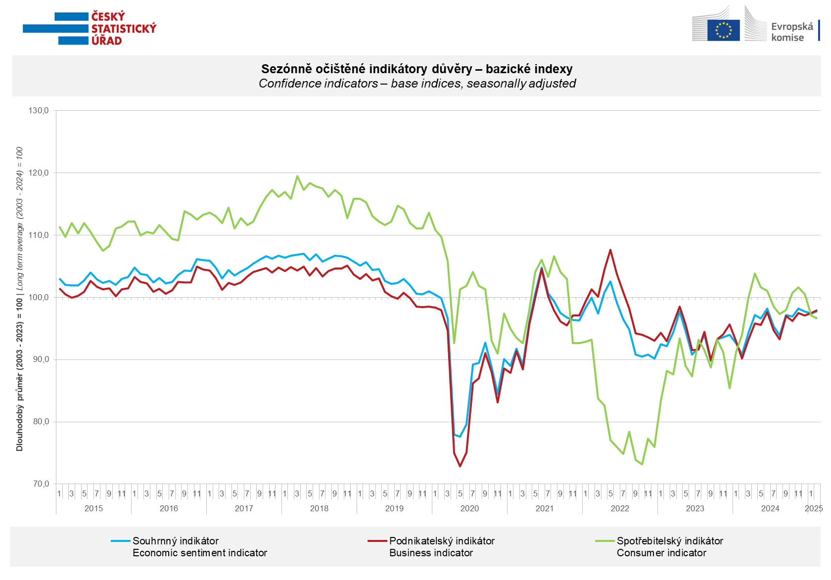

**Business** confidence in the economy increased in trade (+3.7 points), construction (+3.0 points) and slightly in industry (+0.3 points). In selected service sectors, confidence was unchanged m-o-m and remained at the January value of 100.5.

**Consumer** confidence fell slightly m-o-m. The confidence indicator fell by 0.5 points to 96.6 in February. The share of consumers expecting *the overall economic situation* in the Czech Republic to deteriorate over the next twelve months increased for the third consecutive month. The share of households *expecting their financial situation* to deteriorate over the next twelve months was unchanged from January. The number of households assessing *their current financial situation* as worse than in the previous twelve months fell slightly m-om. The proportion of consumers who believe that the current period is not conducive to *making large purchases* remained almost unchanged.

***

More detailed information on the development of business and consumer confidence can be found in [*the supplementary information to the RI business surveys.*](https://csu.gov.cz/docs/107532/56e01dc3-e0bd-7c97-6f79-e00032c11ac2/akpr022125_komentar.pdf)

***

In January 2025, we change the base to calculate the basis index in a news release by the Czech Statistical Office. For 2025, we calculate the long-term average from January 2003 to December 2024. The long-term average is changed one a year in news release publication data in January.

Notes:

Responsible manager: Juraj Lojka, Director of Business Statistics Coordination and Business Cycle Surveys Department, tel. +420731439291, e-mail: juraj.lojka@csu.gov.cz

Contact person: Jiri Obst, Head of Business Cycle Surveys Unit, tel. +420604815440, e-mail: [jiri.obst@csu.gov.cz](mailto:jiri.obst@csu.gov.cz)

Data source: CZSO business survey, Data Collect consumer survey (https://www.datacollect.cz)

Data collection date: Business part: February 17, 2025

Consumer part: February 17, 2025

Next News Release: March 21, 2025

This press release wasn´t edited for language.

Detailed time series of Balances and basic

indices of confidence indicators: <https://csu.gov.cz/produkty/kpr_ts>

*Business and Consumers Surveys are co-financed by grant agreements of the European Commission DG ECFIN.*

[*https://ec.europa.eu/info/business-economy-euro/indicators-statistics/economic-databases/business-and-consumer-surveys_en*](https://ec.europa.eu/info/business-economy-euro/indicators-statistics/economic-databases/business-and-consumer-surveys_en)

*Link to European database:* [*https://ec.europa.eu/eurostat/web/euro-indicators/database*](https://ec.europa.eu/eurostat/web/euro-indicators/database)

Annex:

Additional information to NR Business cycle survey

Table Confidence Indicators – basic indices

Graph 1 Confidence indicators – base indices, seasonally adjusted (2003–2025)

Graph 2.1 Confidence Indicators for industry, construction, trade, and in selected services – base indices, seasonally adjusted (2003–2025)

Graph 2.2 Balances of seasonally adjusted confidence indicators for industry, construction, trade, and in selected services (2003–2025)

Graph 3 Economic Sentiment Indicators – international comparison, seasonally adjusted (2007-2025)