November 24, 2023

Consumer confidence has decreased m-o-m, while entrepreneurs are slightly more optimistic in comparison

Business cycle survey – November 2023
The composite confidence indicator (economic sentiment indicator) – in the basis index form – increased by 0.3 points to 93.1 m-o-m, reflecting different developments in its components. The business confidence indicator rose by 0.7 percentage points to 93.5 while the consumer confidence indicator decreased by 2.0 points to 90.7.

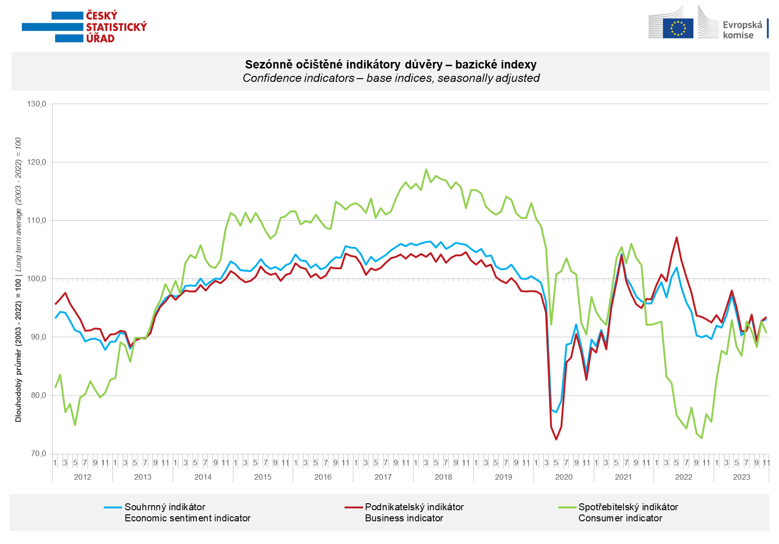

In November, confidence in the economy increased in the construction sector (+6.6 points), in selected services (+1.3 points), and slightly in retail (+0.2 points). However, in the industrial sector, confidence slightly decreased compared to October (-0.3 points).

Consumer confidence in the economy decreased compared to October. The number of respondents expecting a worsening of the overall economic situation in the Czech Republic over the next twelve months remained almost unchanged m-o-m. The number of households evaluating their current financial situation worse than the previous twelve months increased, as did the number of respondents expecting its deterioration in the next twelve months. The proportion of consumers who believe that the current time is not suitable for making major purchases slightly increased compared to October.

***
More detailed information on the development of business and consumer confidence can be found in the supplementary information to the RI business surveys.

Notes:

Responsible manager: Juraj Lojka, Director of Business Statistics Coordination and Business Cycle Surveys Department, tel. +420731439291, e-mail: juraj.lojka@czso.cz
Contact person: Jiri Obst, Head of Business Cycle Surveys Unit, tel. +420604815440, e-mail: jiri.obst@czso.cz
Data source: CZSO business survey, Data Collect consumer survey (https://www.datacollect.cz)
Data collection date: Business part: November 20, 2023
Consumer part: November 16, 2023
Next News Release: December 27, 2023

This press release wasn´t edited for language.

Detailed time series of Balances and basic
indices of confidence indicators: https://www.czso.cz/csu/czso/kpr_ts
Business and Consumers Surveys are co-financed by grant agreements of the European Commission DG ECFIN.
https://ec.europa.eu/info/business-economy-euro/indicators-statistics/economic-databases/business-and-consumer-surveys_en
Link to European database: https://ec.europa.eu/eurostat/web/euro-indicators/database

Annex:
Additional information to NR Business cycle survey
Table Confidence Indicators – basic indices
Graph 1 Confidence indicators – base indices, seasonally adjusted (2003–2023)
Graph 2.1 Confidence Indicators for industry, construction, trade, and in selected services – base indices, seasonally adjusted (2003–2023)
Graph 2.2 Balances of seasonally adjusted confidence indicators for industry, construction, trade, and in selected services (2003–2023)
Graph 3 Economic Sentiment Indicators – international comparison, seasonally adjusted (2007-2023)

