1 October 2025

Balance of the general government sector for 2024 ended up in deficit

Notification of government deficit and debt – 2024

For the year 2024, the balance of the general government sector ended up with a deficit corresponding to 2.0% of the GDP. The general government sector debt in the end of the year 2024 reached 43.3% of the GDP while the year-on-year increase was by 1.1 percentage point (p. p.).

“Compared to the spring notification, the balance of the general government sector improved by 0.2 p. p. and ended up with a deficit of 2.0% of the GDP, mainly as a result of updated information on the corporate income tax. The relative debt reached 43.3% of the GDP,” Helena Houžvičková, Director of the Government and Financial Accounts Department of the Czech Statistical Office (CZSO), stated.

The balance of the general government sector for 2024 has been revised compared to the notification from April 2025 by +CZK 13.7 bn. All subsectors of the general government sector improved, as follows: the central government sector balance +CZK 7.5 bn, the local government sector balance +CZK 4.2 bn, and social security funds (of health insurance companies) +CZK 2.0 bn. The reduction in the deficit was mainly contributed to by updated data on tax revenue from the corporate income tax.

Tab. 1.1 Notification table of government deficit and debt, the Czech Republic
 | Unit | 2021 | 2022 | 2023 | 2024
Net borrowing/lending of general government | CZK mill. | -312 308 | -216 345 | -286 066 | -163 487
General government consolidated gross debt | CZK mill. | 2 566 752 | 2 997 632 | 3 234 102 | 3 488 471
Net borrowing/lending of general government as % of GDP | % | -5.0 | -3.1 | -3.7 | -2.0
General government consolidated gross debt as % of GDP | % | 40.7 | 42.5 | 42.2 | 43.3

The total general government sector revenue increased in 2024 by 7.5%, y-o-y, which was an increase by CZK 229.7 bn in absolute terms. Received social contributions, revenue from income taxes and from taxes on production and imports were increasing the most.

The total general government sector expenditure increased in 2024 by 3.2%, y-o-y, i.e. by CZK 107.1 bn. The biggest increase was recorded for social benefits paid. On the other hand, the biggest decrease was recorded in subsidies.

In the end of 2024, the relative debt of the general government reached 43.3% of the GDP. In the year-on-year comparison, the relative debt increased by 1.1 p. p. An increase in the nominal GDP contributed to the decrease of the relative amount of the debt (-2.1 p. p.), whereas the nominal growth of the debt contributed in relation to the GDP to an increase by 3.2 p. p.

Chart 1.1 Year-on-year relative changes in government debt
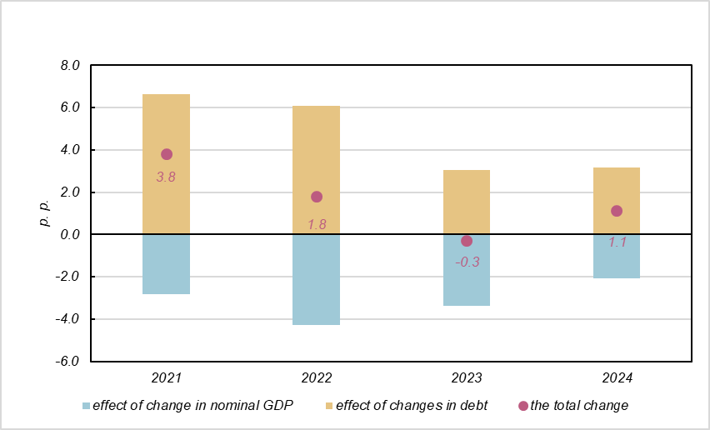

Compared to the spring notification, the amount of the debt in the end of 2024 decreased by CZK 3.4 bn and reached CZK 3 488.5 bn.

Indicators presented in the Tab. 1 were transmitted to Eurostat on 30 September 2025.
Notes:
Notification of government deficit and debt is compiled always for the past four years and submitted to the European Commission by each Member State of the European Union always at the end of March and September each year, including a projection for the current year. The projection for the current year is compiled and published by the Ministry of Finance of the Czech Republic. Quantification of fiscal indicators is based on the ESA 2010 methodology and serves the assessment of how the Maastricht convergence criteria are complied with. Pursuant to the Maastricht criteria, the government deficit must not exceed 3% of the GDP and the level of the accumulated government debt must not exceed 60% of the GDP.

Government surplus/deficit is represented by the item B.9 “net borrowing (−) or net lending (+)” in the system of national accounts. The indicator refers to the ability of the general government sector in the given year to finance other sectors of the economy (+) or the need of the general government sector to be financed (−) by other sectors.

The government debt consists of consolidated liabilities of the general government sector in the form of currency and deposits, issued debt securities, and received loans. In case of foreign exchange debt instruments hedged against currency risk, value in CZK is obtained by means of a contractual exchange rate.

Responsible head at the CZSO: | Helena Houžvičková. Director of the Government and Financial Accounts Department,  phone number: (+420) 704 688 734,  e-mail: helena.houzvickova@csu.gov.cz
Contact person: | Jaroslav Kahoun, Head of the Government Accounts Unit, phone number: (+420) 274 054 232, e-mail: jaroslav.kahoun@csu.gov.cz
The next news release will be published on: | 21 October 2025

