December 27, 2022

Confidence in the economy decreased at the end of the year

Business cycle survey – December 2022
The composite confidence indicator (economic sentiment indicator) – in the basis index form – compared to November, slightly decreased by 0.6 percentage points to 89.5, with the same developments of its components. The business confidence indicator decreased by 0.5 percentage points to 92.5 and the consumer confidence indicator decreased by 1.3 percentage points to 74.7.
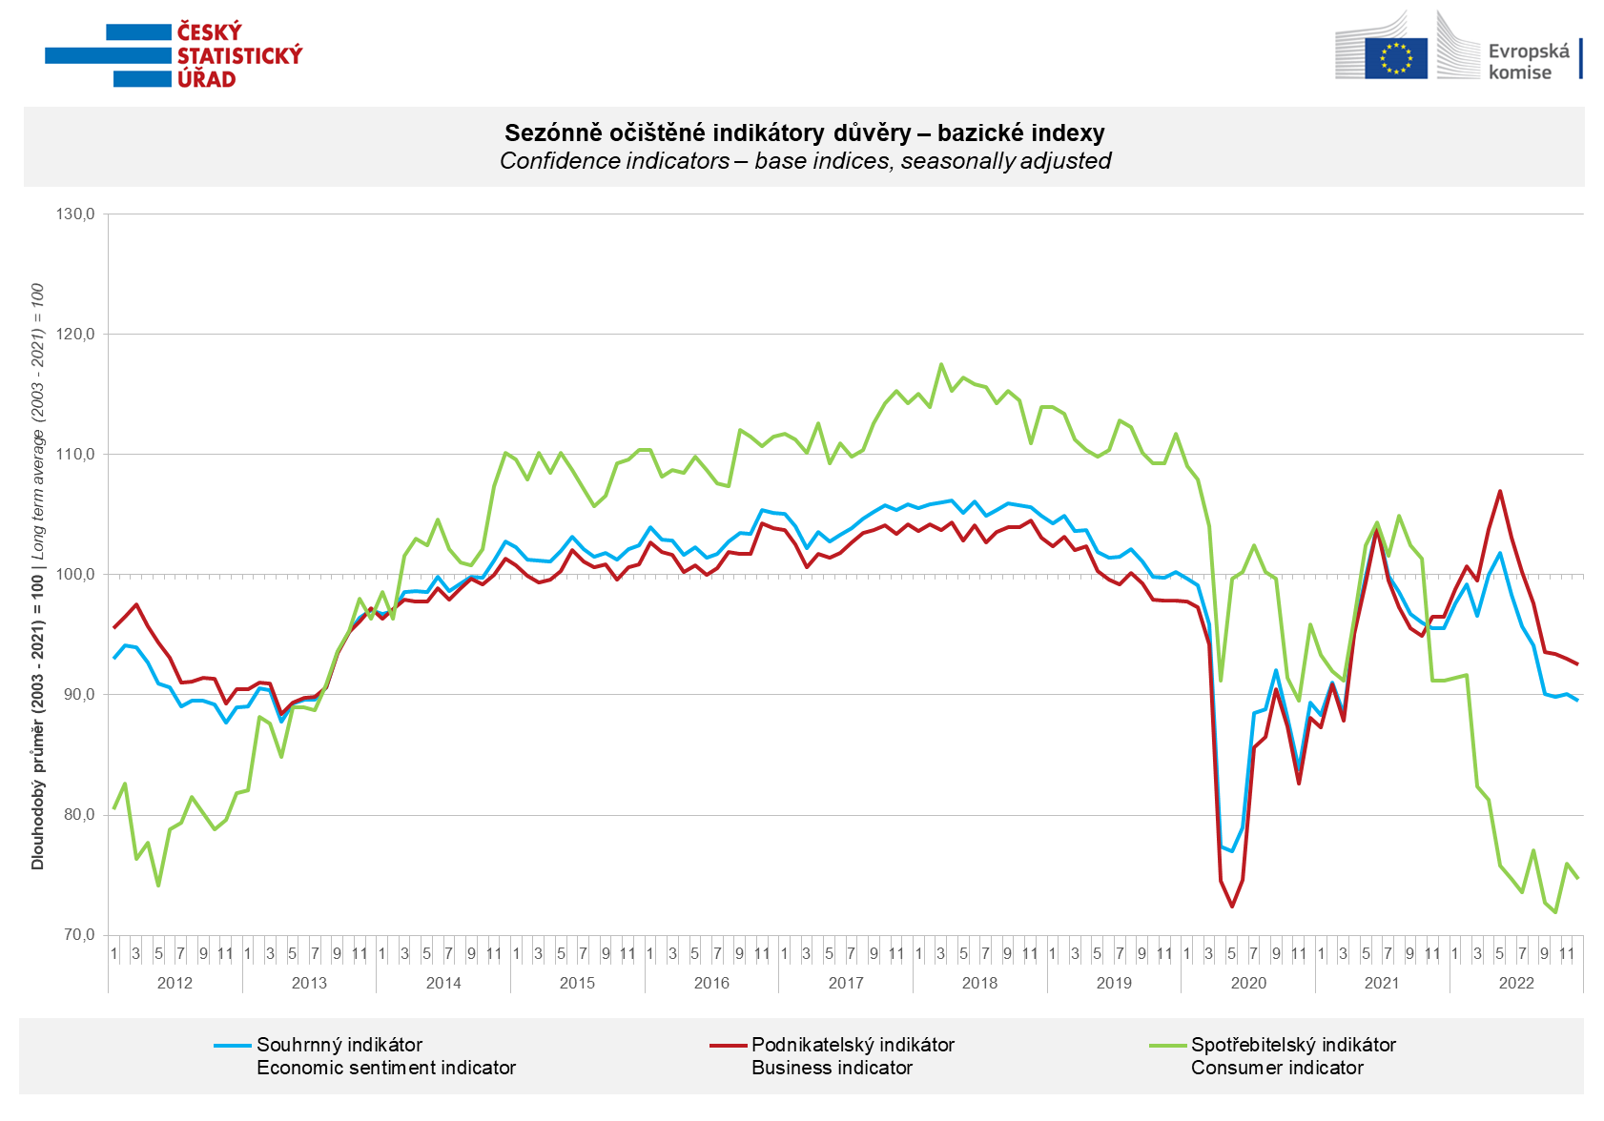

In December, the confidence of entrepreneurs fell significantly in the construction and trade sectors. In selected service sectors (including the financial sector) it did not change m-o-m, in industry it increased slightly.

Confidence in the economy among consumers fell again after a slight recovery in November. Compared to last month, households are less worried about the deterioration of the overall economic situation. However, they rate their current financial situation worse. Compared to November, the number of respondents expecting further deterioration in the next 12 months did not change. In December, the number of households who believe that the current time is suitable for making large purchases decreased. Expectations of further price growth have decreased.

***
More detailed information on the development of business and consumer confidence can be found in the supplementary information to the RI business surveys.

Notes:

Responsible manager: Juraj Lojka, Director of Business Statistics Coordination and Business Cycle Surveys Department, tel. +420731439291, e-mail: juraj.lojka@czso.cz
Contact person: Jiri Obst, Head of Business Cycle Surveys Unit, tel. +420604815440, e-mail: jiri.obst@czso.cz
Data source: CZSO business survey, Data Collect consumer survey (https://www.datacollect.cz)
Data collection date: Business part: December 19, 2022
Consumer part: December 15, 2022
Next News Release: January 24, 2023

This press release wasn´t edited for language.

Detailed time series of Balances and basic
indices of confidence indicators: https://www.czso.cz/csu/czso/kpr_ts
Business and Consumers Surveys are co-financed by grant agreements of the European Commission DG ECFIN.
https://ec.europa.eu/info/business-economy-euro/indicators-statistics/economic-databases/business-and-consumer-surveys_en
Link to European database: https://ec.europa.eu/eurostat/web/euro-indicators/business-and-consumer surveys

Annex:
Additional information to NR Business cycle survey
Table Confidence Indicators – basic indices
Graph 1 Confidence indicators – base indices, seasonally adjusted (2003–2022)
Graph 2.1 Confidence Indicators for industry, construction, trade, and in selected services – base indices, seasonally adjusted (2003–2022)
Graph 2.2 Balances of seasonally adjusted confidence indicators for industry, construction, trade, and in selected services (2003–2022)
Graph 3 Economic Sentiment Indicators – international comparison, seasonally adjusted (2007-2022)

