30 October 2024

GDP increased by 0.3%, quarter-on-quarter

GDP preliminary estimate – the third quarter of 2024

**According to a preliminary estimate, the gross domestic product increased by 0.3%, quarter-on-quarter, in the Q3 2024. In the year-on-year comparison, it increased by 1.3%.**

The gross domestic product (GDP) adjusted for price effects and seasonally adjusted[1] increased in the Q3 2024, according to the preliminary estimate, by 0.3% compared to the previous quarter. When compared to the corresponding quarter of the previous year, it increased by 1.3%.

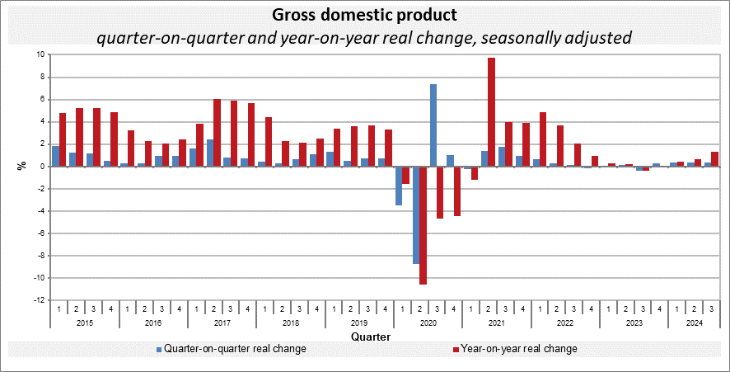

The quarter-on-quarter GDP growth was supported by an increasing domestic demand. External demand stagnated.

*“The year-on-year growth of the economy was mainly contributed to by final consumption expenditure of households, which has been continually increasing since the beginning of the year. Final consumption expenditure of general government and external demand had a positive contribution, too. Conversely, gross capital formation had a negative influence,”* Vladimír Kermiet, Director of the National Accounts Department of the Czech Statistical Office (CZSO), said.

The quarter-on-quarter growth of the gross value added was positively influenced mainly by manufacturing. Construction was successful. The year-on-year growth was mainly supported by a group of economic activities of trade, transportation, accommodation and food service activities, and financial and insurance activities. Most of economic activities of services were also successful. On the other hand, a decrease continued in industry.

Employment[2] remained unchanged, quarter-on-quarter; compared to the corresponding quarter of the previous year, it increased by 0.5%.

Responsible head at the CZSO: Vladimír Kermiet, Director of the National Accounts Department, phone number: (+420) 274 054 247,

*e-mail:* [*vladimir.kermiet@csu.gov.cz*](mailto:vladimir.kermiet@csu.gov.cz)

Contact person: Jan Benedikt, Head of the Quarterly Estimates Unit,

phone number: (+420) 274 052 750,

e‑mail: [jan.benedikt@csu.gov.cz](mailto:jan.benedikt@czso.cz)

Used data sources updated as at: 23 October 2024

Related CZSO web page: [Quarterly GDP estimates | Statistics (gov.cz)](https://csu.gov.cz/quarterly-gdp-estimates?pocet=10&start=0&podskupiny=051&razeni=-datumVydani)

*Next news release will be published on: 29 November 2024*

*(GDP resources and uses for the Q3 2024)*

1. *All data presented in this news release are adjusted for seasonal and calendar effects.* 
2. *in terms of national accounts*