November 24, 2022

Overall confidence in the economy increased slightly month-on-month

Business cycle survey – November 2022
The composite confidence indicator (economic sentiment indicator) – in the basis index form – increased slightly by 0.3 percentage points to 90.1, m-o-m, with the different developments of its components. The business confidence indicator decreased by 0.4 percentage points to 93.0 and the consumer confidence indicator increased by 4.1 percentage points to 76.0.

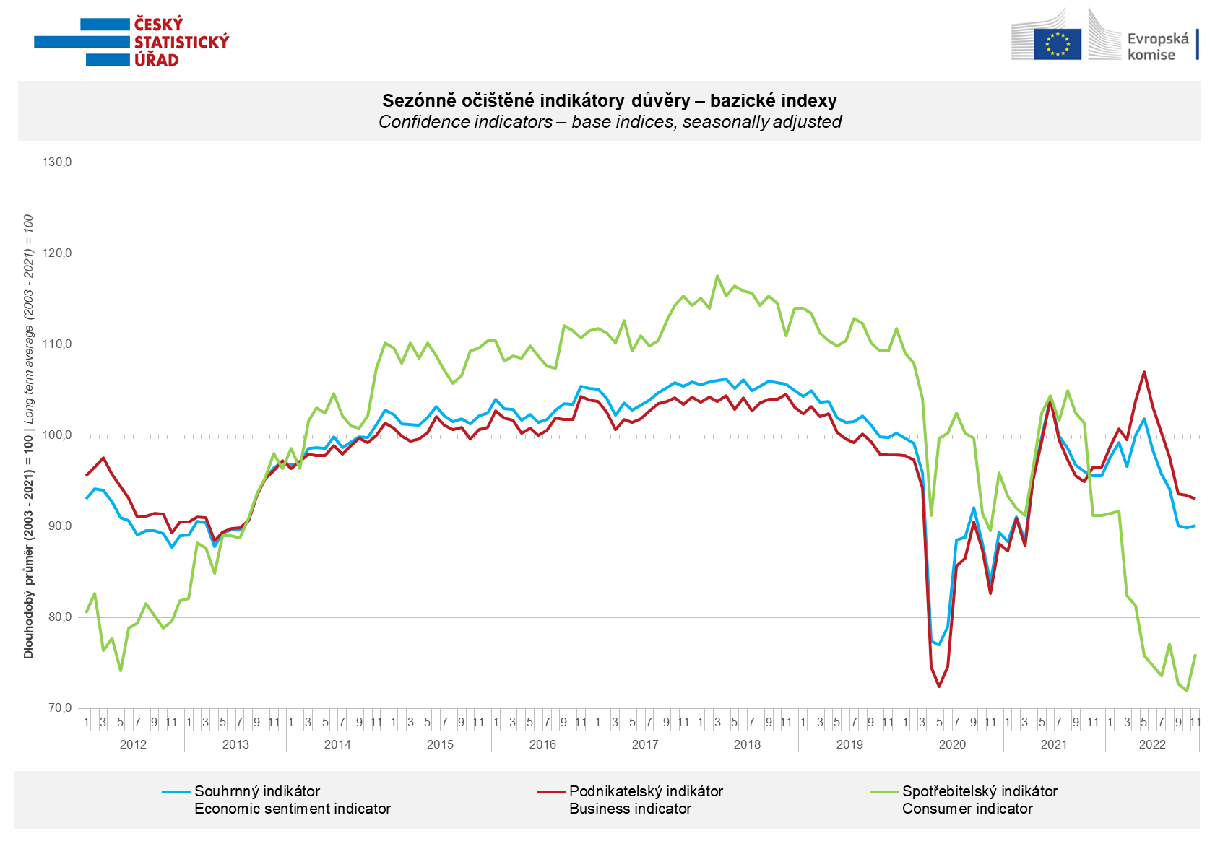

In November, confidence in the economy among entrepreneurs decreased in all sectors except construction.

Confidence in the economy among consumers rebounded from the bottom in November, rising 4.1 points month-on-month. Compared to October, respondents are less worried about the deterioration of the overall economic situation and their own financial situation. The number of respondents assessing their financial situation worse compared to the period of the previous twelve months has hardly changed and remains high. The number of respondents who do not find the current time suitable for making large purchases has also hardly changed.

***
More detailed information on the development of business and consumer confidence can be found in the supplementary information to the RI business surveys.

Notes:

Responsible manager: Juraj Lojka, Director of Business Statistics Coordination and Business Cycle Surveys Department, tel. +420731439291, e-mail: juraj.lojka@czso.cz
Contact person: Jiri Obst, Head of Business Cycle Surveys Unit, tel. +420604815440, e-mail: jiri.obst@czso.cz
Data source: CZSO business survey, Data Collect consumer survey (https://www.datacollect.cz)
Data collection date: Business part: November 18, 2022
Consumer part: November 15, 2022
Next News Release: December 27, 2022

This press release wasn´t edited for language.

Detailed time series of Balances and basic
indices of confidence indicators: https://www.czso.cz/csu/czso/kpr_ts
Business and Consumers Surveys are co-financed by grant agreements of the European Commission DG ECFIN.
https://ec.europa.eu/info/business-economy-euro/indicators-statistics/economic-databases/business-and-consumer-surveys_en
Link to European database: https://ec.europa.eu/eurostat/web/euro-indicators/business-and-consumer surveys

Annex:
Additional information to NR Business cycle survey
Table Confidence Indicators – basic indices
Graph 1 Confidence indicators – base indices, seasonally adjusted (2003–2022)
Graph 2.1 Confidence Indicators for industry, construction, trade, and in selected services – base indices, seasonally adjusted (2003–2022)
Graph 2.2 Balances of seasonally adjusted confidence indicators for industry, construction, trade, and in selected services (2003–2022)
Graph 3 Economic Sentiment Indicators – international comparison, seasonally adjusted (2007-2022)

