February 24, 2023

Consumer confidence in the economy increased again m-o-m, business confidence decreased

Business cycle survey – February 2023
The composite confidence indicator (economic sentiment indicator) – in the basis index form – slightly decreased by 0.3 points compared to January to 91.7, with the different developments of its components. The business confidence indicator decreased by 1.3 percentage points to 92.5 and the consumer confidence indicator increased by 4.8 points to 87.7.
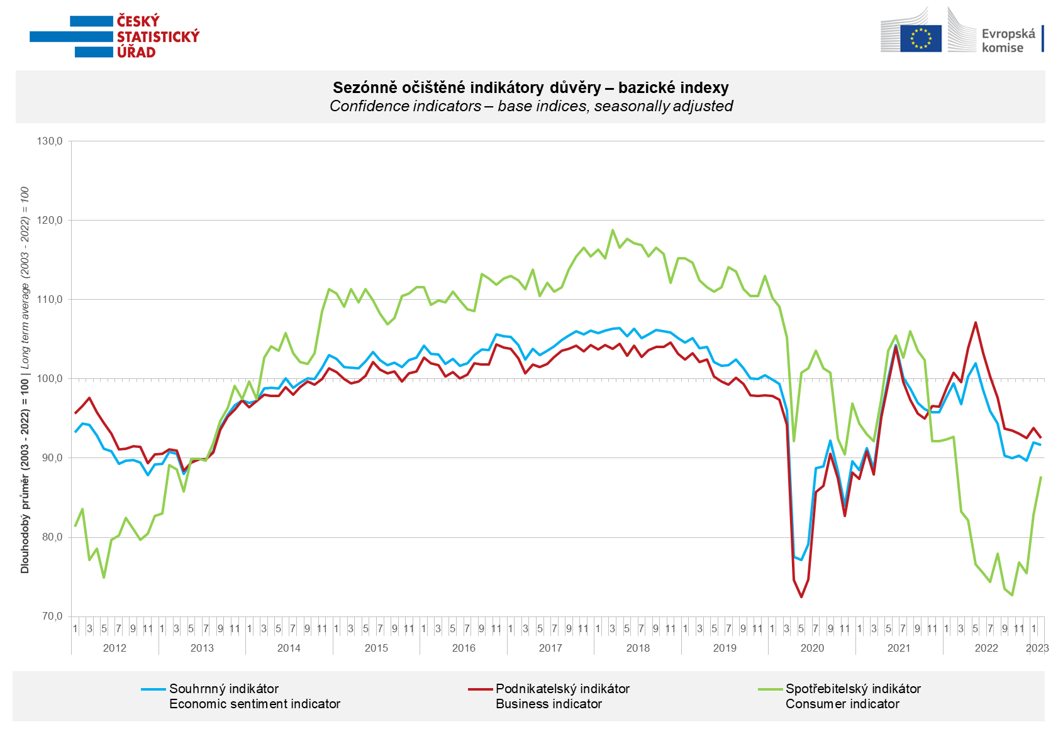

In February, confidence among entrepreneurs increased in selected sectors of services and construction. On the contrary, it decreased in trade and industry compared to January.

Among consumers, confidence in the economy increased for the second time in a row. The number of households assessing their current financial situation worse than it was in the previous twelve months was almost unchanged compared to January. M-o-m, the number of respondents expecting a worsening of their financial situation in the next 12 months decreased significantly. Compared to last month, households are also less worried about the deterioration of the overall economic situation. The share of consumers who believe that the current time is not suitable for making large purchases decreased slightly m-o-m.
***
More detailed information on the development of business and consumer confidence can be found in the supplementary information to the RI business surveys.

***
In January 2023, we change the base to calculate the basis index in a news release by the Czech Statistical Office. For 2023, we calculate the long-term average from January 2003 to December 2022. The long-term average is changed one a year in news release publication data in January.

Notes:

Responsible manager: Juraj Lojka, Director of Business Statistics Coordination and Business Cycle Surveys Department, tel. +420731439291, e-mail: juraj.lojka@czso.cz
Contact person: Jiri Obst, Head of Business Cycle Surveys Unit, tel. +420604815440, e-mail: jiri.obst@czso.cz
Data source: CZSO business survey, Data Collect consumer survey (https://www.datacollect.cz)
Data collection date: Business part: February 17, 2023
Consumer part: February 15, 2023
Next News Release: March 24, 2023

This press release wasn´t edited for language.

Detailed time series of Balances and basic
indices of confidence indicators: https://www.czso.cz/csu/czso/kpr_ts
Business and Consumers Surveys are co-financed by grant agreements of the European Commission DG ECFIN.
https://ec.europa.eu/info/business-economy-euro/indicators-statistics/economic-databases/business-and-consumer-surveys_en
Link to European database: https://ec.europa.eu/eurostat/web/euro-indicators/business-and-consumer surveys

Annex:
Additional information to NR Business cycle survey
Table Confidence Indicators – basic indices
Graph 1 Confidence indicators – base indices, seasonally adjusted (2003–2023)
Graph 2.1 Confidence Indicators for industry, construction, trade, and in selected services – base indices, seasonally adjusted (2003–2023)
Graph 2.2 Balances of seasonally adjusted confidence indicators for industry, construction, trade, and in selected services (2003–2023)
Graph 3 Economic Sentiment Indicators – international comparison, seasonally adjusted (2007-2023)

