March 21, 2025

Overall confidence in the economy increased

Business cycle survey – March 2025

The composite confidence indicator (economic sentiment indicator), in the basic index form – increased by 1.7 points to 99.5 m-o-m, with the same development of its components. The business confidence indicator increased by 1.6 points to 99.6, the consumer confidence indicator rose by 2.2 points to 98.8. Compared to March last year, the composite indicator and the business indicator are at a higher level.
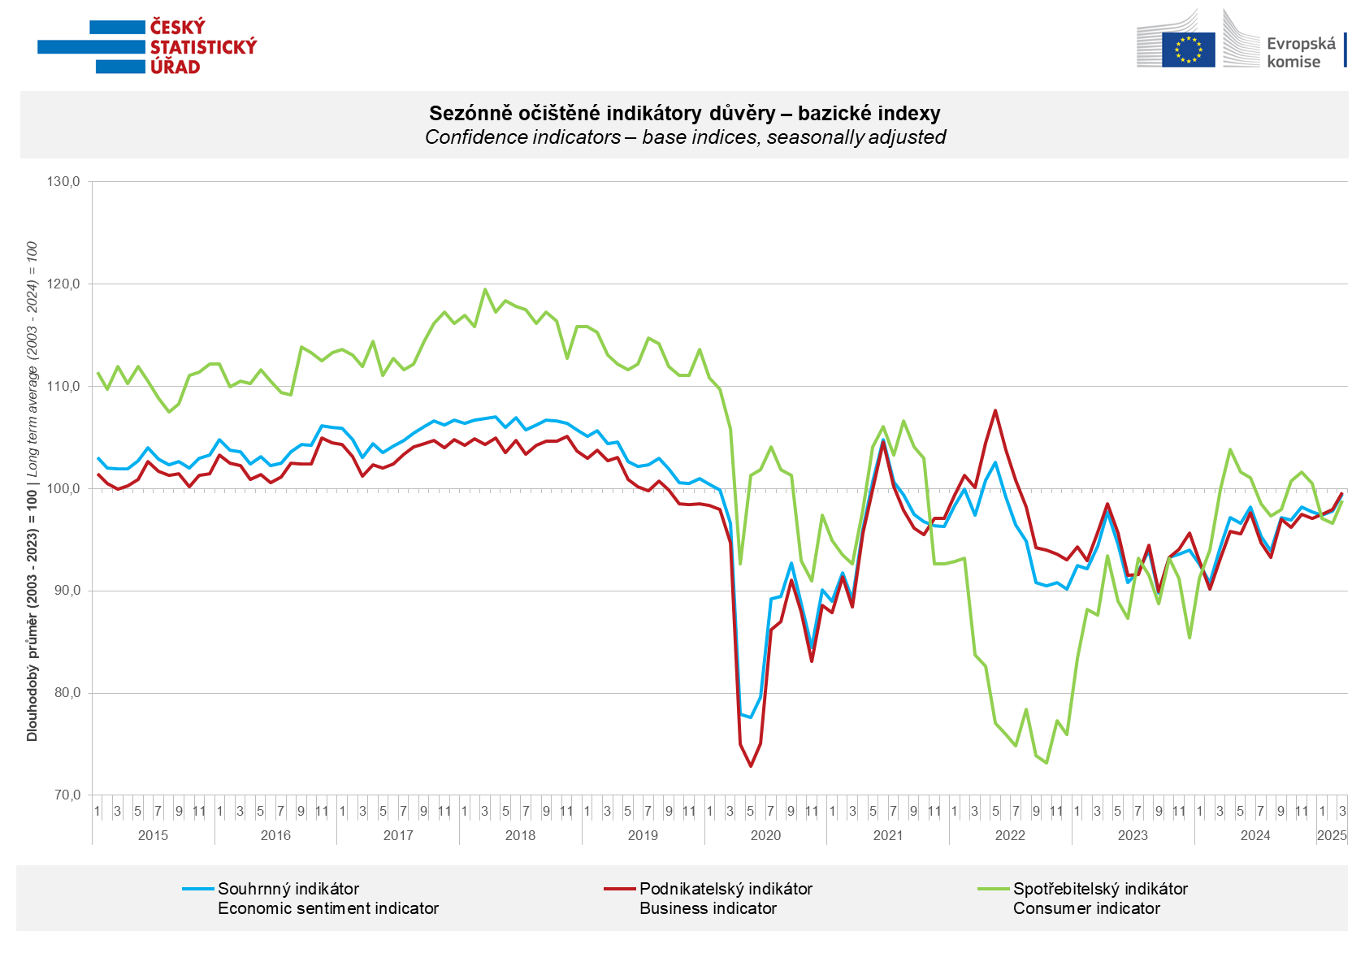

Business confidence in the economy increased in March across all sectors. Compared with February, it increased the most in trade (+2.3 points), followed by selected services (+1.8 points), industry (+1.3 points) and construction (+1.1 points).

Consumer confidence increased compared the last month. The confidence indicator rose by 2.2 points to 98.8 in March. The share of consumers expecting the overall economic situation in the Czech Republic to deteriorate over the next twelve months decreased, but remained relatively high. The share of households expecting their financial situation to deteriorate over the next twelve months decreased slightly compared with February. The number of households assessing their current financial situation as worse than in the previous twelve months remained the same as in February. The proportion of consumers who believe that the current period is not conducive to making large purchases decreased slightly.
***
More detailed information on the development of business and consumer confidence can be found in the supplementary information to the RI business surveys.

Notes:

Responsible manager: Juraj Lojka, Director of Business Statistics Coordination and Business Cycle Surveys Department, tel. +420731439291, e-mail: juraj.lojka@csu.gov.cz
Contact person: Jiri Obst, Head of Business Cycle Surveys Unit, tel. +420604815440, e-mail: jiri.obst@csu.gov.cz
Data source: CZSO business survey, Data Collect consumer survey (https://www.datacollect.cz)
Data collection date: Business part: March 17, 2025
Consumer part: March 17, 2025
Next News Release: April 24, 2025

This press release wasn´t edited for language.

Detailed time series of Balances and basic
indices of confidence indicators: https://csu.gov.cz/produkty/kpr_ts
Business and Consumers Surveys are co-financed by grant agreements of the European Commission DG ECFIN.
https://ec.europa.eu/info/business-economy-euro/indicators-statistics/economic-databases/business-and-consumer-surveys_en
Link to European database: https://ec.europa.eu/eurostat/web/euro-indicators/database

Annex:
Additional information to NR Business cycle survey
Table Confidence Indicators – basic indices
Graph 1 Confidence indicators – base indices, seasonally adjusted (2003–2025)
Graph 2.1 Confidence Indicators for industry, construction, trade, and in selected services – base indices, seasonally adjusted (2003–2025)
Graph 2.2 Balances of seasonally adjusted confidence indicators for industry, construction, trade, and in selected services (2003–2025)
Graph 3 Economic Sentiment Indicators – international comparison, seasonally adjusted (2007-2025)

