1 October 2025

General government sector balance ended up in a surplus

Government deficit and debt – the second quarter of 2025
In the Q2 2025, the general government sector balance ended up with a surplus corresponding to 0.4% of the GDP. The government debt ratio reached 43.8% of the GDP.

In the Q2 2025, the general government sector surplus reached CZK 8.3 billion, which means that it improved by CZK 4.6 billion in the year-on-year comparison. The central government ended up with a surplus of CZK 32.0 billion that improved by CZK 12.8 billion, y-o-y. Performance of the local government sector ended up with a surplus in the amount of CZK 41.0 billion, which means, in a year-on-year comparison, a worsening by CZK 10.7 billion. Performance of social security funds (of health insurance companies) ended up with a deficit of CZK 0.8 billion.

“In the second quarter of 2025, the general government sector ended up with a surplus of CZK 8.3 billion, which is in relative terms 0.4% of the GDP. The government debt ratio increased by 1.4 p. p., year-on-year,” Helena Houžvičková, Director of the Government and Financial Accounts Department of the Czech Statistical Office (CZSO), stated.

Tab. 1.1 The general government sector balance
(Data in the table are not seasonally adjusted; they cannot be compared quarter-on-quarter.)
 | Q2 2023 | Q3 2023 | Q4 2023 | Q1 2024 | Q2 2024 | Q3 2024 | Q4 2024 | Q1 2025 | Q2 2025
CZK bn | -15.4 | -45.0 | -114.7 | -59.0 | 3.7 | -31.6 | -76.6 | -71.3 | 8.3
% of the GDP | -0.8 | -2.3 | -5.7 | -3.2 | 0.2 | -1.5 | -3.6 | -3.6 | 0.4

The total government revenues increased by 6.0%, y-o-y, and reached 42.5% of the GDP. Especially the following contributed to the y-o-y increase in revenues: received income taxes and received social contributions. The total government expenditure increased by 5.5%, y-o-y, and reached 42.1% of the GDP. An increase was mainly recorded in compensation of employees paid, gross capital formation, and social benefits.

The nominal debt of the general government increased, year-on-year, by CZK 306.2 bn to CZK 3 627.0 bn. The government debt ratio increased from 42.4% to 43.8% of the GDP, y-o-y; the influence of the nominal change of the debt was +3.7 p. p., while the increasing nominal GDP contributed to a decrease in indebtedness by –2.3 p. p. In the quarter-on-quarter comparison, the debt increased by CZK 91.9 bn, the nominal change of the debt was +1.1 p. p., whereas an increase in the nominal GDP contributed to a decrease in the indebtedness by –0.6 p. p., which resulted in an increase in the debt ratio by 0.5 p. p., quarter-on-quarter.

Regarding the debt structure, a year-on-year increase was mainly recorded in issued debt securities (CZK +237.9 bn).

In the Q2 2025, the quarter-on-quarter change in the debt (an increase by CZK 91.9 bn) was significantly different from the general government sector balance (the surplus of CZK 8.3 bn). The general government sector borrowed by CZK 100.2 bn more than its balance was, which resulted in an increase in the value of assets held, especially of deposits.

Chart 1.1 Debt of the general government sector

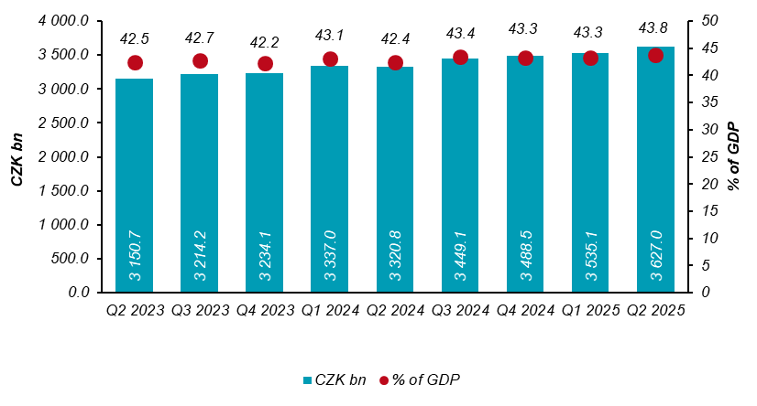

Chart 1.2 Year-on-year relative changes in government debt
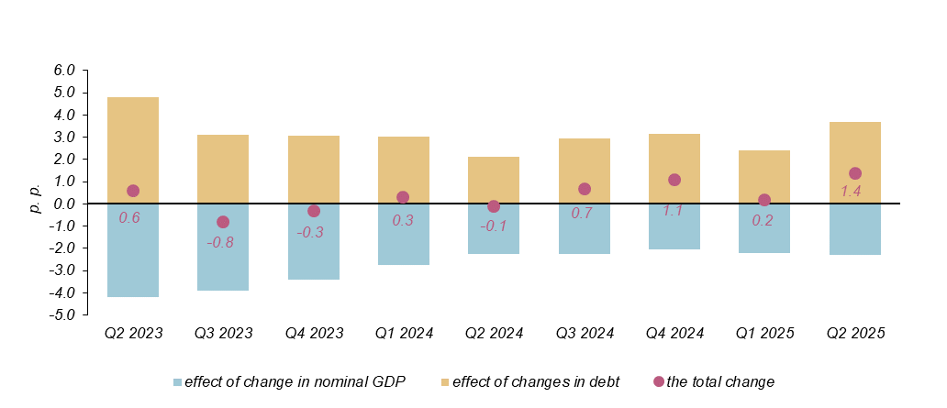

The general government sector balance after seasonal adjustment as well as adjustment for calendar effects ended up with a deficit of CZK 34.8 bn, which corresponded to 1.6% of the GDP. The general government sector balance improved by CZK 5.4 bn, q-o-q. The development of the general government sector balance adjusted by seasonal and calendar effects is shown in the chart below.

Chart 1.3 Seasonally adjusted general government sector balance
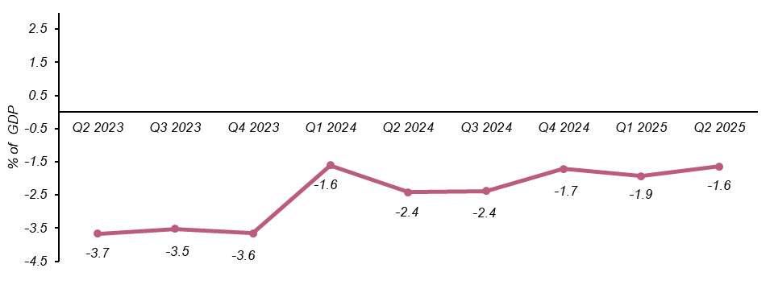
Notes:
Quantification of fiscal indicators of government deficit and debt mentioned above is based on the ESA2010 methodology. Data published in this news release are methodologically consistent with the data used for the statistics of the Excessive Deficit Procedure (EDP) purposes and for the assessment of how Maastricht convergence criteria are met.

The government surplus/deficit is represented by the item B.9 “net borrowing (−) or net lending (+)” in the system of national accounts. It refers to the ability of the general government sector to finance other sectors of the economy (+) or the need of the general government sector to be financed (−) by other sectors of the economy in the given period.

The general government debt is the amount of consolidated liabilities of the general government sector comprising the following items: received deposits, issued debt securities, and received loans. In case of foreign exchange debt instruments hedged against the currency risk, the value in CZK is obtained by means of the contractual exchange rate.

The general government sector balance is compared with the amount of the GDP in the given quarter at current prices. The amount of the consolidated general government debt is compared with the sum of quarterly GDP for the last four quarters at current prices. Fiscal indicators of quarterly government deficit and debt are published within the Transmission programme (Tab. 25 and Tab. 28) on the CZSO’s website General government sector in the “GDP, National Accounts” section. Unless otherwise stated, data are not seasonally adjusted as well as they are not adjusted for calendar effects. Time series of seasonally adjusted sector accounts for the government sector (the item of net lending / net borrowing) Time series of seasonally adjusted sector accounts for S.13.

Responsible head at the CZSO: | Helena Houžvičková. Director of the Government and Financial Accounts Department,  phone number: (+420) 704 688 734,  e-mail: helena.houzvickova@csu.gov.cz
Contact person: | Jaroslav Kahoun, Head of the Government Accounts Unit, phone number: (+420) 274 054 232, e-mail: jaroslav.kahoun@csu.gov.cz
The next news release will be published on: | 6 January 2026

