30 April 2025

GDP increased by 0.5%, quarter-on-quarter

GDP preliminary estimate – the first quarter of 2025
According to a preliminary estimate, the gross domestic product increased by 0.5%, quarter-on-quarter, in the Q1 2025, and by 2.0%, year-on-year.

The gross domestic product (GDP) adjusted for price effects and seasonally adjusted was in the Q1 2025 by 0.5% higher, compared to the previous quarter, according to the preliminary estimate. In comparison to the corresponding quarter of 2024, it increased by 2.0%.

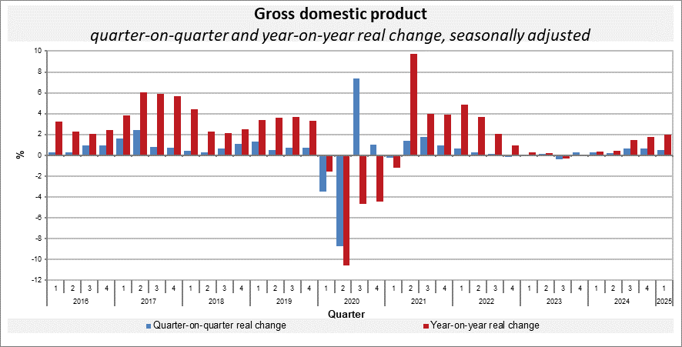

The quarter-on-quarter GDP growth was mainly influenced by final consumption expenditure of households that continued to increase. The expenditure on gross capital formation as well as the external demand also had a slightly positive influence.

“The year-on-year growth of the economy by 2.0% was solely supported by the domestic demand, especially by final consumption expenditure of households. The international trade balance had a negative contribution,” Vladimír Kermiet, Director of the National Accounts Department of the Czech Statistical Office (CZSO), informed.

The gross value added was increasing in both the comparisons in construction, a group of economic activities of trade, transportation, accommodation and food service activities as well as in other services. A decrease occurred in manufacturing.
Employment increased by 0.5%, quarter-on-quarter. Compared to the corresponding quarter of the previous year, it increased by 0.9%.

Responsible head at the CZSO: Vladimír Kermiet, Director of the National Accounts Department, phone number: (+420) 274 054 247,
e-mail: vladimir.kermiet@csu.gov.cz
Contact person: Jan Benedikt, Head of the Quarterly Estimates Unit,
phone number: (+420) 274 052 750,
e-mail: jan.benedikt@csu.gov.cz
Used data sources updated as at: 23 April 2025
Related CZSO web page: Quarterly GDP estimates | Statistics (gov.cz)
The next news release will be published on: 30 May 2025
(GDP resources and uses for the Q1 2025)

All data presented in this news release have been adjusted for seasonal and calendar effects (different number of working days).
in terms of national accounts

