July 24, 2025

Business confidence indicator fell down its long-term average, consumer confidence indicator increased

Business cycle survey – July 2025

The composite confidence indicator (economic sentiment indicator), in the basic index form – decreased by 0.4 points to 99.7 m-o-m, with the different development of its components. The business confidence indicator fell by 1.2 point to 98.8, while the consumer confidence indicator increased by 3.4 points to 104.1.

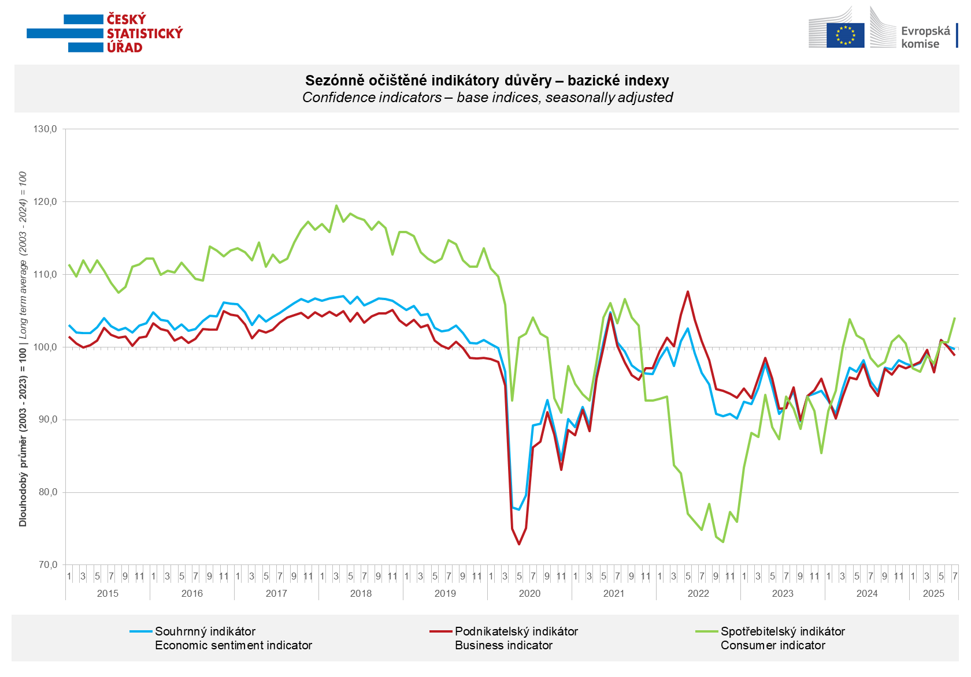

In July, business confidence increased only in the trade (+2.6 points). On the other hand, we see decreases in the selected services sector (- 2.1 points) and in industry (-1.0 points). In the construction sector, confidence is stable.

Consumer confidence increased from June. The indicator increased by 3.4 points to 104.1. The balance of responses to questions on the overall economic situation gets worse in the Czech Republic decreased. The balance of responses to questions about the improvement of the expected financial situation of households in the next 12 months increased. Compared to the previous month, the number of respondents that assessment of their current financial situation remained more or less at the previous month's level compared with the previous 12 months did not change. The number of respondents who do not plan to make large purchases in the next 12 months has decreased slightly.
***
More detailed information on the development of business and consumer confidence can be found in the supplementary information to the RI business surveys.

Notes:

Responsible manager: Juraj Lojka, Director of Business Statistics Coordination and Business Cycle Surveys Department, tel. +420731439291, e-mail: juraj.lojka@csu.gov.cz
Contact person: Jiri Obst, Head of Business Cycle Surveys Unit, tel. +420604815440, e-mail: jiri.obst@csu.gov.cz
Data source: CZSO business survey, Data Collect consumer survey (https://www.datacollect.cz)
Data collection date: Business part: July 17, 2025
Consumer part: July 15, 2025
Next News Release: August 25, 2025

This press release wasn´t edited for language.

Detailed time series of Balances and basic
indices of confidence indicators: https://csu.gov.cz/produkty/kpr_ts
Business and Consumers Surveys are co-financed by grant agreements of the European Commission DG ECFIN.
https://ec.europa.eu/info/business-economy-euro/indicators-statistics/economic-databases/business-and-consumer-surveys_en
Link to European database: https://ec.europa.eu/eurostat/web/euro-indicators/database

Annex:
Additional information to NR Business cycle survey
Table Confidence Indicators – basic indices
Graph 1 Confidence indicators – base indices, seasonally adjusted (2003–2025)
Graph 2.1 Confidence Indicators for industry, construction, trade, and in selected services – base indices, seasonally adjusted (2003–2025)
Graph 2.2 Balances of seasonally adjusted confidence indicators for industry, construction, trade, and in selected services (2003–2025)
Graph 3 Economic Sentiment Indicators – international comparison, seasonally adjusted (2007-2025)
Graph 4 Production Capacity Utilisation in Manufacturing Industry (2003-2025)
Graph 5 Limits of Production in Industry (2005-2025)
Graph 6 Limits of Production in Construction (2005-2025)
Graph 7 Limits of Production in Selected Services (2005-2025)

