October 24, 2025

Confidence in the economy continued to grow in October

Business cycle survey – October 2025

The composite confidence indicator (economic sentiment indicator), expressed as a basic index, rose slightly by 2.1 points m-o-m to 104.0, with both of its components showing the same development. The business confidence indicator rose by 1.8 points to 103.4 and the consumer confidence indicator rose by 3.9 points to 107.4.

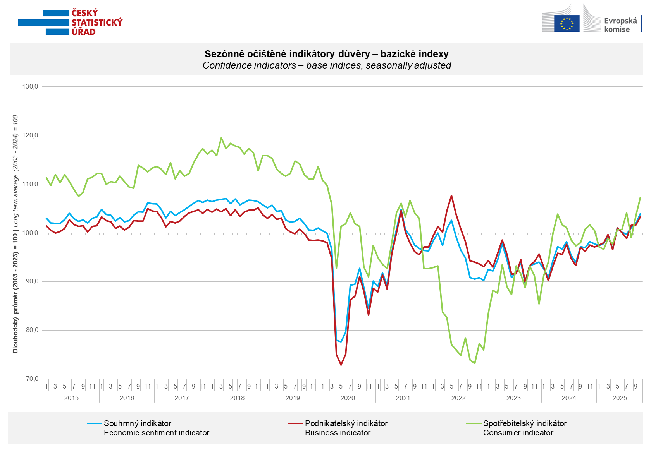

Confidence in the economy increased in October in industry (+4.3 points) and slightly in selected service sectors (+0.6 points). It declined in trade and construction (-4.0 points and -3.6 points).

Consumer confidence rose m-o-m in October. The confidence indicator rose by 3.9 points to 107.4. The share of consumers expecting the overall economic situation in Czechia to deteriorate over the next twelve months fell significantly m-o-m. Compared with September, the share of households expecting their financial situation to improve over the next twelve months also increased. On the other hand, there was a slight increase in the share of respondents who assess their current financial situation as worse than in the previous twelve months. The number of respondents who do not plan to make any major purchases in the next twelve months increased slightly.
***
More detailed information on the development of business and consumer confidence can be found in the supplementary information to the RI business surveys.

Notes:

Responsible manager: Juraj Lojka, Director of Business Statistics Coordination and Business Cycle Surveys Department, tel. +420731439291, e-mail: juraj.lojka@csu.gov.cz
Contact person: Jiri Obst, Head of Business Cycle Surveys Unit, tel. +420604815440, e-mail: jiri.obst@csu.gov.cz
Data source: CZSO business survey, Data Collect consumer survey (https://www.datacollect.cz)
Data collection date: Business part: October 17, 2025
Consumer part: October 15, 2025
Next News Release: November 24, 2025

This press release wasn´t edited for language.

Detailed time series of Balances and basic
indices of confidence indicators: https://csu.gov.cz/produkty/kpr_ts
Business and Consumers Surveys are co-financed by grant agreements of the European Commission DG ECFIN.
https://ec.europa.eu/info/business-economy-euro/indicators-statistics/economic-databases/business-and-consumer-surveys_en
Link to European database: https://ec.europa.eu/eurostat/web/euro-indicators/database

Annex:
Additional information to NR Business cycle survey
Table Confidence Indicators – basic indices
Graph 1 Confidence indicators – base indices, seasonally adjusted (2003–2025)
Graph 2.1 Confidence Indicators for industry, construction, trade, and in selected services – base indices, seasonally adjusted (2003–2025)
Graph 2.2 Balances of seasonally adjusted confidence indicators for industry, construction, trade, and in selected services (2003–2025)
Graph 3 Economic Sentiment Indicators – international comparison, seasonally adjusted (2007-2025)
Graph 4 Production Capacity Utilisation in Manufacturing Industry (2003-2025)
Graph 5 Limits of Production in Industry (2005-2025)
Graph 6 Limits of Production in Construction (2005-2025)
Graph 7 Limits of Production in Selected Services (2005-2025)

