30 April 2026

GDP increased by 0.2%, quarter-on-quarter

GDP preliminary estimate – the first quarter of 2026
According to a preliminary estimate, the gross domestic product increased by 0.2%, quarter-on-quarter, in the Q1 2026, and by 2.1%, year-on-year.

The gross domestic product (GDP) adjusted for price effects and seasonally adjusted was in the Q1 2026 by 0.2% higher, compared to the previous quarter, according to the preliminary estimate. In comparison to the corresponding quarter of 2025, it increased by 2.1%.

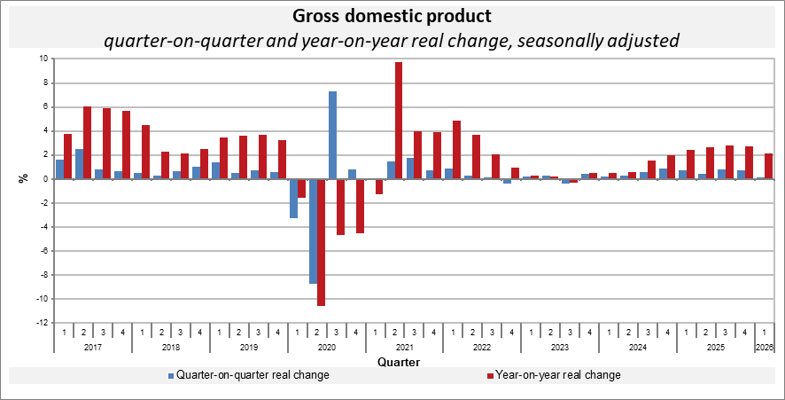

The quarter-on-quarter GDP growth was positively influenced especially by an increasing gross capital formation. The international trade balance had a negative influence.

“The year-on-year growth of GDP by 2.1% was solely supported by the domestic demand, mainly by final consumption expenditure of households and by gross fixed capital formation. The international trade balance had a negative contribution,” Vladimír Kermiet, Director of the National Accounts Department of the Czech Statistical Office (CZSO), informed.

The development of the gross value added in the quarter-on-quarter comparison was positively influenced by most economic activities of services. A negative influence mainly came from industry. Especially industry and a group of economic activities of trade, transportation, accommodation and food service activities contributed the most to the year-on-year growth of the gross value added.

Employment remained unchanged, quarter-on-quarter. Compared to the corresponding quarter of the previous year, it increased by 0.7%.

Responsible head at the CZSO: Vladimír Kermiet, Director of the National Accounts Department, phone number: (+420) 274 054 247,
e-mail: vladimir.kermiet@csu.gov.cz
Contact person: Jan Benedikt, Head of the Quarterly Estimates Unit,
phone number: (+420) 274 052 750,
e-mail: jan.benedikt@csu.gov.cz
Used data sources updated as at: 22 April 2026
Related CZSO’s web page: Quarterly GDP estimates | Statistics (gov.cz)
The next news release will be published on: 29 May 2026
(GDP resources and uses for the Q1 2026)

All data presented in this news release have been adjusted for seasonal and calendar effects (different number of working days).
in terms of national accounts

