Overall confidence in the economy decreased slightly
24. 08. 2026

Business Cycle Survey – August 2026
The composite confidence indicator (economic sentiment indicator), expressed as a basic index, decreased slightly by 0.6 points in August to 100.5. The development of both of its components was different. While the business confidence indicator remained unchanged at its July level of 100.2, the consumer confidence indicator decreased by 3.3 points to 102.3.
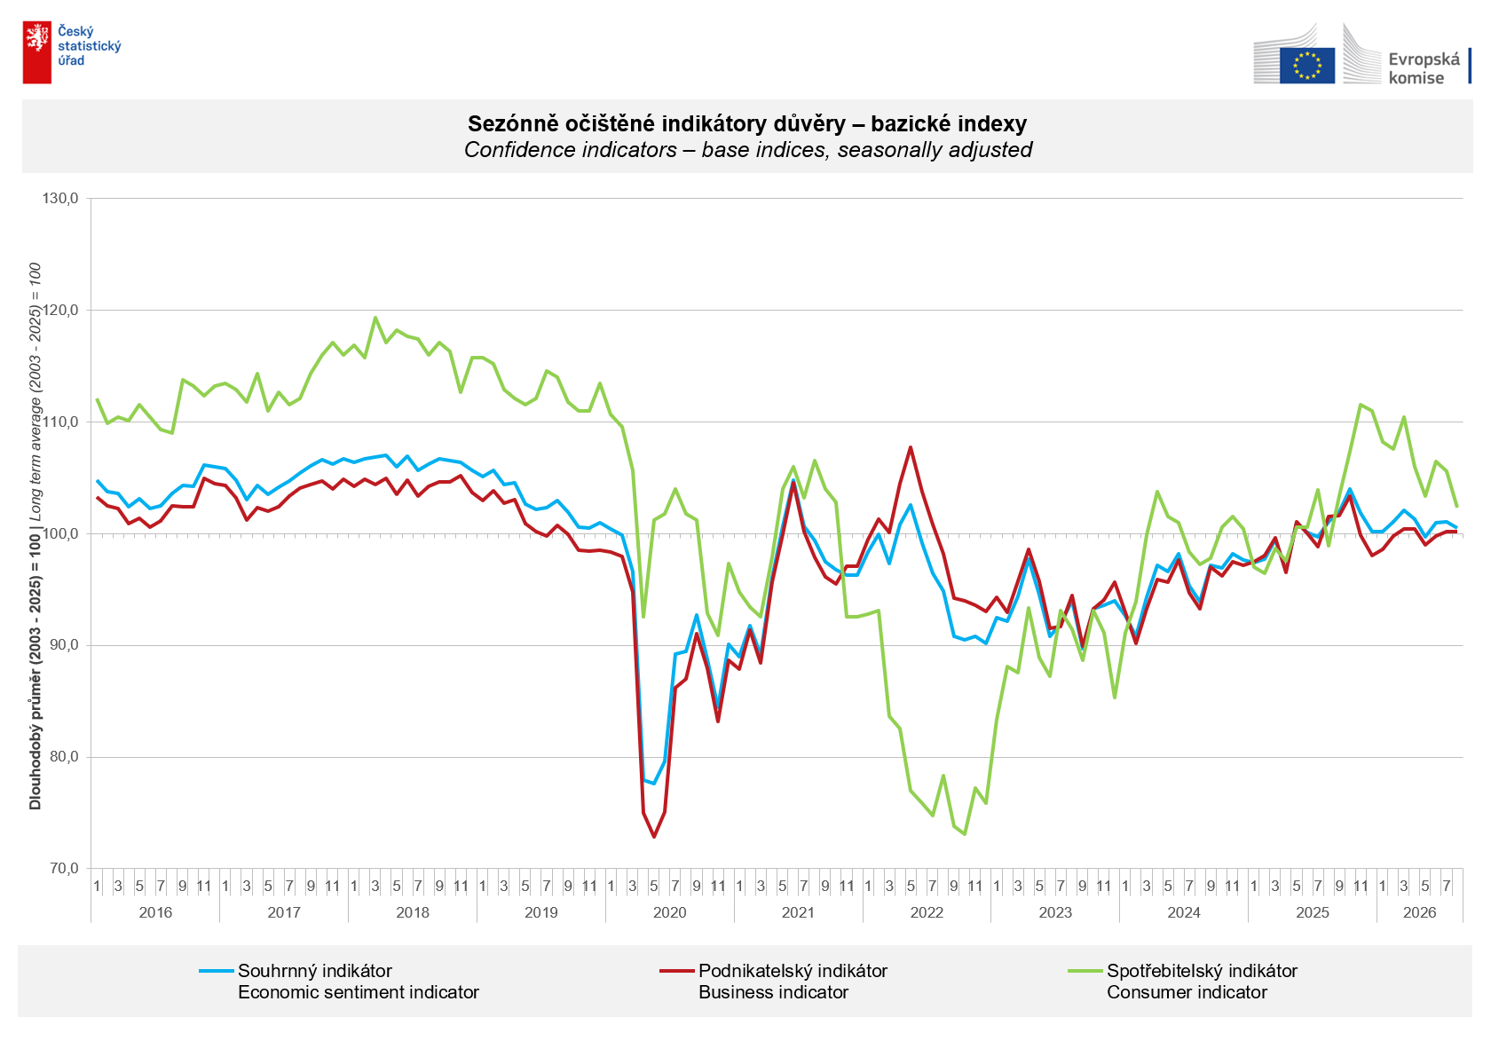
Business confidence in the economy increased only marginally in the industrial sector (+0.3 points) in August. It decreased in trade by 1.1 points, in construction by 0.6 points, and slightly also in selected service sectors (-0.2 points).

Consumer confidence in the economy decreased compared to July. The confidence indicator decreased by 3.3 points to 102.3. The share of consumers expecting a deterioration in the overall economic situation in Czechia over the next twelve months increased for the second consecutive month. The proportion of respondents assessing their current financial situation as worse than in the previous twelve months increased slightly compared to July. The share of households expecting an improvement in their financial situation over the next twelve months remained at the level of the previous month. The number of respondents not planning to make major purchases over the next twelve months increased.
***
More detailed information on the development of business and consumer confidence can be found in the supplementary information to the RI business surveys.

Notes:

Responsible manager: Juraj Lojka, Director of Business Statistics Coordination and Business Cycle Surveys Department, tel. +420731439291, e-mail: juraj.lojka@csu.gov.cz
Contact person: Jiri Obst, Head of Business Cycle Surveys Unit, tel. +420604815440, e-mail: jiri.obst@csu.gov.cz
Data source: CZSO business survey, Data Collect consumer survey (https://www.datacollect.cz)
Data collection date: Business part: August 17, 2026
Consumer part: August 17, 2026
Next News Release: September 24, 2026

This press release wasn´t edited for language.

Detailed time series of Balances and basic
indices of confidence indicators: https://csu.gov.cz/produkty/kpr_ts
Business and Consumers Surveys are co-financed by grant agreements of the European Commission DG ECFIN.
https://ec.europa.eu/info/business-economy-euro/indicators-statistics/economic-databases/business-and-consumer-surveys_en
Link to European database: https://ec.europa.eu/eurostat/web/euro-indicators/database

Annex:
Additional information to NR Business cycle survey
Table Confidence Indicators – basic indices
Graph 1 Confidence indicators – base indices, seasonally adjusted (2003–2026)
Graph 2.1 Confidence Indicators for industry, construction, trade, and in selected services – base indices, seasonally adjusted (2003–2026)
Graph 2.2 Balances of seasonally adjusted confidence indicators for industry, construction, trade, and in selected services (2003–2026)
Graph 3 Economic Sentiment Indicators – international comparison, seasonally adjusted (2007-2026)

