According to the Flash estimate, year-on-year growth of consumer prices is expected to be 2.4% in October
04. 11. 2026

Flash estimate of Consumer price index – October 2026
According to the Flash estimate, consumer prices in October 2026 rose by 0.4%, month-on-month, and by 2.4%, year-on-year. Final data will be published by Czech Statistical Office on 10 November 2026.

Flash estimate of CPI (%)
10/2026
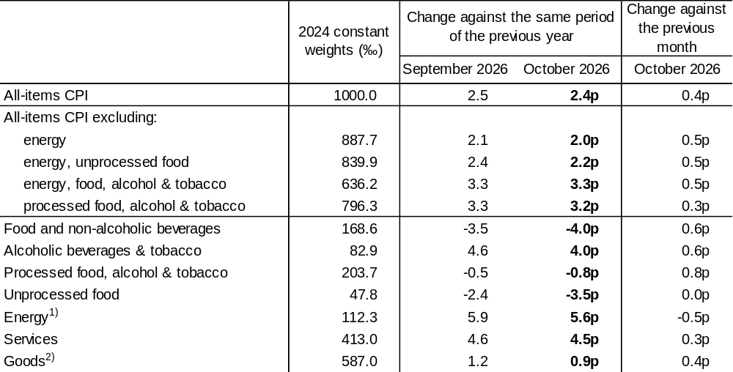
¹⁾ Includes automotive fuels (energy is classified in goods).
²⁾ Includes water supply, according to Eurostat concept.
p – preliminary

Notes:

Responsible manager of the CZSO: Vladimir Caba, Director of Price Statistics Department, phone (+420) 274052873, email: vladimir.caba@csu.gov.cz
Contact: Pavla Sediva, Head of the Consumer Price Statistics Unit, phone (+420) 274052138, email: pavla.sediva@csu.gov.cz
Data source: Direct field survey of prices, centrally surveyed prices and reporting
End of data collection: 20th day of the reference month
Related publications: 012024-26 Consumer Price Indices – inflation (periodicity: monthly), 012018-26 Consumer Price Indices – Basic Breakdown (periodicity: monthly) and 012019-26 Consumer Price Indices – Detailed Breakdown (periodicity: annually)
Internet: www.csu.gov.cz/inflation-consumer-prices
News Release Inflation: 10 November 2026
Text not edited for language

Annexes:
Table Flash estimate of CPI (%)

