January 24, 2022

Overall confidence in the economy increased after six months

Business cycle survey – January 2022
The composite confidence indicator (economic sentiment indicator) – in the basis index form – increased by 2.0 percentage points to 97.6, m-o-m, with both components increasing. Business confidence indicator increased by 2.3 percentage points to 98.8, the consumer confidence indicator increased by 0.2 percentage points to 91.4.

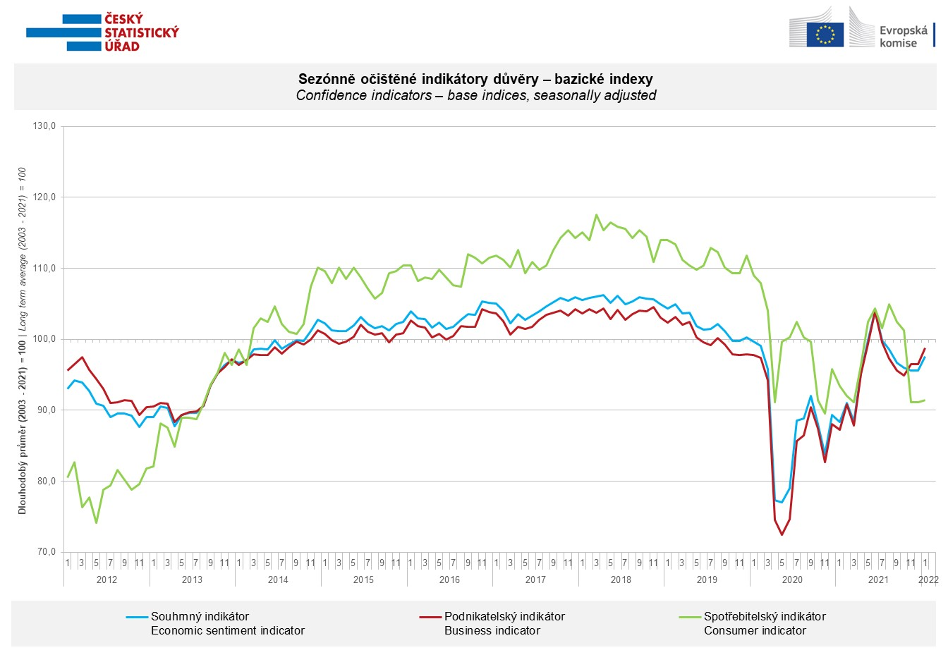
The month-on-month growth in economic sentiment among entrepreneurs was mainly due to an increase in confidence in industry, due to expectations of a high increase in the pace of production activity for the next three months. Confidence also increased in construction and selected services compared to December, while it decreased slightly in trade.

The very slight month-on-month increase in consumer confidence was mainly is related, among other things, to the decline in the number of households assessing their current financial situation negatively compared to the last twelve months.

***
More detailed information on the development of business and consumer confidence can be found in the supplementary information to the RI business surveys.

***
In January 2022, we change the base to calculate the basis index in a news release by the Czech Statistical Office. For 2022, we calculate the long-term average from January 2003 to December 2021. The long-term average is changed one a year in news release publication data in January.

From January 2022, in accordance with the requirements and the methodology of the European Commission, the consumer confidence indicator is newly composed of the following four indicators (expected financial situation of the household over the next 12 months,, expected general economic situation in the country over the next 12 months, change in financial situation of households over the last 12 months, intended spending on major purchases in next 12 months compared to the past 12 months). See the methodological explanations for more information.
Notes:

Responsible manager: Juraj Lojka, Director of Business Statistics Coordination and Business Cycle Surveys Department, tel. +420731439291, e-mail: juraj.lojka@czso.cz
Contact person: Jiri Obst, Head of Business Cycle Surveys Unit, tel. +420604815440, e-mail: jiri.obst@czso.cz
Data source: CZSO business survey, Data Collect consumer survey (https://www.datacollect.cz)
Data collection date: Business part: January 17, 2022
Consumer part: January 17, 2022
Next News Release: February 24, 2022

This press release wasn´t edited for language.

Detailed time series of Balances and basic
indices of confidence indicators: https://www.czso.cz/csu/czso/kpr_ts
Business and Consumers Surveys are co-financed by grant agreements of the European Commission DG ECFIN.
https://ec.europa.eu/info/business-economy-euro/indicators-statistics/economic-databases/business-and-consumer-surveys_en
Link to European database: https://ec.europa.eu/eurostat/web/euro-indicators/business-and-consumer surveys

Annex:
Additional information to NR Business cycle survey
Table Confidence Indicators – basic indices
Graph 1 Confidence indicators – base indices, seasonally adjusted (2003–2022)
Graph 2.1 Confidence Indicators for industry, construction, trade, and in selected services – base indices, seasonally adjusted (2003–2022)
Graph 2.2 Balances of seasonally adjusted confidence indicators for industry, construction, trade, and in selected services (2003–2022)
Graph 3 Economic Sentiment Indicators – international comparison, seasonally adjusted (2007-2022)
Graph 4 Production Capacity Utilisation in Manufacturing Industry (2003-2022)
Graph 5 Limits of Production in Industry (2005-2022)
Graph 6 Limits of Production in Construction (2005-2022)
Graph 7 Limits of Production in Selected Services (2005-2022)

