March 24, 2026

Overall confidence in the economy has been rising slightly since the beginning of the year

Business cycle survey – March 2026

The composite confidence indicator (economic sentiment indicator), expressed as a basic index, rose by 1 point m-o-m to 102.1 in March, when both of its components develop in the same way. The business confidence indicator rose slightly by 0.6 points to 100.4 and the consumer confidence indicator rose by 2.8 points to 110.4.
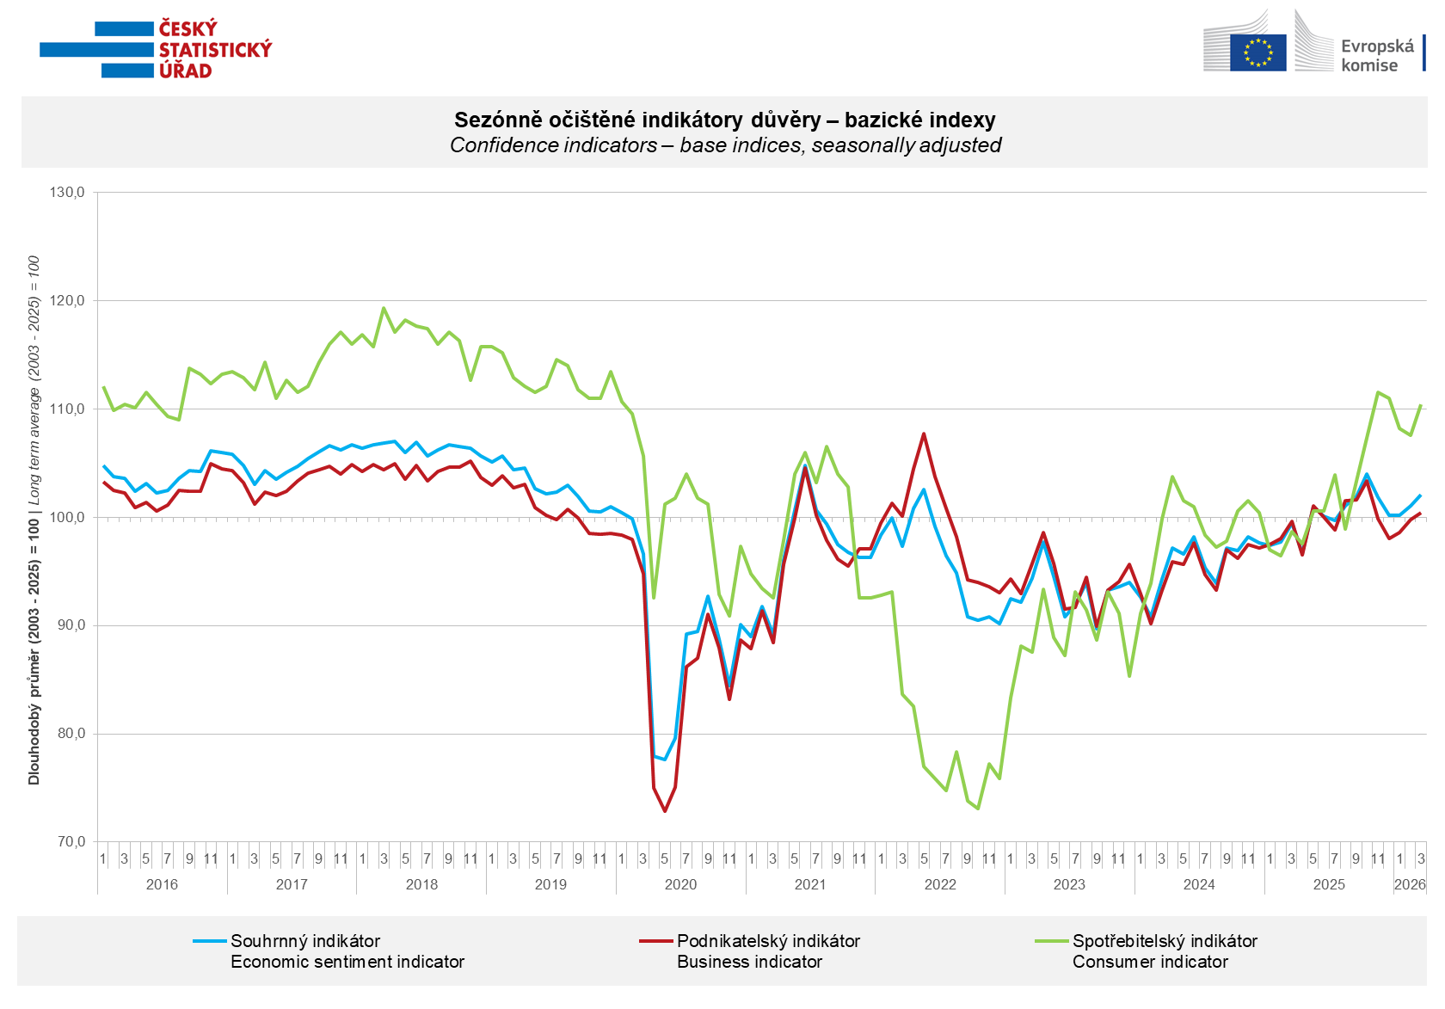

Economic confidence rose m-o-m in March in industry (+2.0 points) and in trade (+1.4 points). In construction, economic confidence fell by 2.3 points compared with February, and in selected services, it declined slightly by 0.6 points.

Consumer confidence rose m-o-m. The confidence indicator increased by 2.8 points to 110.4. The share of consumers expecting the overall economic situation in the Czech Republic to worsen over the next twelve months declined for the second month in a row. The share of respondents who assess their current financial situation as worse than it was in the previous twelve months also decreased slightly. The share of households expecting an improvement in their financial situation over the next twelve months remained virtually unchanged m-o-m. The number of respondents who do not plan to make major purchases in the next twelve months decreased slightly compared to February. Consumer concerns about rising prices increased m-o-m.
***
More detailed information on the development of business and consumer confidence can be found in the supplementary information to the RI business surveys.

Notes:

Responsible manager: Juraj Lojka, Director of Business Statistics Coordination and Business Cycle Surveys Department, tel. +420731439291, e-mail: juraj.lojka@csu.gov.cz
Contact person: Jiri Obst, Head of Business Cycle Surveys Unit, tel. +420604815440, e-mail: jiri.obst@csu.gov.cz
Data source: CZSO business survey, Data Collect consumer survey (https://www.datacollect.cz)
Data collection date: Business part: March 17, 2026
Consumer part: March 16, 2026
Next News Release: April 24, 2026

This press release wasn´t edited for language.

Detailed time series of Balances and basic
indices of confidence indicators: https://csu.gov.cz/produkty/kpr_ts
Business and Consumers Surveys are co-financed by grant agreements of the European Commission DG ECFIN.
https://ec.europa.eu/info/business-economy-euro/indicators-statistics/economic-databases/business-and-consumer-surveys_en
Link to European database: https://ec.europa.eu/eurostat/web/euro-indicators/database
Note: In the News Release, information about the development of consumer concerns about price increases was added (at 9:50) to the text regarding the consumer confidence indicator.

Annex:
Additional information to NR Business cycle survey
Table Confidence Indicators – basic indices
Graph 1 Confidence indicators – base indices, seasonally adjusted (2003–2026)
Graph 2.1 Confidence Indicators for industry, construction, trade, and in selected services – base indices, seasonally adjusted (2003–2026)
Graph 2.2 Balances of seasonally adjusted confidence indicators for industry, construction, trade, and in selected services (2003–2026)
Graph 3 Economic Sentiment Indicators – international comparison, seasonally adjusted (2007-2026)

