7 May 2026

Industrial production increased by 1.6%, year-on-year, in the first quarter

Supplementary information to the news release on industry – March 2026
Industry in the first quarter
Industrial production was in real terms by 0.7% lower, quarter-on-quarter (q-o-q), in the Q1 2026. In the year-on-year comparison, it increased by 1.6%. In the first quarter of 2026, there was the same number of working days as in the Q1 2025.

Industrial production increased, year-on-year, in each of the three months of the first quarter of 2026. However, the growth rate gradually decelerated from 2.7% in January to 0.9% in March. The moderate year-on-year production growth in the first quarter was solely owing to manufacturing, the production of which increased, y-o-y, by 2.1%. On the other hand, performance of economic activities (industries) of mining and quarrying and electricity, gas, steam and air conditioning supply was lower.

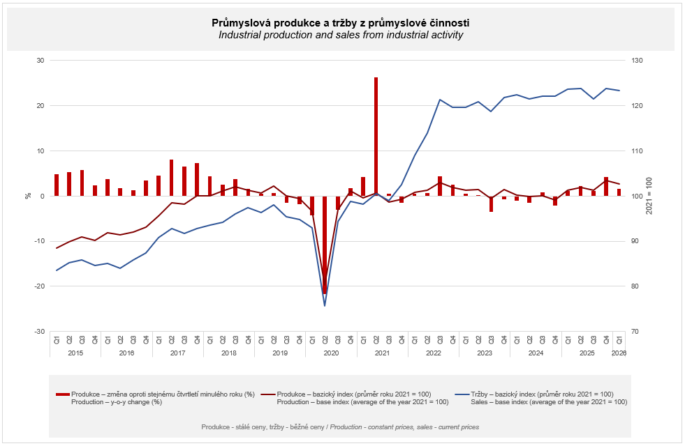

The industry in total increased by 1.6%, to which manufacture of motor vehicles, trailers and semi-trailers contributed by three quarters of a percentage point (p. p.). Production of this economic activity (industry) increased by 3.9%, y-o-y. The second highest contribution to the growth came from manufacture of fabricated metal products (a contribution of +0.68 p. p., an increase by 6.8%). Manufacture of other transport equipment, in which production increased by almost a quarter, year-on-year, contributed with a third of a percentage point to the growth of industry.
The following had the highest negative contributions to the result: manufacture of machinery and equipment (a contribution of -0.29 p. p., a decrease by 4.1%), repair and installation of machinery and equipment (a contribution of -0.28 p. p., a decrease by 9.6%), and electricity, gas, steam and air conditioning supply (a contribution of -0.14 p. p., a decrease by 1.3%).

Sales from industrial activity at current prices decreased by 0.4%, y-o-y, in the Q1 2026. Direct export sales of industrial enterprises decreased at current prices by 0.5%. Domestic sales, which also include indirect export via non-industrial enterprises, decreased at current prices by 0.3%.
The following contributed the most to the decrease: manufacture of machinery and equipment (a contribution of -0.31 p. p., a decrease by 4.7%), manufacture of chemicals and chemical products (a contribution of -0.23 p. p., a decrease by 7.1%), and manufacture of electrical equipment (a contribution of -0.16 p. p., a decrease by 2.4%).
On the other hand, the following contributed the most in a positive sense to the development of sales from industrial activity: manufacture of motor vehicles, trailers and semi-trailers (a contribution of +0.41 p. p., an increase by 1.5%), manufacture of fabricated metal products (a contribution of +0.35 p. p., an increase by 4.6%), and manufacture of other transport equipment (a contribution of +0.28 p. p., an increase by 19.1%).

The value of new orders at current prices in surveyed industrial CZ-NACE activities in the Q1 2026 increased by 4.3%, year-on-year. Non-domestic new orders increased by 4.8%. Domestic new orders increased by 3.3%.
The following contributed in rather a dominant way to the increase in the value of new orders in total: manufacture of motor vehicles, trailers and semi-trailers (a contribution of +4.48 p. p., an increase by 11.8%), manufacture of fabricated metal products (a contribution of +0.54 p. p., an increase by 4.4%), and manufacture of electrical equipment (a contribution of +0.46 p. p., an increase by 4.0%).
The biggest decrease was recorded by manufacture of other transport equipment (a contribution of -0.40 p. p., a decrease by 14.2%), manufacture of machinery and equipment (a contribution of -0.36 p. p., a decrease by 3.4%), and manufacture of chemicals and chemical products (a contribution of -0.30 p. p., a decrease by 5.6%).

The average registered number of employees in industry in the Q1 2026 was by 1.1% lower compared to the corresponding period of the previous year.

Notes:
Contact person: Veronika Doležalová, Head of Industrial Statistics Unit, phone number (+420) 734 352 291, e-mail: veronika.dolezalova@csu.gov.cz

Related outputs: time series in DataStat – topic: Short-term statistics on industry

